Name________________________________________ Block_____
Farming, Mining, and Ranching
Read pgs. 184-187 and respond to the following questions.
1. Why was farming on the Great Plains not exactly an ideal situation?

2. What is “dry farming”?

3. Describe late 19th century farming inventions.
Late 1800s farming Inventions | Importance of Invention
1.
2.
3.
4.

4. What were “bonanza farms”?

5. What problems did bonanza farms cause?

6. What 2 issues caused massive debt for farmers?
1.

2.

7. How did the lure of quick wealth through mining affect small towns?

8. What was placer mining?

9. Why did mining become the realm of big business?

10. What did Americans learn from Mexicans about ranching?

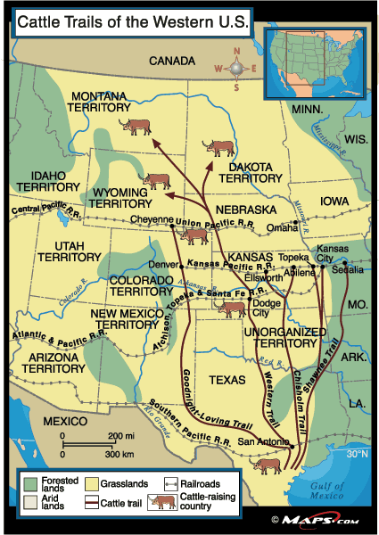
11. How did demand for beef spur the growth of the cattle industry?

12. What was the “long drive”?

13. What were some dangers of the long drive?

14. Judging from the map, why do you think cattle trails followed the route they did?

15. What 3 factors led to the end of the cattle boom?
1.

2.

3.

