Name_____________________________________________ Block_____
AMERICAN EXPANSIONISM PACKET
Should U.S. actions in world affairs around the turn of the 20th century be praised or condemned?
Examine the political cartoon and answer these questions.
1. What are the characters and symbols in the cartoon, and what does each one represent?

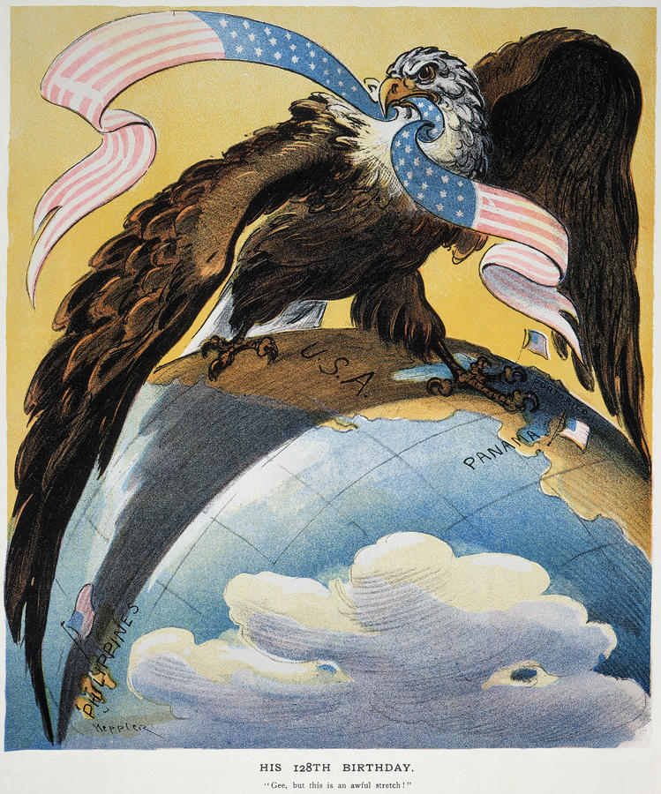

2. How do the words/caption help you identify the cartoonist’s intention?

3. What opinion is the cartoonist expressing?

4. Fill in the T-chart with at least two arguments for and two arguments against U.S. expansionism around the turn of the 20th century.

Arguments For US Expansionism
Arguments Against US Expansionism

5. Complete the spoke diagram.

Causes of the Spanish-American War

6. List two results of the Spanish-American War as outlined in the peace treaty with Spain.

1.

2.

7. Why were Filipino fighters willing to ally themselves with Admiral Dewey and the United States? Why did they eventually feel betrayed by the United States?

8. Fill in one speech bubble with praise for U.S. actions in the Philippines and the other with condemnation.

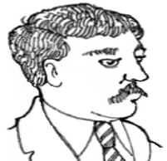
U.S. Expansionist
Anti-imperialist

9. What 2 reasons made Hawaii an important asset to the United States?

1.

2.

10. How did Queen Liliuokalani feel about US involvement in Hawaii?

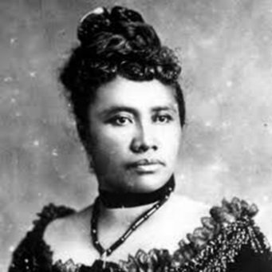

11. How did Sanford Dole (ya, the Duck Dynasty-looking pineapple guy) respond to the queen?

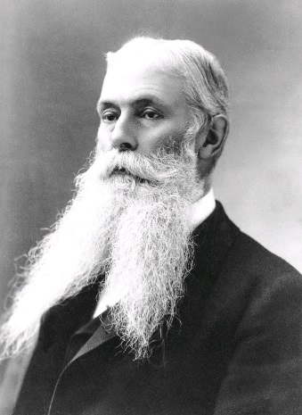

12. President William McKinley said about the annexation of Hawaii (write the quote on p. 268)…

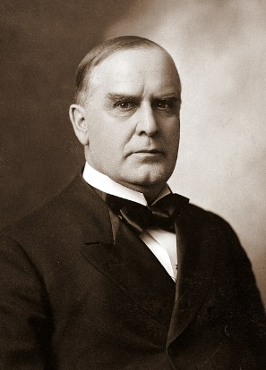

13. Analyze the cartoon and answer the questions…Look at the cartoon on p. 269 of your book for a clearer, color version.
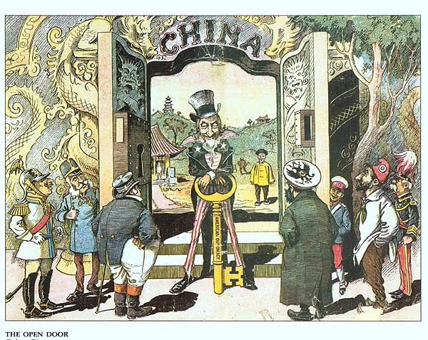
A. What are the characters and symbols in the cartoon, and what does each one represent?

B. How do the words/caption help you identify the cartoonist’s intention?

C. What action is taking place in the cartoon?

D. What opinion is the cartoonist expressing?

14. Create a political cartoon that shows your praise or condemnation of one of these topics: U.S. expansionist policy around the turn of the 20th century in the Spanish-American War, the Philippines. Hawaii, or China. Your cartoon should clearly convey your point of view on U.S. actions for that topic. It should also contain at least three of the following elements:
- symbols (images that represent something else)
- important people
- exaggerated details
- a caption
- other devices such as labels, speech balloons, or thought bubbles

