American Revolution:
Study Packet
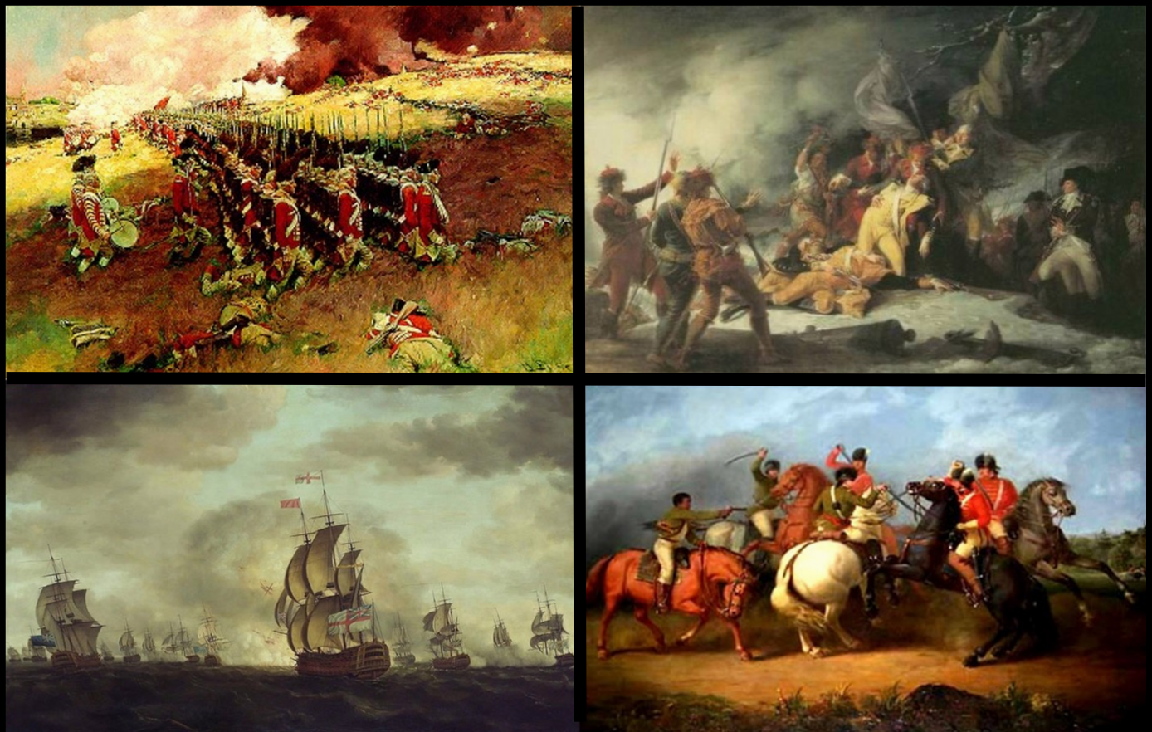

_________
50

Name:______________________ Block:____

Essential Questions

Complete the following questions in a short paragraph. (10 points)

1. What were the advantages of each side as they entered the war?

2. What were the main ideas of the Declaration of Independence?

3. Why was the battle of Saratoga a turning point in the war?

4. How did the Americans and French defeat the British as Yorktown?

Short Essay Questions

Complete the following questions in complete sentences. (10 points)

1. What characteristics did George Washington posses that allowed him to be an effective leader?

2. How did American patriots justify the existence of slavery while fighting for their own freedom from England?

3. Explain in detail the effect of the Revolutionary War on Native Americans, their land, their culture and their existence.

4.. Describe the Revolutionary War in military terms (strategic and tactical). Was the outcome predictable or not? Explain.

5. What is the value of alliances in a time of war? Could the war have been won without the French or with the Hessians?

6. Was the Revolutionary War a popular uprising? Explain using historical evidence and reasoning.

7. How did economic forces create, sustain and become affected by the Revolutionary War in the American colonies?

8. What impact did American domestic support (Tories) for the British have on the conduct of the war and the message of revolution?

9. . How can revolutions fail? What political, economic and social forces contribute to the loss of a revolutionary struggle?

10. How did Common Sense affect the colonists?

Writing Assignments

Choose 2 of the following to complete in a minimum of 200 words. Attach to packet. (10 points each)

1. You are Benedict Arnold. Write a letter to King George explaining why you want to switch to the British side.

2. You are Thomas Jefferson. Discuss in a conversation with your wife the difficulties faced in writing the Declaration of Independence.

3. You are Molly Pitcher and Betsy Ross. Have a debate about who played a more important role in the Revolution.

Project

Task:
Students will work in pairs to create a newscast based on your role as a television war correspondent and anchorperson.

Requirements:
- Minimum of 2 stories per person
- Must be typed (350+words each)
- Must have interviews in each piece
- Will present broadcast in front of class

Options:
Can cover any of the following topic areas:
Battles
Leaders
Soldiers
Families back home
Military “experts”
…or any other ideas you run by me

Due date:________________________

Political Cartoons
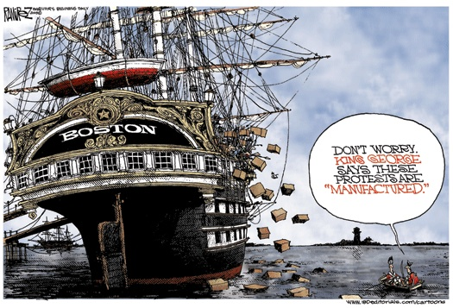

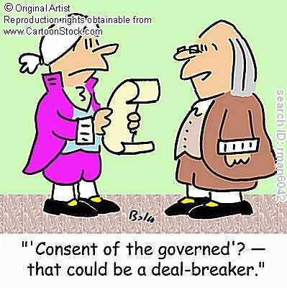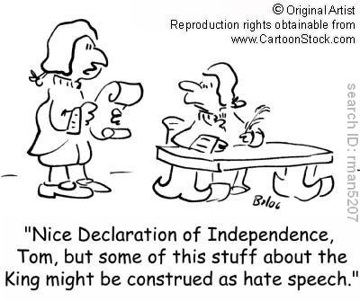

Project

