Anti-Vietnam War Movement: Mini-DBQ

Central Historical Questions:
Why did many Americans oppose the Vietnam War?

Anti-Vietnam War Movement Timeline
1965 | 180,000 American forces in Vietnam
1967 | 500, 000 American forces in Vietnam
Oct. 1967 | 75,000 protest against the Vietnam War in Washington D.C.
Jan. 1968  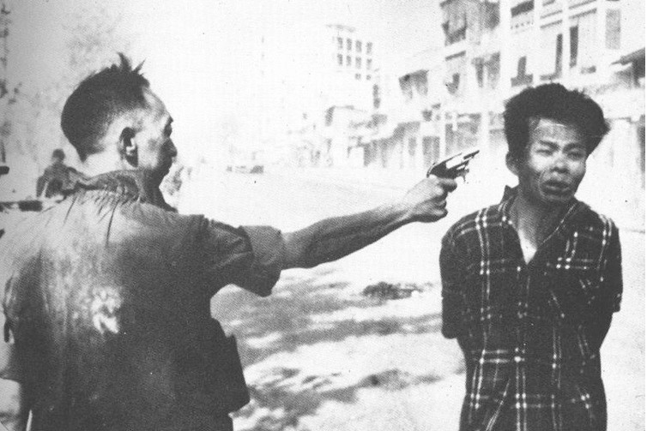 | Tet Offensive: Surprise attack on South Vietnamese cities by Vietcong and North Vietnamese forces. Ultimately, it was a military loss for the Communists. But Americans watched on TV and were shocked and horrified that the U.S. was caught off-guard.  CBS news anchor, Walter Cronkite, famously said, “"We have been too often disappointed by the optimism of the American leaders, both in Vietnam and Washington,. . . [We] are mired in a stalemate that could only be ended by negotiation, not victory."
Feb. 1968 | 60% of Americans disapprove of Johnson’s handling of the war
April 4, 1968 | Martin Luther King, Jr. assassinated
June 4, 1968 | Robert F. Kennedy assassinated. Many believe that RFK would have been the Democratic nominee for president.
Jan-June 1968 | 221 college protests against the Vietnam war
Aug. 1968  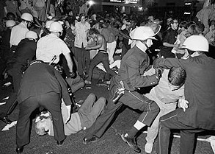 | Democratic National Convention: 10,000 anti-war protesters clash with policemen and National Guardsmen. The violence is caught on television.
Nov. 1969 | My Lai Massacre: Americans first hear of the My Lai massacre, which occurred in March 1968, when U.S. troops brutally attacked 300-500 Vietnamese, mostly women and children. Knowledge of the incident sparks public outrage.
April 1970 | Cambodia: President Nixon announces that American forces have bombed parts of the Ho Chi Minh trail throughout Laos and Cambodia. This announcement angers Americans because Nixon campaigned on the promise of ending the war.
May 1970  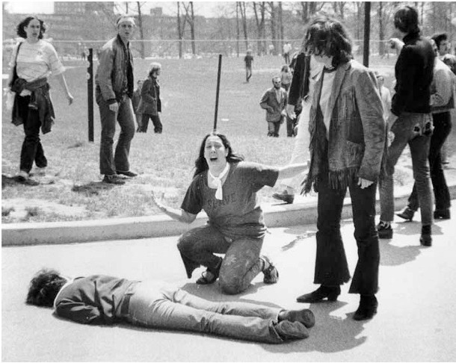 | Kent State: Student protest at Kent State University against Nixon’s invasion of Cambodia. National Guardsmen are brought in to break up the protest. They wound 9 students and kill 4 (2 of whom were not involved in the protest).  Jackson State: (June 1970) Student protest at an all-black college in Mississippi. National Guardsmen shoot and kill 2 students, wounding 12.
June 1971 | Pentagon Papers: Top-secret military report that was leaked to the New York Times and revealed that the U.S. had drawn up plans to go to war with Vietnam even when President Johnson claimed he wouldn’t send troops.

Document A: Martin Luther King, Jr.

I come to this platform tonight to make a passionate plea to my beloved nation.

There is at the outset a very obvious . . . connection between the war in Vietnam and the struggle I and others have been waging in America. A few years ago. . .it seemed as if there was a real promise of hope for the poor, both black and white, through the poverty program. There were experiments, hopes, new beginnings. Then came the buildup in Vietnam, and I watched this program broken and eviscerated [gutted] . . . . And I knew that America would never invest the necessary funds or energies in rehabilitation of its poor so long as adventures like Vietnam continued to draw men and skills and money like some demonic, destructive suction tube. So I was increasingly compelled to see the war as an enemy of the poor and to attack it as such.

Perhaps a more tragic recognition of reality took place when it became clear to me that the war was doing far more than devastating the hopes of the poor at home. . . . We were taking the black young men who had been crippled by our society and sending them eight thousand miles away to guarantee liberties in Southeast Asia which they had not found in southwest Georgia and East Harlem. So we have been repeatedly faced with the cruel irony of watching Negro and white boys on TV screens as they kill and die together for a nation that has been unable to seat them together in the same schools.. . .

As I have walked among the desperate, rejected, and angry young men, I have told them that Molotov cocktails and rifles would not solve their problems. . . .But they asked, and rightly so, "What about Vietnam?" . . . Their questions hit home, and I knew that I could never again raise my voice against the violence of the oppressed in the ghettos without having first spoken clearly to the greatest purveyor [supplier] of violence in the world today: my own government. For the sake of those boys, for the sake of this government, for the sake of the hundreds of thousands trembling under our violence, I cannot be silent.

Somehow this madness must cease. We must stop now. I speak as a child of God and brother to the suffering poor of Vietnam. I speak for those whose land is being laid waste, whose homes are being destroyed, whose culture is being subverted. I speak for the poor of America who are paying the double price of smashed hopes at home, and death and corruption in Vietnam. I speak as a citizen of the world, for the world as it stands aghast at the path we have taken. I speak as one who loves America, to the leaders of our own nation: The great initiative [power to take charge] in this war is ours; the initiative to stop it must be ours.

Source: Martin Luther King’s speech, “Beyond Vietnam,” delivered April 4, 1967, at a meeting of Clergy and Laity Concerned at Riverside Church in New York City.

Document B: John Kerry

I would like to talk on behalf of all those veterans. . .

In our opinion and from our experience, there is nothing in South Vietnam which could happen that realistically threatens the United States of America. And to attempt to justify the loss of one American life in Vietnam, Cambodia or Laos by linking such loss to the preservation of freedom. . .is to us the height of criminal hypocrisy, and it is that kind of hypocrisy which we feel has torn this country apart. . .

We found most people didn't even know the difference between communism and democracy. They only wanted to work in rice paddies without helicopters strafing [repeatedly attacking] them and bombs with napalm burning their villages and tearing their country apart. . . .

We rationalized destroying villages in order to save them. . . .We learned the meaning of free fire zones, shooting anything that moves, and we watched while America placed a cheapness on the lives of orientals. . .

Each day . . . someone has to give up his life so that the United States doesn't have to admit something that the entire world already knows, so that we can't say that we have made a mistake. Someone has to die so that President Nixon won't be, and these are his words, "the first President to lose a war."

We are asking Americans to think about that because how do you ask a man to be the last man to die in Vietnam? How do you ask a man to be the last man to die for a mistake?. . .

We are here to ask, and we are here to ask vehemently, where are the leaders of our country? Where is the leadership? We're here to ask where are McNamara, Rostow, Bundy, Gilpatrick, and so many others? Where are they now that we, the men they sent off to war, have returned? These are the commanders who have deserted their troops. And there is no more serious crime in the laws of war.

We wish that a merciful God could wipe away our own memories of that service as easily as this administration has wiped away their memories of us. But all that they have done . . . is to make more clear than ever our own determination to undertake one last mission -- to search out and destroy . . .the hate and fear that have driven this country these last ten years and more.

Source: John Kerry, testimony to the U.S. Senate Committee on Foreign Relations, April 23, 1971. John Kerry was a veteran who returned from Vietnam in April 1969, having won early transfer out of the conflict because of his three Purple Hearts. He joined a group called Vietnam Veterans Against the War.

