APUSH Unit 3 DBQ Essay

Suggested reading period: 15 minutes
Suggested writing period: 45 minutes

Directions: Answer the prompt using the accompanying documents and outside information. The documents have been edited for the purpose of this exercise. You are advised to spend 15 minutes reading and planning and 45 minutes writing your answer.

In your response you should do the following.
- State a relevant thesis that directly addresses all parts of the question.
- Support the thesis or a relevant argument with evidence from all or all but one of the documents.
- Incorporate analysis of all or all but one of the documents into your argument.
- Focus your analysis of each document on at least one of the following: historical context, intended audience, purpose, and/or point of view.
- Support your argument with analysis of historical examples outside the documents.
- Connect historical phenomena relevant to your argument to broader events or processes.
- Synthesize the elements above into a persuasive essay that extends your argument, connects it to a different historical context, or accounts for contradictory evidence on the topic.

Prompt: To what extent did the Articles of Confederation provide the United States with an effective
government between 1781 and 1789?

Document 1

Source: The Articles of Confederation, 1777

The United States in Congress assembled shall never engage in war, …nor enter into any treaties or alliances, nor coin money, nor regulate the value thereof, nor ascertain the sums and expenses necessary for the defense and welfare of the United States, or any of them, nor emit bills, nor borrow money on the credit of the United States, nor appropriate money, nor agree upon the number of vessels of war, to be built or purchased, or the number of land or sea forces to be raised, nor appoint a commander in chief of army or navy, unless nine States assent to the same: nor shall a question on any other point, …be determined, unless by the votes of a majority of the United States in Congress assembled.

Document 2

Source: Alexander Hamilton writing on commerce, April 18, 1872

The vesting Congress with the power of regulating trade ought to have been a principal object of the confederation for a variety of reasons. It is as necessary for the purposes of commerce as of revenue. There are some, who maintain, that trade will regulate itself, and is not to be benefitted by the encouragements, or restraints of government. Such persons will imagine, that there is no need of a common directing power. This is one of those wild speculative paradoxes, which have grown into credit among us, contrary to the uniform practice and sense of the most enlightened nations…

To preserve the ballance of trade in favour of a nation ought to be a leading aim of its policy….No mode can be so convenient as a source of revenue to the United States. It is agreed that imposts on trade, when not immoderate, or improperly laid, is one of the most eligible species of taxation.

Document 3

Source: The Definitive Treaty of Peace, Paris, September 30, 1783

Article 1st:
His Brittanic Majesty acknowledges the said United States, viz., New Hampshire, Massachusetts Bay, Rhode Island and Providence Plantations, Connecticut, New York, New Jersey, Pennsylvania, Delaware, Maryland, Virginia, North Carolina, South Carolina and Georgia, to be free sovereign and Independent States; that he treats with them as such, and for himself his Heirs & Successors, relinquishes all claims to the Government, Propriety, and Territorial Rights of the same and every Part thereof.

Document 4

Source: Land Ordinance of 1785, Congress of the United States, 1785

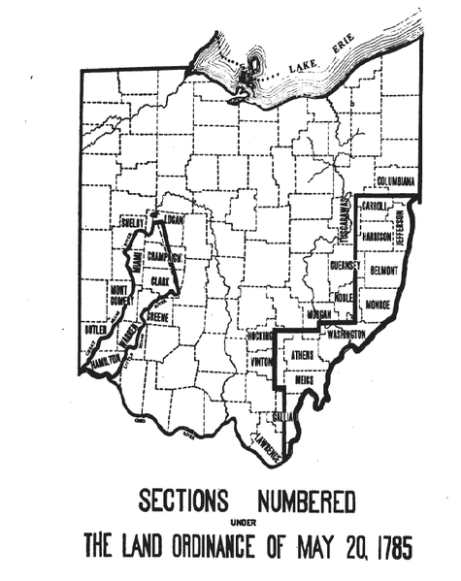

Document 5

Source: “An Address to the People,” by Daniel Gray, Shays Rebellion participant, 1786

An ADDRESS to the PEOPLE of the several Towns in the County of Hampshire, from the Body now at arms.

Gentlemen,

WE have thought proper to inform you of some of the principal causes of the late risings of the people, and also of their present movement, viz.

1st: The present expensive mode of collecting debts, which by the reason of the great scarcity of cash, will be necessity fill our goals with unhappy debtors, and thereby render a reputable body of people incapable of being serviceable either to themselves or the community.

2d. The monies raised by impost and excise being appropriated to discharge the interest of governmental securities, and not the foreign debt, when these securities are not subject to taxation.

3d. A suspension of the Writ of Habeas Corpus, by which those persons who have stepped forth to assert and maintain the rights of the people, are liable to be the taken, and conveyed even to the most distant part of the commonwealth, and thereby subject to an unjust punishment.

4th. The unlimited power granted to Justices of the Peace, Sheriffs, Deputy-Sheriffs and Constables, by the Riot Act, indemnifying them in the prosecution thereof, when perhaps wholly actuated from a principle of revenge, hatred and envy.

Furthermore, be assured, that this body now at arms, despise the idea of being initiated by British emissaries, which is to strenuously propagated by the enemies of our liberties: We also with the most proper and speedy measures may be taken to discharge both our foreign and domestic debt.

Document 6

Source: Vices of the Political System of the U. States, by James Madison, 1787

From the number of [State] Legislatures, the sphere of life from which most of their members are taken, and the circumstances under which their legislative business is carried on, [violations of the law of nations and treaties] must frequently happen. Accordingly not a year has passed without instances of them in some one or other of the States. The Treaty of Peace--the treaty with France--the treaty with Holland have each been violated. [See the complaints to Congress on these subjects.] The causes of these irregularities must necessarily produce frequent violations of the law of nations in other respects.

As yet foreign powers have not been rigorous in [committing action] on us. This moderation, however cannot be mistaken for a permanent partiality to our faults, or a permanent security agst. those disputes with other nations, which being among the greatest of public calamities, it ought to be least in the power of any part of the community to bring on the whole.

Document 7

Source: Ordinance of 1787, Congress of the United States, 1787

ARTICLE VI
There shall be neither slavery nor involuntary servitude in the said territory, otherwise than in punishment of crimes, whereof the party shall have been duly convicted: provided always that any person escaping into the same, from whom labor or service is lawfully claimed in any one of the original states, such fugitive may be lawfully reclaimed and conveyed to the person claiming his or her labor or service as aforesaid.

