AP UNITED STATES HISTORY
Chapter 3 Materials
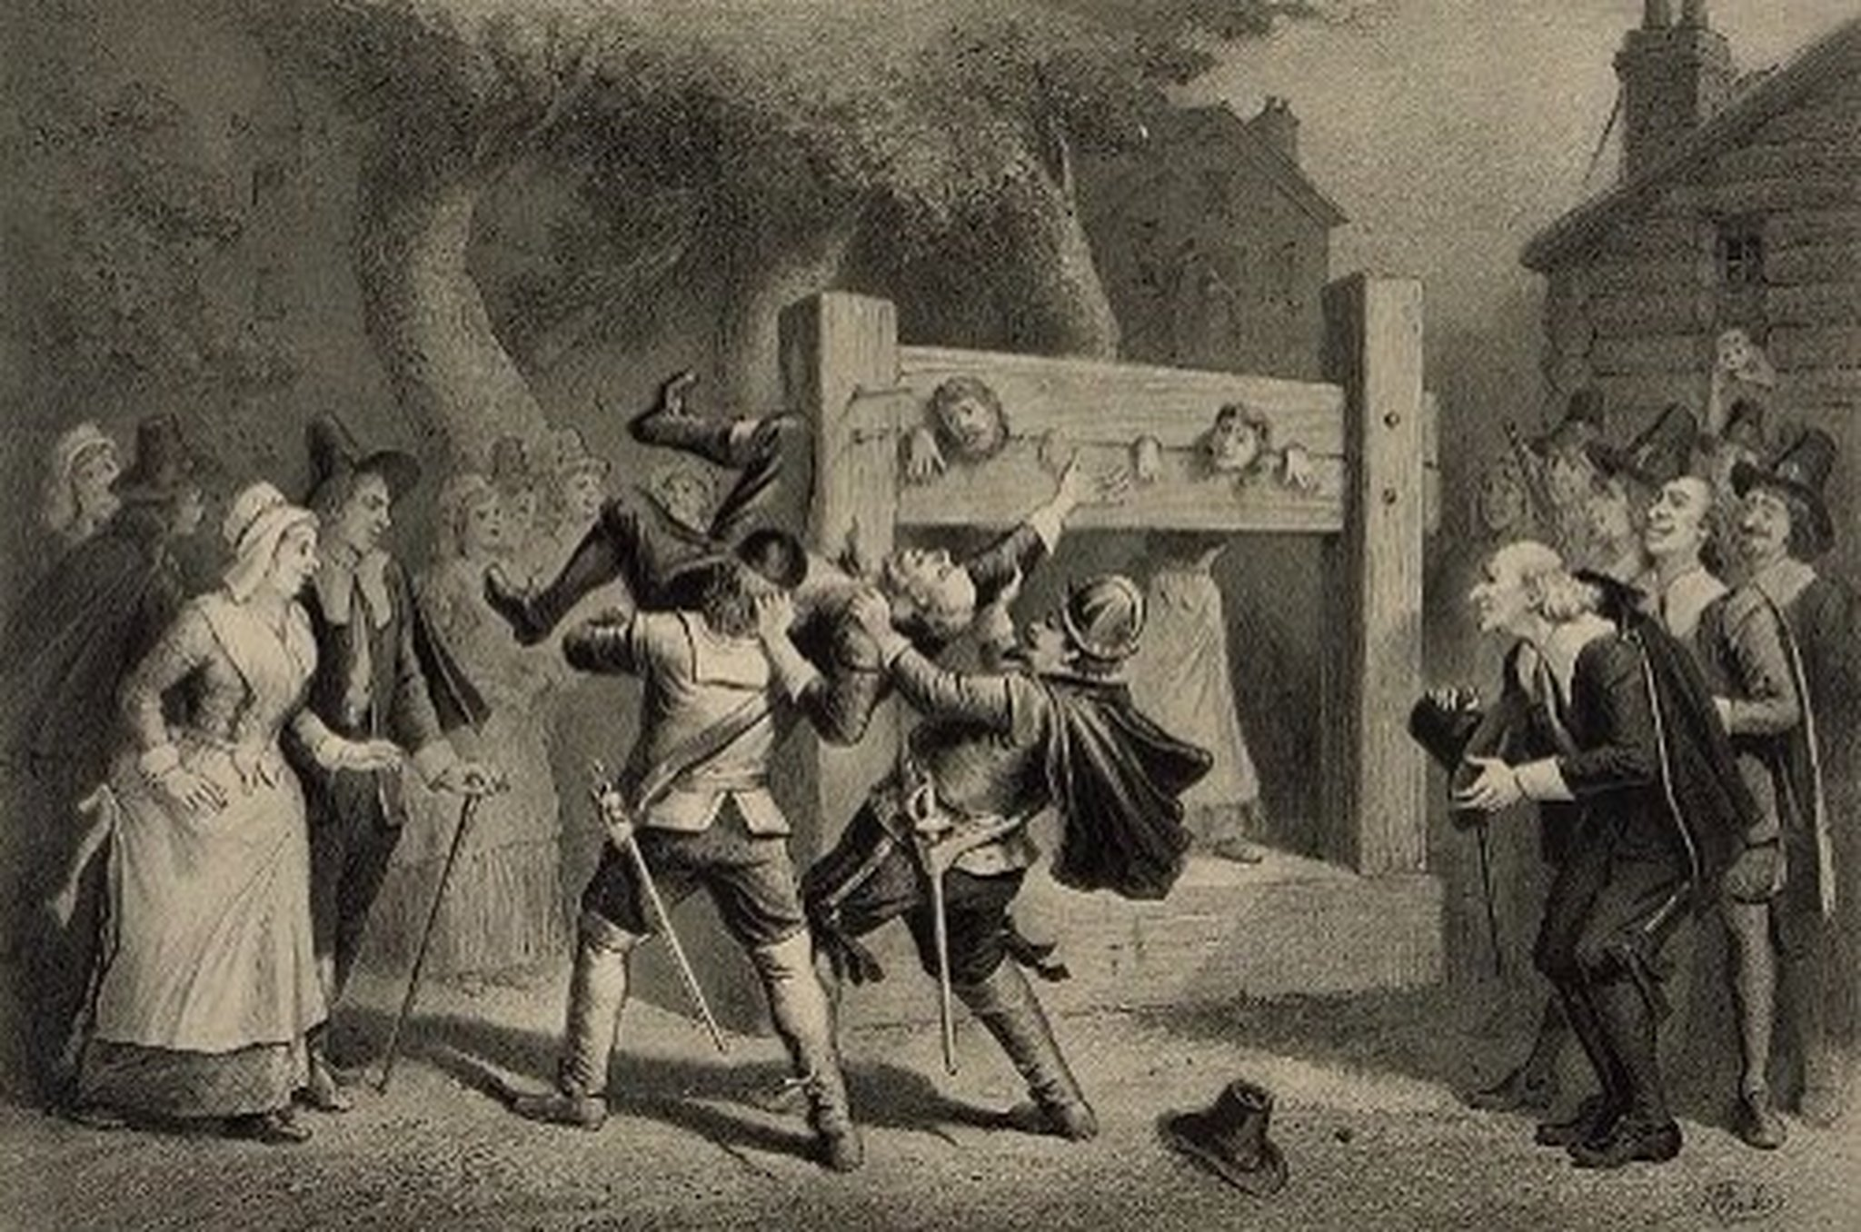

Creating Anglo-America, 1660-1750
Mr. Bailey-Room 401
cbailey@quaboagrsd.org
bailey401.weebly.com

Creating Anglo-America: Terms
Metacom (p. 94)  King Philip’s War (p. 95)  mercantilist system (p. 95)  Navigation Acts (p. 96)  Covenant Chain (p. 98)  Yamasee uprising (p. 99)  Society of Friends (Quakers)  (p. 100)  sugar (p. 103)  Las Siete Partidas (p. 105)  Bacon’s Rebellion (p. 106)  slave code (p. 108)  Anglicanism (p. 109) | Glorious Revolution (p. 109)  English Bill of Rights (p. 109)  Lords of Trade (p. 110)  Dominion of New England  (p. 110)  English Toleration Act (p. 111)  Salem witch trials (p. 112)  redemptioners (p. 116)  Walking Purchase (p. 120)  backcountry (p. 120)  artisans (p. 122)  “cousinocracy” (p. 125)

William Penn, Pennsylvania Charter of Privileges (1701)
KNOW YE THEREFORE, That for the further Well-being and good Government of the said Province, and Territories; I the said William Penn do declare, grant and confirm, unto all the Freemen, Planters and Adventurers, and other Inhabitants of this Province and Territories, these following Liberties, Franchises and Privileges…
HIPP/NOTES:
BECAUSE no People can be truly happy, though under the greatest Enjoyment of Civil Liberties, if abridged of the Freedom of their Consciences, as to their Religious Profession and Worship: And Almighty God being the only Lord of Conscience, Father of Lights and Spirits; and the Author as well as Object of all divine Knowledge, Faith and Worship, who only doth enlighten the Minds, and persuade and convince the Understandings of People, I do hereby grant and declare, That no Person or Persons, inhabiting in this Province or Territories, who shall confess and acknowledge One almighty God, the Creator, Upholder and Ruler of the World; and profess him or themselves obliged to live quietly under the Civil Government, shall be in any Case molested or prejudiced, in his or their Person or Estate, because of his or their conscientious Persuasion or Practice, nor be compelled to frequent or maintain any religious Worship, Place or Ministry, contrary to his or their Mind, or to do or suffer any other Act or Thing, contrary to their religious Persuasion.
AND that all Persons who also profess to believe in Jesus Christ, the Savior of the World, shall be capable (notwithstanding their other Persuasions and Practices in Point of Conscience and Religion) to serve this Government in any Capacity, both legislatively and executively…
FOR the well governing of this Province and Territories, there shall be an Assembly yearly chosen, by the Freemen thereof, to consist of Four Persons out of each County, of most Note for Virtue, Wisdom and Ability,…Which Assembly shall have Power to choose a Speaker and other their Officers; prepare Bills in order to pass into Laws; impeach Criminals, and redress Grievances; and shall have all other Powers and Privileges of an Assembly, according to the Rights of the free-born Subjects of England.
QUESTIONS…
1. What are Penn’s arguments in favor of religious liberty?

2. Why does the document refer to “the rights of the free-born subjects of England?”
FROM Letter by a Female Indentured Servant (September 22, 1756)
Only a minority of emigrants from Europe to British North America were fully free. Indentured servants were men and women who surrendered their freedom for a specified period of time in exchange for passage to America. This letter by Elizabeth Sprigs of Maryland to her father in England expresses complaints voiced by many indentured servants.
HIPP/NOTES:
Honored Father,
My being forever banished from your sight, will I hope pardon the boldness I now take of troubling you with these. My long silence has been purely owing to my undutifulness to you, and well knowing I had offended in the highest degree, put a tie on my tongue and pen, for fear I should be extinct from your good graces and add a further trouble to you. . . .
O Dear Father, believe what I am going to relate the words of truth and sincerity and balance my former bad conduct [to] my sufferings here, and then I am sure you’ll pity your distressed daughter. What we unfortunate English people suffer here is beyond the probability of you in England to conceive. Let it suffice that I am one of the unhappy number, am toiling almost day and night, and very often in the horse’s drudgery, with only this comfort that you bitch you do not do half enough, and then tied up and whipped to that degree that you now serve an animal. Scarce any thing but Indian corn and salt to eat and that even begrudged nay many Negroes are better used, almost naked no shoes nor stockings to wear, and the comfort after slaving during master’s pleasure, what rest we can get is to wrap ourselves up in a blanket and lie upon the ground. This is the deplorable condition your poor Betty endures, and now I beg if you have any bowels of compassion left show it by sending me some relief. Clothing is the principal thing wanting, which if you should condescend to, may easily send them to me by any of the ships bound to Baltimore town, Patapsco River, Maryland. And give me leave to conclude in duty to you and uncles and aunts, and respect to all friends. . . .
Elizabeth Sprigs

QUESTION…
1. Why does Elizabeth Sprigs compare her condition unfavorably to that of blacks?

Historical Content & Context
Intended Audience
Point of View
Purpose

FROM Letter by a Swiss-German Immigrant to Pennsylvania (August 23, 1769)
HIPP/NOTES:
Germans were among the most numerous immigrants to the eighteenth-century colonies. Many wrote letters to family members at home, relating their experiences and impressions.
Dearest Father, Brother, and Sister and Brother-in-law,
I have told you quite fully about the trip, and I will tell you what will not surprise you—that we have a free country. Of the sundry craftsmen, one may do whatever one wants. Nor does the land require payment of tithes [taxes to support a local landlord, typical in Europe]. . . . The land is very big from Canada to the east of us to Carolina in the south and to the Spanish border in the west. . . . One can settle wherever one wants without
I have always enough to do and we have no shortage of food. Bread is plentiful. If I work for two days I earn more bread than in eight days [at home]. . . . Also I can buy many things so reasonably [for example] a pair of shoes for [roughly] seven Pennsylvania shillings. . . .I think that with God’s help I will obtain land. I am not pushing for it until I am in a better position.
I would like for my brother to come . . . and it will then be even nicer in the country. . . . I assume that the land has been described to you sufficiently by various people and it is not surprising that the immigrant agents [demand payment]. For the journey is long and it costs much to stay away for one year. . . .
Johannes Hanner

QUESTIONS…
1. What does Johannes Hanner have in mind when he calls America a “free country”?

2. What factors might explain the different experiences of the emigrants to British North America from the previous two documents?

Historical Content & Context
Intended Audience
Point of View
Purpose

An Apprentice's Indenture Contract
HIPP/NOTES:
I, William Mathews… of the city of New York…does voluntarily and of his own free will…put himself as an apprentice cordwainer to Thomas Windover...
[William Mathews] will live and…serve from August 15, 1718, until the full term of seven years be completed and ended…[he] shall faithfully serve his master, shall faithfully keep his secrets, and gladly obey his lawful commands everywhere….He shall not waste his said master’s goods nor lend them unlawfully to any. He shall not…contract matrimony within the [seven years].
At cards, dice, or any other unlawful game, he shall not play…with his own goods or the goods of others. Without a license from his master he shall neither buy nor sell during the said term. He shall not absent himself day or night from his master’s service without his leave, not haunt alehouses, but in all things he shall behave himself as a faithful apprentice toward his master….
The master…shall, by the best means or methods, teach or cause the apprentice to be taught the art or mystery of a cordwainer. He shall find and provide unto the said apprentice sufficient meat, drink, apparel, lodging, and washing fit for an apprentice. During the said term, every night in winter he shall give the apprentice one quarter of schooling. At the expiration of the said term he shall provide him with a sufficient new suit of apparel, four shirts, and two necklets.
QUESTIONS…
1. What obligations does each party assume in this document?

2. How is the liberty of the apprentice limited by the indenture?

Historical Content & Context
Intended Audience
Point of View
Purpose
John Lawson, Women in the Household Economy (1709)
HIPP/NOTES:
The Women are the most industrious Sex in that Place, and, by their good Houswifery, make a great deal of Cloth of their own Cotton, Wool and Flax; some of them keeping their Families (though large) very decently apparelled, both with Linens and Woolens, so that they have no occasion to run into the Merchant’s Debt, or lay their Money out on Stores for Clothing…
They marry very young; some at Thirteen or Fourteen; and She that stays till Twenty is reckoned a stale Maid — which is a very indifferent Character in that warm Country. The Women are very fruitful; most Houses being full of Little Ones. It has been observed, that Women long married, and without Children, in other Places, have removed to Carolina, and become joyful Mothers. They have very easy Travail in their Child-bearing, in which they are so happy, as seldom to miscarry…
Many of the Women are very handy in Canoes, and will manage them with great Dexterity and Skill, which they become accustomed to in this watery Country. They are ready to help their Husbands in any servile Work, as Planting, when the Season of the Weather requires Expedition; Pride seldom banishing good Houswifery. The Girls are not bred up to the Wheel, and Sewing only; but the Dairy and Affairs of the House they are very well acquainted withal; so that you shall see them, whilst very young, manage their Business with a great deal of Conduct and Alacrity. The Children of both Sexes are very docile, and learn anything with a great deal of Ease and Method; and those that have the Advantages of Education write good Hands and prove good Accountants, which is most coveted, and indeed most necessary in these Parts.
QUESTIONS…
1. What are the most important kinds of work done by Carolina women, according to Lawson?

2. How strict do gender roles appear to have been in early Carolina, circa 1709? Give evidence to back your conclusion, evidence drawn from the document.

Historical Content & Context
Intended Audience
Point of View
Purpose
Beginnings of English America: Political Cartoons
Analyze the cartoon and answer the questions.
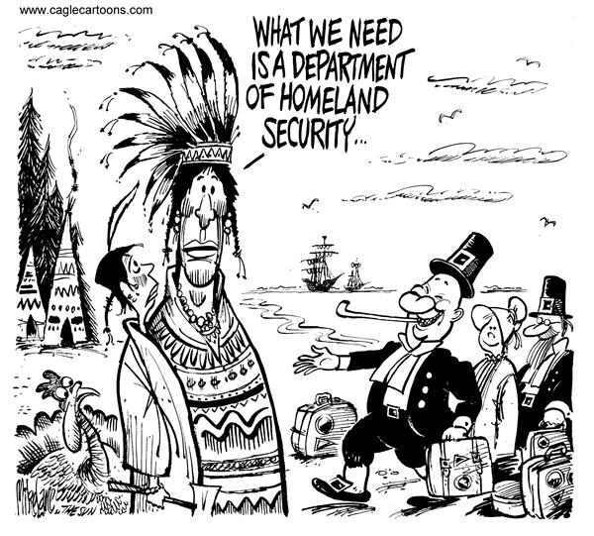
1. What are the characters and symbols in the cartoon, and what does each one represent?

2. How do the words help you identify the cartoonist’s intention?

3. What action is taking place in the cartoon?

4. What opinion is the cartoonist expressing?

Analyze the cartoon and answer the questions.
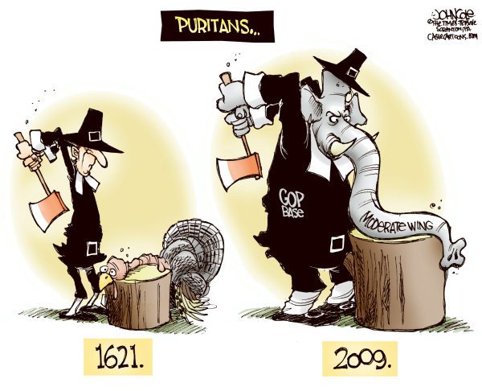
1. What are the characters and symbols in the cartoon, and what does each one represent?

2. How do the words help you identify the cartoonist’s intention?

3. What action is taking place in the cartoon?

4. What opinion is the cartoonist expressing?

REVIEW QUESTIONS
1. Both the Puritans and William Penn viewed their colonies as “holy experiments.” How did they differ?

2. The textbook states, “Prejudice by itself did not create American slavery.” Examine the forces and events that led to slavery in North America, and the role that racial prejudice played.

3. How were the actions of King James II toward New England perceived as threats to colonial liberty?

4. How did King Philip’s War, Bacon’s Rebellion, and the Salem witch trials illustrate a widespread crisis in British North America in the late seventeenth century?

5. The social structure of the eighteenth-century colonies was growing more open for some but not for others. For whom was there more opportunity, and for whom not?

6. By the end of the seventeenth century, commerce was the foundation of empire and the leading cause of competition between European empires. Explain how the North American colonies were directly linked to Atlantic commerce by laws and trade.

7. If you traveled outside of eighteenth-century New England, you might agree with fellow travelers that the colonies were demonstrating greater diversity in many ways. How would you support this claim?

8. Despite their lack of rights, hard-working women and children were often the key to the success of independent family farmers. Demonstrate the truth of this statement.

FREEDOM QUESTIONS
1. English settlers insisted that true freedom for Native Americans meant they must abandon their traditions and accept English ways. Examine the changes to Native American life by the mid-eighteenth century, and discuss whether Native American freedom increased by any standards.

2. Freedom and lack of freedom existed side-by-side in the English colonies. Using examples from Pennsylvania and elsewhere, demonstrate how greater freedom for some colonists in one area meant less freedom for others.

3. British citizens connected freedom and liberty to land ownership and not having to work for wages. Why did they make these connections and what were the consequences for the social structure?

4. Some historians have argued that the freedoms and prosperity of the British Empire were all based on slavery. Examine this statement using specific examples.

5. Many British settlers in North America believed it was the “best poor man’s country,” and that they were the freest people in the world. What factors would lead to such a claim?

