AP UNITED STATES HISTORY
Chapter 4 Materials
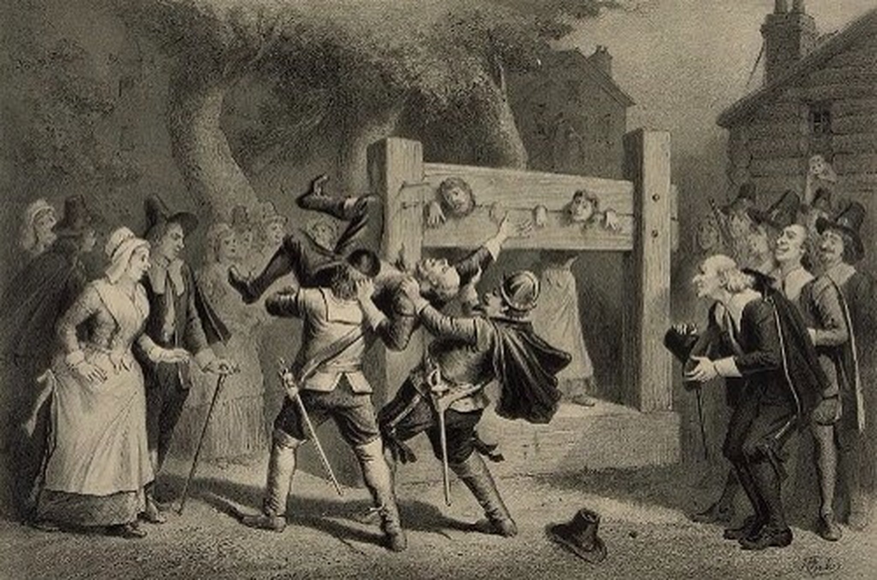

Creating Anglo-America, 1660-1750
Mr. Bailey-Room 401
cbailey@quaboagrsd.org
bailey401.weebly.com

Creating Anglo-America: Terms

Benjamin Franklin on George Whitefield

Autobiography of Benjamin Franklin (Project Gutenburg):
http://www.gutenberg.org/cache/epub/148/pg148.txt

In 1739 arrived among us from Ireland the Reverend Mr. Whitefield, who had made himself remarkable there as an itinerant preacher. He was at first permitted to preach in some of our churches; but the clergy, taking a dislike to him, soon refus'd him their pulpits, and he was oblig'd to preach in the fields. The multitudes of all sects and denominations that attended his sermons were enormous, and it was matter of speculation to me, who was one of the number, to observe the extraordinary influence of his oratory on his hearers, and how much they admir'd and respected him, notwithstanding his common abuse of them, by assuring them that they were naturally half beasts and half devils. It was wonderful to see the change soon made in the manners of our inhabitants. From being thoughtless or indifferent about religion, it seem'd as if all the world were growing religious, so that one could not walk thro' the town in an evening without hearing psalms sung in different families of every street.
And it being found inconvenient to assemble in the open air, subject to its inclemencies, the building of a house to meet in was no sooner propos'd, and persons appointed to receive contributions, but sufficient sums were soon receiv'd to procure the ground and erect the building, which was one hundred feet long and seventy broad, about the size of Westminster Hall; and the work was carried on with such spirit as to be finished in a much shorter time than could have been expected. Both house and ground were vested in trustees, expressly for the use of any preacher of any religious persuasion who might desire to say something to the people at Philadelphia; the design in building not being to accommodate any particular sect, but the inhabitants in general; so that even if the Mufti of Constantinople were to send a missionary to preach Mohammedanism to us, he would find a pulpit at his service.
Mr. Whitefield, in leaving us, went preaching all the way thro' the colonies to Georgia. The settlement of that province had lately been begun, but, instead of being made with hardy, industrious husbandmen, accustomed to labor, the only people fit for such an enterprise, it was with families of broken shop-keepers and other insolvent debtors, many of indolent and idle habits, taken out of the jails, who, being set down in the woods, unqualified for clearing land, and unable to endure the hardships of a new settlement, perished in numbers, leaving many helpless children unprovided for. The sight of their miserable situation inspir'd the benevolent heart of Mr. Whitefield with the idea of building an Orphan House there, in which they might be supported and educated. Returning northward, he preach'd up this charity, and made large collections, for his eloquence had a wonderful power over the hearts and purses of his hearers, of which I myself was an instance.
I did not disapprove of the design, but, as Georgia was then destitute of materials and workmen, and it was proposed to send them from Philadelphia at a great expense, I thought it would have been better to have built the house here, and brought the children to it. This I advis'd; but he was resolute in his first project, rejected my counsel, and I therefore refus'd to contribute. I happened soon after to attend one of his sermons, in the course of which I perceived he intended to finish with a collection, and I silently resolved he should get nothing from me, I had in my pocket a handful of copper money, three or four silver dollars, and five pistoles in gold. As he proceeded I began to soften, and concluded to give the coppers. Another stroke of his oratory made me asham'd of that, and determin'd me to give the silver; and he finish'd so admirably, that I empty'd my pocket wholly into the collector's dish, gold and all….
Some of Mr. Whitefield's enemies affected to suppose that he would apply these collections to his own private emolument; but I who was intimately acquainted with him (being employed in printing his Sermons and Journals, etc.), never had the least suspicion of his integrity, but am to this day decidedly of opinion that he was in all his conduct a perfectly honest man, and methinks my testimony in his favour ought to have the more weight, as we had no religious connection. He us'd, indeed, sometimes to pray for my conversion, but never had the satisfaction of believing that his prayers were heard. Ours was a mere civil friendship, sincere on both sides, and lasted to his death.
The following instance will show something of the terms on which we stood. Upon one of his arrivals from England at Boston, he wrote to me that he should come soon to Philadelphia, but knew not where he could lodge when there, as he understood his old friend and host, Mr. Benezet, was removed to Germantown. My answer was, "You know my house; if you can make shift with its scanty accommodations, you will be most heartily welcome." He reply'd, that if I made that kind offer for Christ's sake, I should not miss of a reward. And I returned, "Don't let me be mistaken; it was not for Christ's sake, but for your sake." One of our common acquaintance jocosely remark'd, that, knowing it to be the custom of the saints, when they received any favour, to shift the burden of the obligation from off their own shoulders, and place it in heaven, I had contriv'd to fix it on earth.
The last time I saw Mr. Whitefield was in London, when he consulted me about his Orphan House concern, and his purpose of appropriating it to the establishment of a college.
He had a loud and clear voice, and articulated his words and sentences so perfectly, that he might be heard and understood at a great distance, especially as his auditories, however numerous, observ'd the most exact silence. He preach'd one evening from the top of the Court-house steps, which are in the middle of Market-street, and on the west side of Second-street, which crosses it at right angles. Both streets were fill'd with his hearers to a considerable distance. Being among the hindmost in Market-street, I had the curiosity to learn how far he could be heard, by retiring backwards down the street towards the river; and I found his voice distinct till I came near Front-street, when some noise in that street obscur'd it. Imagining then a semi-circle, of which my distance should be the radius, and that it were fill'd with auditors, to each of whom I allow'd two square feet, I computed that he might well be heard by more than thirty thousand. This reconcil'd me to the newspaper accounts of his having preach'd to twenty-five thousand people in the fields, and to the antient histories of generals haranguing whole armies, of which I had sometimes doubted.
By hearing him often, I came to distinguish easily between sermons newly compos'd, and those which he had often preach'd in the course of his travels. His delivery of the latter was so improv'd by frequent repetitions that every accent, every emphasis, every modulation of voice, was so perfectly well turn'd and well plac'd, that, without being interested in the subject, one could not help being pleas'd with the discourse; a pleasure of much the same kind with that receiv'd from an excellent piece of musick. This is an advantage itinerant preachers have over those who are stationary, as the latter can not well improve their delivery of a sermon by so many rehearsals.
His writing and printing from time to time gave great advantage to his enemies… Critics attack'd his writings violently, and with so much appearance of reason as to diminish the number of his votaries and prevent their encrease; so that I am of opinion if he had never written any thing, he would have left behind him a much more numerous and important sect, and his reputation might in that case have been still growing, even after his death…

“Sinners in the Hands of an Angry God”

Excerpts from Jonathan Edwards’ Famous Sermon:
Source: http://www.cs.indiana.edu/~port/teach/relg/sinners.short.htm

Text for the sermon: `Their foot shall slide in due time' Deut. 32: 35
In this verse is threatened the vengeance of God on the wicked unbelieving Israelites, who were God's visible people, and who lived under the means of grace; but who, notwithstanding all God's wonderful works towards them, remained… void of counsel, having no understanding in them. Under all the cultivations of heaven, they brought forth bitter and poisonous fruit. The expression I have chosen for my text, Their foot shall slide in due time, seems to imply the following doings, relating to the punishment and destruction to which these wicked Israelites were exposed.
1. That they were always exposed to destruction; as one that stands or walks in slippery places is always exposed to fall…
2. It implies, that they were always exposed to sudden unexpected destruction. As he that walks in slippery places is every moment liable to fall, he cannot foresee one moment whether he shall stand or fall the next; and when he does fall, he falls at once without warning…
3. Another thing implied is, that they are liable to fall of themselves, without being thrown down by the hand of another; as he that stands or walks on slippery ground needs nothing but his own weight to throw him down.
4. That the reason why they are not fallen already, and do not fall now, is only that God's appointed time is not come. For it is said, that when that due time, or appointed time comes, their foot shall slide…
The observation from the words that I would now insist upon is this. "There is nothing that keeps wicked men at any one moment out of hell, but the mere pleasure of God." By the mere pleasure of God, I mean his sovereign pleasure, his arbitrary will, restrained by no obligation…
The truth of this observation may appear by the following considerations.
1. There is no want of power in God to cast wicked men into hell at any moment…
2. They deserve to be cast into hell…
3. They… not only justly deserve to be cast down thither, but… they are bound over already to hell. John iii. 18. "He that believeth not is condemned already." So that every unconverted man properly belongs to hell; that is his place… And thither be is bound…
4. They are now the objects of that very same anger and wrath of God, that is expressed in the torments of hell. And the reason why they do not go down to hell at each moment, is not because God, in whose power they are, is not then very angry with them… The wrath of God burns against them… the pit is prepared, the fire is made ready, the furnace is now hot, ready to receive them; the flames do now rage and glow. The glittering sword is whet, and held over them, and the pit hath opened its mouth under them.
5. The devil stands ready to fall upon them, and seize them as his own, at what moment God shall permit him…
9. All wicked men's pains and contrivance which they use to escape hell, while they continue to reject Christ, and so remain wicked men, do not secure them from hell one moment. Almost every natural man that hears of hell, flatters himself that he shall escape it; he depends upon himself for his own security; he flatters himself in what he has done, in what he is now doing, or what he intends to do… They hear indeed that there are but few saved, and that the greater part of men that have died heretofore are gone to hell…
… If we could speak with them, and inquire of them... whether they expected, when alive, and when they used to hear about hell, ever to be the subjects of that misery, we doubtless, should hear one and another reply, "No, I never intended to come here: I had laid out matters otherwise in my mind; I thought I should contrive well for myself…. I intended to take effectual care; but [death] came upon me unexpected… it came as a thief… wrath was too quick for me. Oh, my cursed foolishness! I was flattering myself… then suddenly destruction came upon me.''
10. God has laid himself under no obligation, by any promise to keep any natural man out of hell one moment. God certainly has made no promises either of eternal life, or of any deliverance or preservation from eternal death, but what are contained in the covenant of grace, the promises that are given in Christ…
So that, thus it is that natural men are held in the hand of God, over the pit of hell; they have deserved the fiery pit, and are already sentenced to it; and God is dreadfully provoked, his anger is as great towards them… and they have done nothing in the least to appease or abate that anger, neither is God in the least bound by any promise to hold them up one moment. The devil is waiting for them, hell is gaping for them, the flames gather and flash about them… In short, they have no refuge, nothing to take hold of, all that preserves them every moment is the mere arbitrary will, and uncovenanted, unobliged forbearance of an incensed God….
Your wickedness makes you ... heavy as lead, and to tend downwards with great weight and pressure towards hell; and if God should let you go, you would immediately sink and swiftly descend and plunge into the bottomless gulf….
The bow of God's wrath is bent, and the arrow made ready on the string, and justice bends the arrow at your heart, and strains the bow, and it is nothing but the mere pleasure of God, and that of an angry God, without any promise or obligation at all, that keeps the arrow one moment from being made drunk with your blood… All you that were never born again, and made new creatures, and raised from being dead in sin… are in the hands of an angry God…
The God that holds you over the pit of hell, much as one holds a spider… over the fire, abhors you, and is dreadfully provoked. His wrath towards you burns like fire; he looks upon you as worthy of nothing else but to be cast into the fire… nothing but his hand that holds you from falling into the fire every moment. It is to be ascribed to nothing else, that you did not go to hell the last night - that you were suffered to awake again in this world, after you closed your eyes to sleep…
O sinner! Consider the fearful danger you are in… You hang by a slender thread, with the flames of divine wrath flashing about it, and ready every moment to singe it, and burn it asunder… and nothing to lay hold of to save yourself, nothing to keep off the flames of wrath, nothing of your own, nothing that you ever have done, nothing that you can do, to induce God to spare you one moment….
Therefore, let everyone that is out of Christ, now awake and fly from the wrath to come. The wrath of Almighty God is now undoubtedly hanging over a great part of this congregation: Let everyone fly out of Sodom: "Haste and escape for your lives, look not behind you, escape to the mountain, lest you be consumed."
QUESTIONS TO CONSIDER:
- According to Edwards, what is every human being’s natural destination upon his or her death?
- What evidence did Edwards use to support his conclusion?
- How does this sermon typify the spirit of the Great Awakening?

Beginnings of English America: Political Cartoons
Analyze the cartoon and answer the questions.
1. What are the characters and symbols in the cartoon, and what does each one represent?

2. How do the words help you identify the cartoonist’s intention?

3. What action is taking place in the cartoon?

4. What opinion is the cartoonist expressing?

Analyze the cartoon and answer the questions.
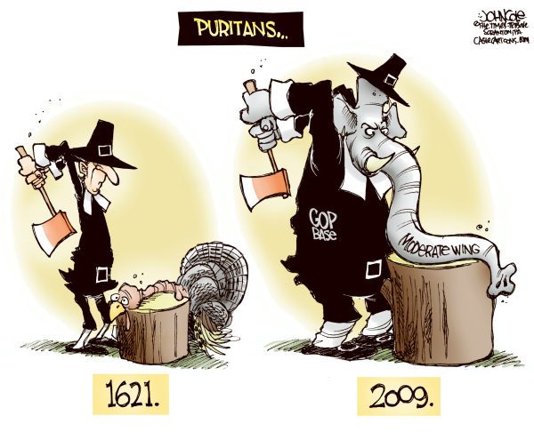
1. What are the characters and symbols in the cartoon, and what does each one represent?

2. How do the words help you identify the cartoonist’s intention?

3. What action is taking place in the cartoon?

4. What opinion is the cartoonist expressing?

