AP UNITED STATES HISTORY
Chapter 5 Materials
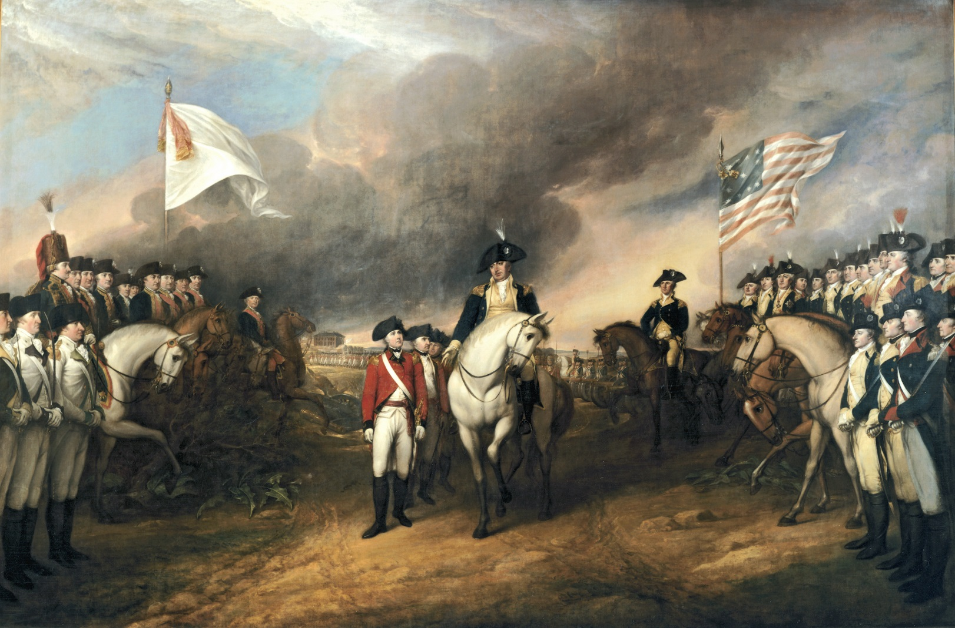

The American Revolution, 1763-1783
Mr. Bailey-Room 401
cbailey@quaboagrsd.org
bailey401.weebly.com

The American Revolution: Terms
Loyal Nine (p. 184)
“virtual representation” (p. 186)
writs of assistance (p. 186)
Sugar Act (p. 186)
Committees of Correspondence
(p. 189)
Sons of Liberty (p. 189)
Regulators (p. 190)
Daughters of Liberty (p. 191)
Boston Massacre (p. 192)
Crispus Attucks (p. 192)
“Wilkes and Liberty” (p. 194)
Boston Tea Party (p. 194)
Quebec Act (p. 195)
Suffolk Resolves (p. 195)
Committees of Safety (p. 196)
Lord Dunmore’s proclamation
(p. 198)
Olive Branch Petition (p. 199)
Common Sense (p. 199)
Declaration of Independence
(p. 202)
“American exceptionalism”
(p. 204)
The American Crisis (p. 208)
Valley Forge (p. 210)
Benedict Arnold (p. 210)
Treaty of Paris (p. 214)

Virginia Stamp Act Resolutions on the Stamp Act (1765)
Patrick Henry, at a meeting of the Virginia House of Burgesses, proposed seven resolutions against the Stamp Act. The first four resolutions were adopted and passed by the House of Burgesses. The Fifth resolution was repealed on the second day of the debates. Though resolutions six and seven were never passed by the House, all seven were widely reported in the colonial press, giving the impression that all passed the Virginia Assembly.
HIPP/NOTES:

The following four resolves were adopted by the House of Burgesses on May 30, 1765:
Resolved, that the first adventurers and settlers of His Majesty's colony and dominion of Virginia brought with them and transmitted to their posterity, and all other His Majesty's subjects since inhabiting in this His Majesty's said colony, all the liberties, privileges, franchises, and immunities that have at any time been held, enjoyed, and possessed by the people of Great Britain.

Resolved, that by two royal charters, granted by King James I, the colonists aforesaid are declared entitled to all liberties, privileges, and immunities of denizens and natural subjects to all intents and purposes as if they had been abiding and born within the Realm of England.

Resolved, that the taxation of the people by themselves, or by persons chosen by themselves to represent them, who can only know what taxes the people are able to bear, or the easiest method of raising them, and must themselves be affected by every tax laid on the people, is the only security against a burdensome taxation, and the distinguishing characteristic of British freedom, without which the ancient constitution cannot exist.

Resolved, that His Majesty's liege people of this his most ancient and loyal colony have without interruption enjoyed the inestimable right of being governed by such laws, respecting their internal policy and taxation, as are derived from their own consent, with the approbation of their sovereign, or his substitute; and that the same has never been forfeited or yielded up, but has been constantly recognized by the kings and people of Great Britain.

The following version of the much-debated fifth resolution (which was not adopted) was found with Patrick Henry's will:
Resolved, therefor that the General Assembly of this Colony have the only and exclusive Right and Power to lay Taxes and Impositions upon the inhabitants of this Colony and that every Attempt to vest such Power in any person or persons whatsoever other than the General Assembly aforesaid has a manifest Tendency to destroy British as well as American Freedom.

The following two resolutions were not passed by the Virginia Assembly, but were reported in several newspapers:
Resolved, That His Majesty's liege people, the inhabitants of this Colony, are not bound to yield obedience to any law or ordinance whatever, designed to impose any taxation whatsoever upon them, other than the laws or ordinances of the General Assembly aforesaid.
HIPP/NOTES:

Resolved, That any person who shall, by speaking or writing, assert or maintain that any person or persons other than the General Assembly of this Colony, have any right or power to impose or lay any taxation on the people here, shall be deemed an enemy to His Majesty's Colony.

QUESTIONS:
1. Why do you think the Virginia House of Burgesses adopted the first four resolutions but rejected the final three?

2. What would be the difference between resting the resolutions’ arguments on “British freedom” and appealing to a more universal concept of liberty?

Historical Content & Context
Intended Audience
Point of View
Purpose

Farmington, Connecticut, Resolutions on the Intolerable Acts (1774)
HIPP/NOTES:
Early in the morning was found the following handbill, posted up in various parts of the town, viz:
"To pass through the fire at six o'clock this evening, in honour to the immortal goddess of Liberty, the late infamous Act of the British Parliament for farther distressing the American Colonies; the place of execution will be the public parade, where all Sons of Liberty are desired to attend.
Accordingly, a very numerous and respectable body were assembled of near one thousand people, when a huge pole, just forty-five feet high was erected, and consecrated to the shrine of liberty; after which the Act of Parliament for blocking up the Boston harbour was read aloud; sentenced to the flames, and executed by the hands of the common hangman; then the following resolves were passed, nem. con.: "
1st. That it is the greatest dignity, interest, and happiness of every American to be united with our parent state, while our liberties are duly secured, maintained, and supported by our rightful sovereign, whose person we greatly revere; whose government while duly administered, we are ready with our lives and properties to support:
2d. That the present ministry, being instigated by the devil, and led on by their wicked and corrupt hearts, have a design to take away our liberties and properties, and to enslave us forever.
3d. That the late Act which their malice hath caused to be passed in Parliament, for blocking up the port of Boston, is unjust, illegal, and oppressive; and that we, and every American, are sharers in the insults offered to the town of Boston.
4th. That those pimps and parasites who dared to advise their master to such detestable measures be held in utter abhorrence by us and every American, and their names loaded with the curses of all succeeding generations.
5th. That we scorn the chains of slavery; we despise every attempt to rivet them upon us; we are the sons of freedom, and resolved, that, till time shall be no more, that god-like virtue shall blazon our hemisphere.
QUESTIONS:
1. How does the language of the resolutions suggest that feelings towards Great Britain have hardened in the colonies?

2. How do the resolutions qualify or limit Americans’ sense of loyalty to the British government?

Historical Content & Context
Intended Audience
Point of View
Purpose
Patrick Henry, “Give Me Liberty or Give Me Death” (1775)
HIPP/NOTES:
They tell us, sir, that we are weak -- unable to cope with so formidable an adversary. But when shall we be stronger? Will it be the next week, or the next year? Will it be when we are totally disarmed, and when a British guard shall be stationed in every house? Shall we gather strength by irresolution and inaction? Shall we acquire the means of effectual resistance, by lying supinely on our backs, and hugging the delusive phantom of hope, until our enemies shall have bound us hand and foot?
Sir, we are not weak, if we make a proper use of the means which the God of nature hath placed in our power. Three millions of people, armed in the holy cause of liberty, and in such a country as that which we possess, are invincible by any force which our enemy can send against us. Besides, sir, we shall not fight our battles alone. There is a just God who presides over the destinies of nations, and who will raise up friends to fight our battles for us.
The battle, sir, is not to the strong alone; it is to the vigilant, the active, the brave. Besides, sir, we have no election. If we were base enough to desire it, it is now too late to retire from the contest. There is no retreat but in submission and slavery! Our chains are forged! Their clanking may be heard on the plains of Boston! The war is inevitable -- and let it come! I repeat it, sir, let it come!
It is in vain, sir, to extenuate the matter. Gentlemen may cry, "Peace! Peace!" -- but there is no peace. The war is actually begun! The next gale that sweeps from the north will bring to our ears the clash of resounding arms! Our brethren are already in the field! Why stand we here idle? What is it that gentlemen wish? What would they have? Is life so dear, or peace so sweet, as to be purchased at the price of chains and slavery? Forbid it, Almighty God! I know not what course others may take; but as for me, give me liberty, or give me death!
QUESTION:
1. Patrick Henry, the flaming young lawyer-orator, urging warlike preparations before the Virginia Assembly, spelled out the reasons for action in his famous speech ending with the immortal words, "Give me liberty or give me death!" Which of his several arguments is the strongest?

Historical Content & Context
Intended Audience
Point of View
Purpose

FROM THOMAS PAINE, Common Sense (1776)
A recent emigrant from England, Thomas Paine in January 1776 published Common Sense, a highly influential pamphlet that in stirring language made the case for American independence.
HIPP/NOTES:

In the following pages I offer nothing more than simple facts, plain arguments, and common sense. . .
Male and female are the distinctions of nature, good and bad the distinctions of heaven; but how a race of men came into the world so exalted above the rest, and distinguished like some new species, is worth enquiring into, and whether they are the means of happiness or of misery to mankind. . . .One of the strongest natural proofs of the folly of hereditary right in kings, is, that nature disapproves it, otherwise she would not so frequently turn it into ridicule, by giving mankind an ass for a lion. . . .
The sun never shined on a cause of greater worth. ‘Tis not the affair of a city, a country, a province, or a kingdom, but of a continent—of at least one eighth part of the habitable globe. ‘Tis not the concern of a day, a year, or an age; posterity are virtually involved in the context, and will be more or less affected, even to the end of time, by the proceedings now. Now is the seed time of continental union, faith and honor. . . .
I challenge the warmest advocate for reconciliation to show a single advantage that this continent can reap by being connected with Great Britain. . . . But the injuries and disadvantages which we sustain by that connection, are without number. . . . Any submission to, or dependence on, Great Britain, tends directly to involve this Continent in European wars and quarrels, and set us at variance with nations who would otherwise seek our friendship, and against whom we have neither anger nor complaint.
O ye that love mankind! Ye that dare oppose, not only the tyranny, but the tyrant, stand forth! Every pot of the old world is overrun with oppression. Freedom hath been hunted round the globe. Asia, and Africa, have long expelled her. Europe regards her like a stranger, and England hath given her warning to depart. O! Receive the fugitive, and prepare in time an asylum for mankind.
QUESTION:
1. What does Paine see as the global significance of the American struggle for independence?

2. Describe 3 arguments does Paine make against reconciling with Britain?

FROM JAMES CHALMERS, Plain Truth (1776)
HIPP/NOTES:
Common Sense inspired a wide-ranging debate about whether American freedom would be more secure inside or outside the British empire. James Chalmers, a Maryland plantation owner, made the case for the Loyalists, as those who opposed American independence were called.
If indignant at the doctrine contained in the pamphlet entitled Common Sense I have expressed myself in the following observations with some ardor . . . [it is because] I adore my country. Passionately devoted to true liberty, I glow with the purest flame of patriotism [and have an] abhorrence of Independency, which if effected, would inevitably plunge our once preeminently envied country into ruin, horror, and desolation. . . .
Can a reasonable being for a moment believe that Great Britain, whose political existence depends on our constitutional obedience, who but yesterday made such prodigious efforts to save us from France, will not exert herself as powerfully to preserve us from our frantic schemes of Independency? . . .We remember with unfeigned gratitude, the many benefits derived through our connections with Great Britain, by whom but yesterday we were emancipated from slavery and death. . . .We venerate the constitution, which with all its imperfections (too often exaggerated) we apprehend almost approaches as near to perfection as human kind can bear. . . .
His scheme of independency would soon, very soon give way to a government imposed on us, by some Cromwell of our armies. . . . A failure of commerce [would] preclude the numerous tribe of planters, farmers and others, from paying their debts. . . . A war will ensue between the creditors and their debtors, which will eventually end in a general abolition of debts.
Volumes were insufficient to describe the horror, misery and desolation, awaiting the people at large in the form of American independence. In short, I affirm that it would be most excellent policy in those who wish for True Liberty to submit by an advantageous reconciliation to the authority of Great Britain. . . . Independence and Slavery are synonymous terms.
QUESTIONS:
1. Why does Chalmers equate independence with slavery?

2. How does the language used by the two writers (Paine and Chalmers) differ, and what does this tell us about their views of politics?

IN CONGRESS, JULY 4, 1776
The unanimous Declaration of the thirteen united States of America
When in the Course of human events it becomes necessary for one people to dissolve the political bands which have connected them with another and to assume among the powers of the earth, the separate and equal station to which the Laws of Nature and of Nature's God entitle them, a decent respect to the opinions of mankind requires that they should declare the causes which impel them to the separation.
We hold these truths to be self-evident, that all men are created equal, that they are endowed by their Creator with certain unalienable Rights, that among these are Life, Liberty and the pursuit of Happiness. — That to secure these rights, Governments are instituted among Men, deriving their just powers from the consent of the governed, — That whenever any Form of Government becomes destructive of these ends, it is the Right of the People to alter or to abolish it, and to institute new Government, laying its foundation on such principles and organizing its powers in such form, as to them shall seem most likely to effect their Safety and Happiness. Prudence, indeed, will dictate that Governments long established should not be changed for light and transient causes; and accordingly all experience hath shewn that mankind are more disposed to suffer, while evils are sufferable than to right themselves by abolishing the forms to which they are accustomed. But when a long train of abuses and usurpations, pursuing invariably the same Object evinces a design to reduce them under absolute Despotism, it is their right, it is their duty, to throw off such Government, and to provide new Guards for their future security. — Such has been the patient sufferance of these Colonies; and such is now the necessity which constrains them to alter their former Systems of Government. The history of the present King of Great Britain is a history of repeated injuries and usurpations, all having in direct object the establishment of an absolute Tyranny over these States. To prove this, let Facts be submitted to a candid world.
He has refused his Assent to Laws, the most wholesome and necessary for the public good.
He has forbidden his Governors to pass Laws of immediate and pressing importance, unless suspended in their operation till his Assent should be obtained; and when so suspended, he has utterly neglected to attend to them.
He has refused to pass other Laws for the accommodation of large districts of people, unless those people would relinquish the right of Representation in the Legislature, a right inestimable to them and formidable to tyrants only…
He has dis-solved Representative Houses repeatedly, for opposing with manly firmness his invasions on the rights of the people.
He has refused for a long time, after such dissolutions, to cause others to be elected, whereby the Legislative Powers, incapable of Annihilation, have returned to the People at large for their exercise…
He has erected a multitude of New Offices, and sent hither swarms of Officers to harass our people and eat out their substance.
He has kept among us, in times of peace, Standing Armies without the Consent of our legislatures.
He has affected to render the Military independent of and superior to the Civil Power…
For quartering large bodies of armed troops among us…
For cutting off our Trade with all parts of the world:
For imposing Taxes on us without our Consent:
For depriving us in many cases, of the benefit of Trial by Jury…
For abolishing the free System of English Laws in a neighbouring Province [Quebec], establishing therein an Arbitrary government, and enlarging its Boundaries so as to render it at once an example and fit instrument for introducing the same absolute rule into these Colonies
For taking away our Charters, abolishing our most valuable Laws and altering fundamentally the Forms of our Governments:
For suspending our own Legislatures, and declaring themselves invested with power to legislate for us in all cases whatsoever.
He has abdicated Government here, by declaring us out of his Protection and waging War against us.
He has plundered our seas, ravaged our coasts, burnt our towns, and destroyed the lives of our people.
He is at this time transporting large Armies of foreign Mercenaries to compleat the works of death, desolation… scarcely paralleled in the most barbarous ages, and totally unworthy the Head of a civilized nation.
He has constrained our fellow Citizens taken Captive on the high Seas to bear Arms against their Country, to become the executioners of their friends and Brethren, or to fall themselves by their Hands.
He has excited domestic insurrections amongst us, and has endeavoured to bring on the inhabitants of our frontiers, the merciless Indian Savages whose known rule of warfare, is an undistinguished destruction of all ages, sexes and conditions.
In every stage of these Oppressions We have Petitioned for Redress in the most humble terms: Our repeated Petitions have been answered only by repeated injury. A Prince, whose character is thus marked by every act which may define a Tyrant, is unfit to be the ruler of a free people.
Nor have We been wanting in attentions to our British brethren. We have warned them from time to time of attempts by their legislature to extend an unwarrantable jurisdiction over us. We have reminded them of the circumstances of our emigration and settlement here. We have appealed to their native justice and magnanimity, and we have conjured them by the ties of our common kindred to disavow these usurpations, which would inevitably interrupt our connections and correspondence. They too have been deaf to the voice of justice and of consanguinity. We must, therefore, acquiesce in the necessity, which denounces our Separation, and hold them, as we hold the rest of mankind, Enemies in War, in Peace Friends.
We, therefore, the Representatives of the united States of America, in General Congress, Assembled, appealing to the Supreme Judge of the world for the rectitude of our intentions, do, in the Name, and by Authority of the good People of these Colonies, solemnly publish and declare, That these united Colonies are, and of Right ought to be Free and Independent States, that they are Absolved from all Allegiance to the British Crown, and that all political connection between them and the State of Great Britain, is and ought to be totally dissolved; and that as Free and Independent States, they have full Power to levy War, conclude Peace, contract Alliances, establish Commerce, and to do all other Acts and Things which Independent States may of right do. — And for the support of this Declaration, with a firm reliance on the protection of Divine Providence, we mutually pledge to each other our Lives, our Fortunes, and our sacred Honor.

QUESTIONS:
1. According to the second paragraph, what is the purpose of government?

2. What do the people have the right to do if their government goes against its original intent?

3. According to the Declaration, who are created equal? Using what you know about commonly held view points during the late 18th century, how do you think Jefferson originally intended it?

4. List 3 examples of the British monarchy’s “abuses?”

5. Summarize the last paragraph of the Declaration.

Thomas Paine, The American Crisis, No. 1 (December 23, 1776)
THESE are the times that try men's souls. The summer soldier and the sunshine patriot will, in this crisis, shrink from the service of their country; but he that stands it now, deserves the love and thanks of man and woman. Tyranny, like hell, is not easily conquered; yet we have this consolation with us, that the harder the conflict, the more glorious the triumph. What we obtain too cheap, we esteem too lightly: it is dearness only that gives every thing its value. Heaven knows how to put a proper price upon its goods; and it would be strange indeed if so celestial an article as FREEDOM should not be highly rated. Britain, with an army to enforce her tyranny, has declared that she has a right (not only to TAX) but "to BIND us in ALL CASES WHATSOEVER," and if being bound in that manner, is not slavery, then is there not such a thing as slavery upon earth. Even the expression is impious; for so unlimited a power can belong only to God.
HIPP/NOTES:
Whether the independence of the continent was declared too soon, or delayed too long, I will not now enter into as an argument; my own simple opinion is, that had it been eight months earlier, it would have been much better. We did not make a proper use of last winter, neither could we, while we were in a dependent state. However, the fault, if it were one, was all our own*; we have none to blame but ourselves. But no great deal is lost yet. All that Howe has been doing for this month past, is rather a ravage than a conquest, which the spirit of the Jerseys, a year ago, would have quickly repulsed, and which time and a little resolution will soon recover.
* The present winter is worth an age, if rightly employed; but, if lost or neglected, the whole continent will partake of the evil; and there is no punishment that man does not deserve, be he who, or what, or where he will, that may be the means of sacrificing a season so precious and useful.
I have as little superstition in me as any man living, but my secret opinion has ever been, and still is, that God Almighty will not give up a people to military destruction, or leave them unsupportedly to perish, who have so earnestly and so repeatedly sought to avoid the calamities of war, by every decent method which wisdom could invent. Neither have I so much of the infidel in me, as to suppose that He has relinquished the government of the world, and given us up to the care of devils; and as I do not, I cannot see on what grounds the king of Britain can look up to heaven for help against us: a common murderer, a highwayman, or a house-breaker, has as good a pretence as he….
I thank God that I fear not. I see no real cause for fear. I know our situation well, and can see the way out of it. While our army was collected, Howe dared not risk a battle; and it is no credit to him that he decamped from the White Plains, and waited a mean opportunity to ravage the defenceless Jerseys; but it is great credit to us, that, with a handful of men, we sustained an orderly retreat for near an hundred miles… Twice we marched back to meet the enemy, and remained out till dark. The sign of fear was not seen in our camp, and had not some of the cowardly and disaffected inhabitants spread false alarms through the country, the Jerseys had never been ravaged. Once more we are again collected and collecting; our new army at both ends of the continent is recruiting fast, and we shall be able to open the next campaign with sixty thousand men, well armed and clothed. This is our situation, and who will may know it. By perseverance and fortitude we have the prospect of a glorious issue; by cowardice and submission, the sad choice of a variety of evils- a ravaged country- a depopulated city- habitations without safety, and slavery without hope- our homes turned into barracks and bawdy-houses for Hessians, and a future race to provide for, whose fathers we shall doubt of. Look on this picture and weep over it! and if there yet remains one thoughtless wretch who believes it not, let him suffer it unlamented.
HIPP/NOTES:
QUESTIONS:
1. Paine uses strong images to evoke ideas and connections. The speech opens with the images of “the sunshine patriot” and “the summer soldier.” Are these images appropriate? Why or why not? What connections can be drawn about a summer soldier and a winter soldier?

2. Paine uses an analogy that connects the King of Britain with a common housebreaker (burglar or thief). What point is he trying to make using this analogy?

3. Where in The Crisis does Paine reaffirm the Puritan belief that America is divinely guided?

Historical Content & Context
Intended Audience
Point of View
Purpose

HOMEWORK ASSIGNMENT
SECONDARY SOURCE ANALYSIS
In a 2008 issue, U.S. News and World Report published a series of articles on the American Revolution. These articles highlight key individuals, groups, and events and represent the most recent scholarship on the Revolution. They also challenge previous interpretations and popular myths – many of which you have probably learned in school.

Choose one of the following pairs of essays for your summary based on what interests you:

Why the Patriots Really Fought / For Blacks, There Was No Clear Choice
In Paris, Taking Salons By Storm / Allied With France, the Enemy of Our Enemy
Benedict Arnold: A Traitor, but Once a Patriot / Rewriting the Legend of Paul Revere
How Washington's Saavy Won the Day / 'Town Destroyer' Versus Iroquois Indians
British Might Meets Yankee Ingenuity / The Unlikely Role of Patriot Pirates
In a Massacre, the Seeds of a Civil War / The Rich Legacy of a Forgotten Founder

YOUR ASSIGNMENT…
After reading the articles and making notes, type a multi-paragraph composition that addresses the following aspects of your articles:

1. Identify each author's thesis. What popular myths are these authors challenging with their theses? How credible do you find their arguments?

2. How do these two articles relate to each other? What comparisons can you draw? Do the authors present similar or opposing views? Some pairs are more difficult to link than others (such as the Massacre / Rich Legacy set), but there is always a link.

3. What have you learned from reading these articles? This should be written in a way to help your classmates to "read" your articles without actually having to read them. There is stuff in all of these articles that is useful to know, so the more you read, the better.

The American Revolution: Political Cartoons
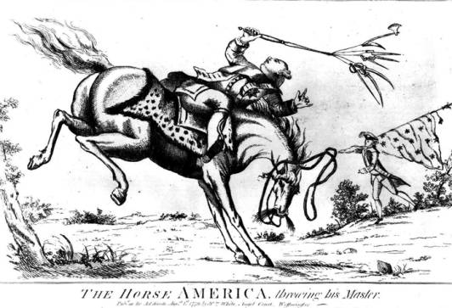
Analyze the cartoon and answer the questions.

1. What are the characters and symbols in the cartoon, and what does each one represent?

2. How do the words help you identify the cartoonist’s intention?

3. What action is taking place in the cartoon?

4. What opinion is the cartoonist expressing?

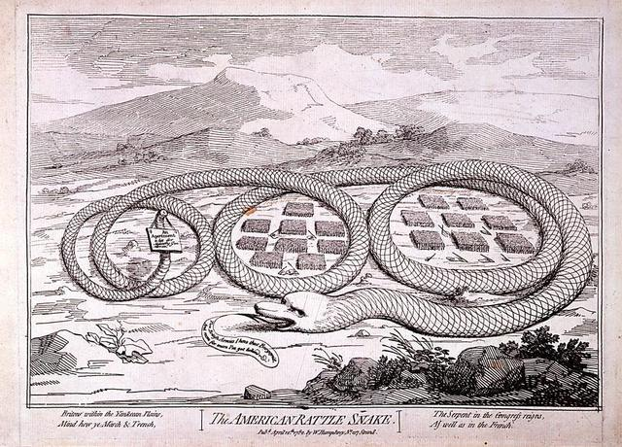
Analyze the cartoon and answer the questions.

1. What are the characters and symbols in the cartoon, and what does each one represent?

2. How do the words help you identify the cartoonist’s intention?

3. What action is taking place in the cartoon?

4. What opinion is the cartoonist expressing?

REVIEW QUESTIONS
1. Explain what “homespun virtue” meant and how it set the colonists apart from the British.

2. Patrick Henry proclaimed that he was not a Virginian, but rather an American. What unified the colonists and what divided them at the time of the Revolution?

3. Discuss the ramifications of using slaves in the British and Continental Armies. Why did the British authorize the use of slaves? Why did the Americans? How did the slaves benefit?

4. Why did the colonists reach the conclusion that membership in the empire threatened their freedoms, rather than guaranteed them?

5. Describe how Common Sense and the Declaration of Independence reflected the ideas put forth by philosophers such as John Locke that liberty was a natural right. Why did they have such an appeal to colonists of all social classes?

6. How would you justify the British view that the colonists owed loyalty to the existing government and gratitude for past actions?

7. Summarize the difference of opinion between British officials and colonial leaders over the issues of taxation and representation.

8. Trace the growth of colonial cooperation against the British government and the development of an “American” identity.

FREEDOM QUESTIONS
1. The grand ideas of liberty and freedom are contagious and often spread rapidly. Why were many colonial elites, who held one definition of liberty, alarmed by the actions and claims of average citizens in the decade before independence?

2. Almost every colonist—even those like Thomas Hutchinson who later became loyalists—opposed the Stamp Act. Identify the many ways colonists identified the Stamp Act as a threat to their freedoms.

3. Explain how each of the following could be viewed as a threat to freedom by different groups of colonists: the growing debt of Virginia planters, a lack of courts in the Carolina backcountry, imports of British manufactured goods, and imports of low-priced tea.

4. Why did some Americans view freedom as dependent upon their remaining loyal to the British government and remaining part of the empire?

5. Many historians say that the Declaration of Independence is the most important document in U.S. history. How did it permanently change the meaning of American freedom? What concepts make it so appealing to people of all social classes, across time and the globe?

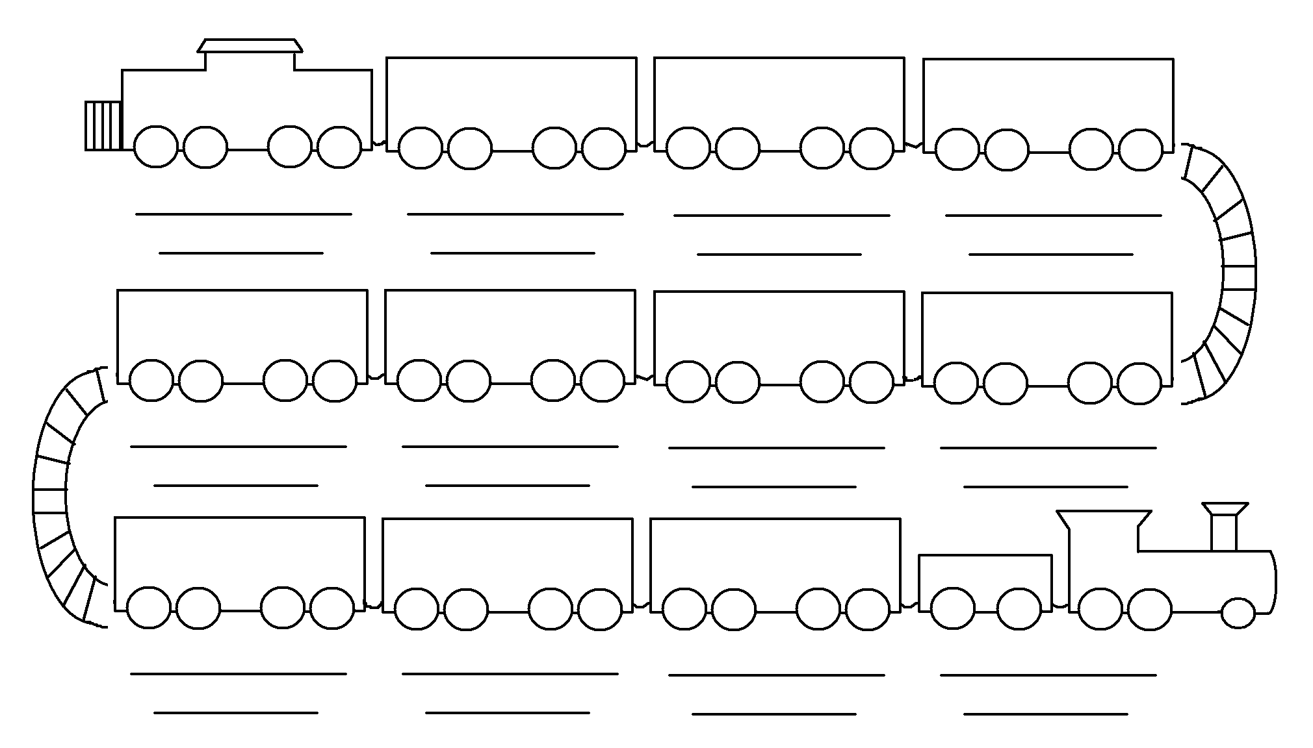
A Long Train of Abuses and Usurpations

Prudence, indeed, will dictate that Governments long established should not be changed for light and transient causes; and accordingly all experience hath shewn that mankind are more disposed to suffer, while evils are sufferable… But when a long train of abuses and usurpations, pursuing invariably the same Object evinces a design to reduce them under absolute Despotism, it is their right, it is their duty, to throw off such Government, and to provide new Guards for their future security.
-- Thomas Jefferson, Declaration of Independence (1776)
Proclamation of 1763 Sugar Act Stamp Act Townshend Acts Boston Massacre
Tea Act Coercive Acts Lexington and Concord Bunker Hill Prohibitory Act

