AP UNITED STATES HISTORY
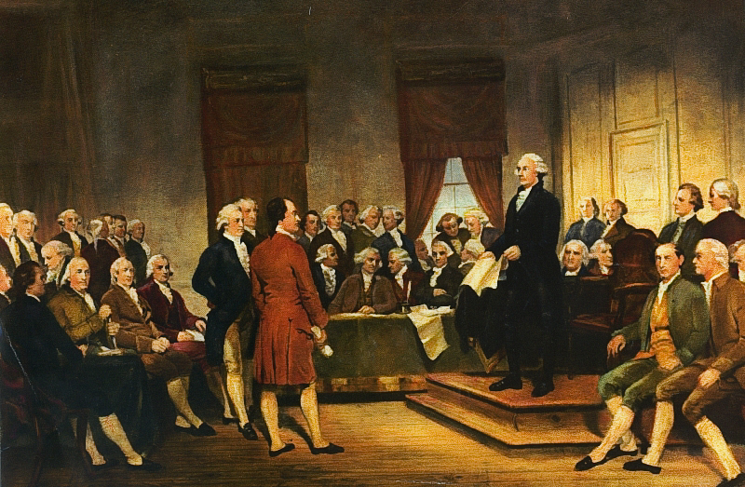
Chapter 7 Materials

Founding a Nation, 1783-1789
Mr. Bailey-Room 401
cbailey@quaboagrsd.org
bailey401.weebly.com

Founding a Nation: Terms
Land Ordinances of 1784 and
1785 (pp. 262–263)
Shays’s Rebellion (p. 265)
Northwest Ordinance of 1787
(p. 266)
international commerce (p. 266)
checks and balances (p. 269)
separation of powers (p. 269)
“high crimes and misdemeanors”
(p. 270)
three-fifths clause (p. 270)
The Federalist (p. 273)
Anti-Federalists (p. 275)
Bill of Rights (p. 275)
civic nationalism (p. 282)
ethnic nationalism (p. 282)
Miami Confederacy (p. 285)
Battle of Fallen Timbers (p. 285)
Treaty of Greenville (p. 285)
“annuity” system (p. 285)
gradual emancipation (p. 286)
Letters from an American Farmer
(p. 286)
“open immigration” (p. 286)
Notes on the State of Virginia (p. 287)

Petition of Inhabitants West of the Ohio River (1785)
To the Honorable the President of the Honor able Congress of the United States of America. The petition, of us the subscribers now residing on the western side of the Ohio, humbly show our grateful acknowledgments to those patriots of our country who under Divine Providence so wisely directed and steered the helm of government: in that great and unparalleled conflict for liberty bringing to a happy period the troubles of the states laying the foundation (by the most Salutary means) of the most glorious form of government any people on Earth could ever yet boast of.
HIPP/NOTES:
Notwithstanding when the joyful sound of peace had reached our ears; we had scarce enough left us to support the crying distresses of our families occasioned wholly by being exposed to the ravages of a cruel and savage enemy; on an open frontier where the most of us had the misfortune to reside through the whole continuance of the war where the only recourse was to sit confined in forts for the preservation of our lives, by which we were reduced almost to the lowest ebb of poverty, the greatest part of us having no property in lands, our stocks reduced almost to nothing, our case seemed desperate.
But viewing as it appeared to us an advantage offering of vacant lands which with the alarming necessities we were under Joined with the future prospect of bettering our circumstances, invited us to enter on those Lands fully determined to comply with every requisition of the legislature…with hopes of future happiness we sat content in the enjoyment of our scanty morsel, thinking ourselves safe under the protection of government, when on the fifth of this instant we ware visited by a command of men sent by the Commandant at Fort McIntosh with orders from Government…to dispossess us and to destroy our dwellings…by which order it now appears our conduct in settling here is considered by the legislature to be prejudicial to the common good, of which we had not the least conception till now. We are greatly distressed in our present circumstances, and humbly pray if you in your wisdom think proper to grant us liberty, to rest where we are and to grant us the preference to our actual settlements when the land is to be settled by order of government.
QUESTIONS:
1. Who do the authors of the petition seem to feel are the greatest enemies of their liberty?

2. Who do the authors claim ought to have preference when Western land is distributed?

Historical Content & Context
Intended Audience
Point of View
Purpose

A Letter From Thomas Jefferson To James Madison
Paris, January 30th, 1787
Dear Sir,
HIPP/NOTES:
My last to you was of the 16th of December; since which, I have received yours of November 25 and December 4, which afforded me, as your letters always do, a treat on matters public, individual, and economical. I am impatient to learn your sentiments on the late troubles in the Eastern states. So far as I have yet seen, they do not appear to threaten serious consequences. Those states have suffered by the stoppage of the channels of their commerce, which have not yet found other issues. This must render money scarce and make the people uneasy. This uneasiness has produced acts absolutely unjustifiable; but I hope they will provoke no severities from their governments…
Societies exist under three forms, sufficiently distinguishable: (1) without government, as among our Indians; (2) under governments, wherein the will of everyone has a just influence, as is the case in England, in a slight degree, and in our states, in a great one; (3) under governments of force, as is the case in all other monarchies, and in most of the other republics.
To have an idea of the curse of existence under these last, they must be seen. It is a government of wolves over sheep. It is a problem, not clear in my mind, that the first condition is not the best. But I believe it to be inconsistent with any great degree of population. The second state has a great deal of good in it. The mass of mankind under that enjoys a precious degree of liberty and happiness. It has its evils, too, the principal of which is the turbulence to which it is subject. But weigh this against the oppressions of monarchy, and it becomes nothing… Even this evil is productive of good. It prevents the degeneracy of government and nourishes a general attention to the public affairs.
I hold it that a little rebellion now and then is a good thing, and as necessary in the political world as storms in the physical. Unsuccessful rebellions, indeed, generally establish the encroachments on the rights of the people which have produced them. An observation of this truth should render honest republican governors so mild in their punishment of rebellions as not to discourage them too much. It is a medicine necessary for the sound health of government.
Yours affectionately,

Th. Jefferson
Historical Content & Context
Intended Audience
Point of View
Purpose
James Madison, Federalist 51 (1787)
HIPP/NOTES:
TO WHAT expedient, then, shall we finally resort, for maintaining in practice the necessary partition of power among the several departments, as laid down in the Constitution?...It is equally evident, that the members of each department should be as little dependent as possible on those of the others, for the emoluments annexed to their offices.
But the great security against a gradual concentration of the several powers in the same department, consists in giving to those who administer each department the necessary constitutional means and personal motives to resist encroachments of the others. The provision for defense must in this, as in all other cases, be made commensurate to the danger of attack. Ambition must be made to counteract ambition. The interest of the man must be connected with the constitutional rights of the place. It may be a reflection on human nature, that such devices should be necessary to control the abuses of government. But what is government itself, but the greatest of all reflections on human nature? If men were angels, no government would be necessary. If angels were to govern men, neither external nor internal controls on government would be necessary. In framing a government which is to be administered by men over men, the great difficulty lies in this: you must first enable the government to control the governed; and in the next place oblige it to control itself. A dependence on the people is, no doubt, the primary control on the government; but experience has taught mankind the necessity of auxiliary precautions.
There are…two considerations particularly applicable to the federal system of America, which place that system in a very interesting point of view…
First. In a single republic, all the power surrendered by the people is submitted to the administration of a single government; and the usurpations are guarded against by a division of the government into distinct and separate departments. In the compound republic of America, the power surrendered by the people is first divided between two distinct governments, and then the portion allotted to each subdivided among distinct and separate departments. Hence a double security arises to the rights of the people. The different governments will control each other, at the same time that each will be controlled by itself.
Second. It is of great importance in a republic not only to guard the society against the oppression of its rulers, but to guard one part of the society against the injustice of the other part. Different interests necessarily exist in different classes of citizens. If a majority be united by a common interest, the rights of the minority will be insecure. There are but two methods of providing against this evil: the one by creating a will in the community independent of the majority -- that is, of the society itself; the other, by comprehending in the society so many separate descriptions of citizens as will render an unjust combination of a majority of the whole very improbable, if not impracticable. The second method will be exemplified in the federal republic of the United States. Whilst all authority in it will be derived from and dependent on the society, the society itself will be broken into so many parts, interests, and classes of citizens, that the rights of individuals, or of the minority, will be in little danger from interested combinations of the majority.
In a free government the security for civil rights must be the same as that for religious rights. It consists in the one case in the multiplicity of interests, and in the other in the multiplicity of sects. The degree of security in both cases will depend on the number of interests and sects; and this may be presumed to depend on the extent of country and number of people comprehended under the same government.
HIPP/NOTES:
Justice is the end of government. It is the end of civil society. It ever has been and ever will be pursued until it be obtained, or until liberty be lost in the pursuit. In a society under the forms of which the stronger faction can readily unite and oppress the weaker, anarchy may as truly be said to reign as in a state of nature, where the weaker individual is not secured against the violence of the stronger…
In the extended republic of the United States, and among the great variety of interests, parties, and sects which it embraces, a coalition of a majority of the whole society could seldom take place on any other principles than those of justice and the general good…It is no less certain than it is important, notwithstanding the contrary opinions which have been entertained, that the larger the society, provided it lie within a practical sphere, the more duly capable it will be of self-government. And happily for the republican cause…
PUBLIUS

QUESTIONS:
1. Why does Madison believe that the example of religious liberty offers a precedent relevant to political rights?

2. How does Madison argue that a large republic is more conducive to liberty than a small one?

Historical Content & Context
Intended Audience
Point of View
Purpose

FROM DAVID RAMSAY, The History of the American Revolution (1789)
A member of the Continental Congress from South Carolina, David Ramsay published his history of the Revolution the year after the Constitution was ratified. In this excerpt, he lauds the principles of representative government and the right of future amendment, embodied in the state constitutions and adopted in the national one, as unique American political principles and the best ways of securing liberty.
HIPP/NOTES:
Theworld has not hitherto exhibited so fair an opportunity for promoting social happiness. It is hoped for the honor of human nature, that the result will prove the fallacy of those theories that mankind are incapable of self-government. The ancients, not knowing the doctrine of representation, were apt in their public meetings to run into confusion, but in America this mode of taking the sense of the people, is so well understood, and so completely reduced to system, that its most populous states are often peaceably convened in an assembly of deputies, not too large for orderly deliberation, and yet representing the whole in equal proportion. These popular branches of legislature are miniature pictures of the community, and from their mode of election are likely to be influenced by the same interests and feelings with the people whom they represent. . . .
In no age before, and in no other country, did man ever possess an election of the kind of government, under which he would choose to live. The constituent parts of the ancient free governments were thrown together by accident. The freedom of modern European governments was, for the most part, obtained by concessions, or liberality of monarchs, or military leaders. In America alone, reason and liberty concurred in the formation of constitutions . . . In one thing they were all perfect. They left the people in the power of altering and amending them, whenever they pleased. In this happy peculiarity they placed the science of politics on a footing with the other sciences, by opening it to improvements from experience, and the discoveries of future ages. By means of this power of amending American constitutions, the friends of mankind have fondly hoped that oppression will one day be no more.
QUESTIONS:
1. Why does Ramsay feel that the power to amend the Constitution is so important a political innovation?

Historical Content & Context
Intended Audience
Point of View
Purpose

FROM JAMES WINTHROP, Anti-Federalist Essay Signed “Agrippa” (1787)
It is the opinion of the ablest writers on the subject that no extensive empire can be governed upon republican principles, and that such a government will degenerate into a despotism, unless it be made up of a confederacy of smaller states, each having the full powers of internal regulation. This is precisely the principle which has hitherto preserved our freedom. No instance can be found of any free government of considerable extent which has been supported upon any other plan. Large and consolidated empires may indeed dazzle the eyes of a distant spectator with their splendor, but if examined more nearly are always found to be full of misery. . . . It is under such tyranny that the Spanish provinces languish, and such would be our misfortune and degradation, if we should submit to have the concerns of the whole empire managed by one empire. To promote the happiness of the people it is necessary that there should be local laws; and it is necessary that those laws should be made by the representatives of those who are immediately subject to [them]. . . .
HIPP/NOTES:
It is impossible for one code of laws to suit Georgia and Massachusetts. They must, therefore, legislate for themselves. Yet there is, I believe, not one point of legislation that is not surrendered in the proposed plan. Questions of every kind respecting property are determinable in a continental court, and so are all kinds of criminal causes. The continental legislature has, therefore, a right to make rules in all cases. . . . No rights are reserved to the citizens. . . . This new system is, therefore, a consolidation of all the states into one large mass, however diverse the parts may be of which it is composed. . . .A bill of rights . . . serves to secure the minority against the usurpation and tyranny of the majority. . . . The experience of all mankind has proved the prevalence of a disposition to use power wantonly. It is therefore as necessary to defend an individual against the majority in a republic as against the king in a monarchy.
QUESTIONS:
1. Why does Winthrop believe that a Bill of Rights is essential in the Constitution?

2. How do Ramsay (previous document) and Winthrop differ concerning how the principle of representation operates in the United States?

Historical Content & Context
Intended Audience
Point of View
Purpose

Letter from Thomas Jefferson to James Madison
From Paris, December 20, 1787
Jefferson shares his first impressions of the proposed Constitution with Madison:
I like much the general idea of framing a government which should go on of itself peaceably, without needing continual recurrence to the state legislatures. I like the organization of the government into Legislative, Judiciary & Executive. I like the power given the Legislature to levy taxes, and for that reason solely approve of the greater house being chosen by the people directly. For tho' I think a house chosen by them will be very illy qualified to legislate for the Union, for foreign nations &c. yet this evil does not weigh against the good of preserving inviolate the fundamental principle that the people are not to be taxed but by representatives chosen immediately by themselves. I am captivated by the compromise of the opposite claims of the great & little states, of the latter to equal, and the former to proportional influence. I am much pleased too with the substitution of the method of voting by persons, instead of that of voting by states: and I like the negative given to the Executive with a third of either house, though I should have liked it better had the Judiciary been associated for that purpose, or invested with a similar and separate power…
I will now add what I do not like. First the omission of a bill of rights providing clearly & without the aid of sophisms for freedom of religion, freedom of the press, protection against standing armies, restriction against monopolies, the eternal & unremitting force of the habeas corpus laws, and trials by jury… a bill of rights is what the people are entitled to against every government on earth, general or particular, & what no just government should refuse, or rest on inferences.
The second feature I dislike, and greatly dislike, is the abandonment in every instance of the necessity of rotation in office, and most particularly in the case of the President. Experience concurs with reason in concluding that the first magistrate will always be re-elected if the Constitution permits it. He is then an officer for life… An incapacity to be elected a second time would have been the only effectual preventative. The power of removing him every fourth year by the vote of the people is a power which will not be exercised. The king of Poland is removable every day by the Diet, yet he is never removed…
I own I am not a friend to a very energetic government. It is always oppressive. The late rebellion in Massachusetts has given more alarm than I think it should have done…
I think our governments will remain virtuous for many centuries; as long as [the people] are chiefly agricultural; and this will be as long as there shall be vacant lands in any part of America. When they get piled upon one another in large cities, as in Europe, they will become corrupt as in Europe. Above all things I hope the education of the common people will be attended to; convinced that on their good sense we may rely with the most security for the preservation of a due degree of liberty…
To what extent does Jefferson sound like a Federalist? | To what extent does Jefferson sound like an Antifederalist?
Founding a Nation: Political Cartoons
Analyze the cartoon and answer the questions.
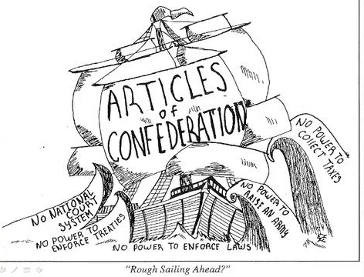
1. What are the characters and symbols in the cartoon, and what does each one represent?

2. How do the words help you identify the cartoonist’s intention?

3. What action is taking place in the cartoon?

4. What opinion is the cartoonist expressing?

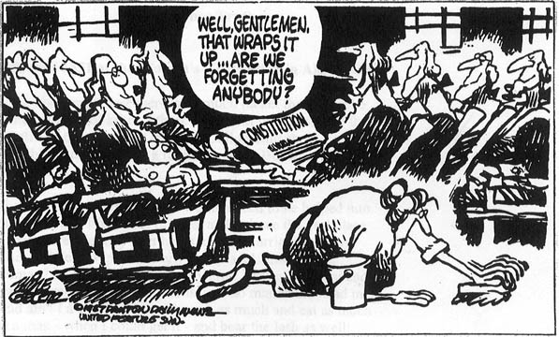
Analyze the cartoon and answer the questions.

1. What are the characters and symbols in the cartoon, and what does each one represent?

2. How do the words help you identify the cartoonist’s intention?

3. What action is taking place in the cartoon?

4. What opinion is the cartoonist expressing?

REVIEW QUESTIONS
1. How did the limited central government created by the Articles of Confederation reflect the issues behind the Revolution and fears for individual liberties?

2. Explain the importance of the Land Ordinances of 1784 and 1785, as well as the Northwest Ordinance of 1787, both for the early republic and future generations.

3. Who were the nationalists of the late 1780s, and why did they believe a new national constitution was necessary?

4. The Constitution has been described as a “bundle of compromises.” Which compromises were the most significant in shaping the direction of the new nation and why?

5. What were the major arguments against the Constitution put forth by the Anti-Federalists?

6. How accurate was Hector St. John de Crevecoeur’s description of America as a melting pot?

FREEDOM QUESTIONS
1. Why did settlers believe that the right to take possession of western lands and use them as they saw fit was an essential part of American freedom? Why did this same freedom not apply to the Native Americans already on the land?

2. James Madison argued that “Liberty may be endangered by the abuses of liberty as well as the abuse of power.” Explain what Madison meant, and how this statement affected the ideas of freedom for the participants at the Constitutional Convention.

3. Why and how did the framers of the Constitution design a government that protected slavery and its advocates?

4. How important was the Bill of Rights at the time it was enacted, and how important is it now?

5. Why does the Constitution never use the word “slavery”?

The Constitutional Convention

When? May-September, ________ Where? _____________________________
For what purpose? _______________________________________
Presiding Officer? ___________________________________

 | Who? | What? | Conflict and/or Solution
Virginia Plan

New Jersey Plan | William Paterson
Great
(aka, Connecticut) Compromise

Slave Trade Compromise | N/A
3/5 Compromise | N/A
Electoral College | N/A |  | Electors = _______________ + _________________
Amendments | N/A | ___ / ___ OF ___________________ + ___ / ___ OF THE _____________________

Enumerated [Delegated] Powers
Article I, Section 8 of the Constitution is widely cited as being an exhaustive list of Congressional power. But, in reality, there are a total of thirty (twenty are listed below) Congressional powers that are listed throughout the document:
- To lay and collect Taxes, Duties [Tariffs], Imposts and Excises, to pay the Debts and provide for the common Defense and general Welfare of the United States; but all Duties, Imposts and Excises shall be uniform throughout the United States;
- Borrow Money
- Regulate Interstate Commerce (foreign Nations, and among the several States)
- Establish Naturalization Laws
- Coin Money and fix the Standard of Weights and Measures;
- To provide for the Punishment of counterfeiting the Securities and current Coin of the United States;
- Establish Post Offices
- Issue Copyrights and Patents
- Establish Federal Courts (The Supreme Court is established explicitly by the Constitution)
- Punish Piracy
- Declare War
- Raise and Support Armies
- Provide and maintain a Navy
- To provide for calling forth the Militia to execute the Laws of the Union, suppress Insurrections and repel Invasions
- To provide for organizing, arming, and disciplining, the Militia
- Legislate for the Federal District (which did not exist at the time)
- Punish Treason
- Admit New States
- To make all Laws which shall be necessary and proper for carrying into Execution the foregoing Powers, and all other Powers vested by this Constitution in the Government of the United States, or in any Department or Officer thereof.
- Propose amendments to the Constitution by a 2/3 vote.

AMENDMENT X: Federalism
The powers not delegated to the United States by the Constitution, nor prohibited by it to the states, are reserved to the states respectively, or to the people.

Identify whether each is a delegated, reserved, or concurrent power according to the Constitution:

CONCURRENT
FEDERAL
STATE

Admit New States
Coin Money
Collect Tariffs
Declare War
Education
Establish Courts
Standardize Weights and Measures
Conduct Foreign Policy
Establish Local Governments
Maintain Army and Navy
Marriage Laws
National Defense
Immigration and Naturalization Laws
Organize and Maintain Militia
Propose Constitutional Amendments
Punish Treason
Ratify Constitutional Amendments
Regulate Foreign Trade
Regulate Intrastate Commerce
Regulate Interstate Commerce
Taxation

The System of Checks and Balances
Various governmental powers are listed below. Identify the branch doing the checking and the branch being checked.
Power | Which Branch Has The Power? | Which Branch's Power is Being Checked?  (Could be more than one)
1) Create and pass legislation.
2) Veto bills.
3) Ratify treaties.
4) Appoint Federal judges.
5) Impeachment of federal officials.
6) Confirm the appointment of presidential appointments.
7) Declare laws unconstitutional.
8) Override Presidential Vetoes.
9) Judges are appointed for life.
10) Controls appropriations of money.

