Name___________________________________________ Block_____

CHINESE IMMIGRATION AND EXCLUSION MINI-DBQ

Central Historical Question:
What factors contributed to the Chinese Exclusion Act?

Background:

  - During Civil War, the North passed laws that helped industry (because the Southern representatives couldn’t block them).
  - Congress passed the Pacific Railway Act of 1863: the government would give RR companies free land and loan them money to build the transcontinental railroad (afterwards, the RR companies were supposed to sell the land on both sides of the track and pay back the government, but they never ended up doing that).
  - Two companies competed to get the most land and money: Union Pacific (built tracks from East to West) and Central Pacific (built tracks from West to East).
  - On May 10, 1869, the Central Pacific Railway met the Union Pacific Railway in Promontory Point, Utah, marking the completion of the transcontinental railroad.
- The building of the railroad depended on the labor of hundreds of thousands of workers. In the West, most of the people who built the railroad were Chinese.

What happened between the 1860s, when Chinese were welcomed, and 1882, when they were excluded?

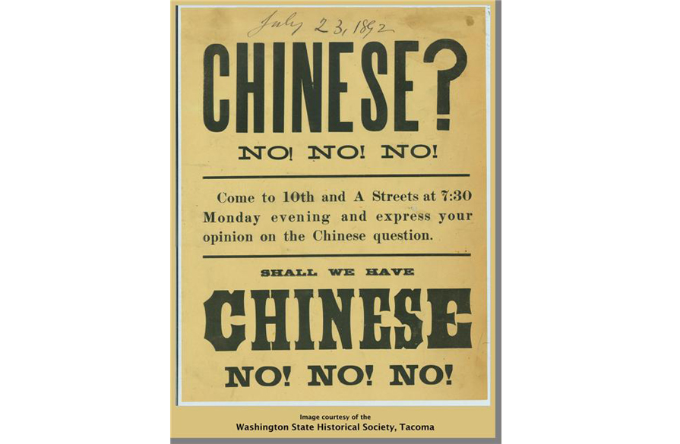

Timeline of Chinese Immigration and Exclusion

1848 Gold discovered at Sutter's Mill, California; many Chinese arrive to mine for gold.

1850 Foreign Miners’ tax mainly targets Chinese and Mexican miners.

1852 Approximately 25,000 Chinese in America.

1854 Court rules that Chinese cannot give testimony in court.

1862 Chinese Consolidated Benevolent Association forms.

1865 Central Pacific Railroad recruits Chinese workers; ultimately employs about 15,000 Chinese workers.

1869 First transcontinental railroad completed.

1870 California passes a law against the importation of Chinese and Japanese women for prostitution.

1871 Los Angeles: anti-Chinese violence; 18 Chinese killed.

1873 Panic of 1873; start of major economic downturn that last through the decade; blamed on corrupt RR companies.

1877 Chico, CA: anti-Chinese violence.

1878 Court rules Chinese ineligible for naturalized citizenship.

1880 Approximately 106,000 Chinese in America; California passes anti-miscegenation law (no interracial marriage).

1882 Chinese Exclusion Act: prohibits Chinese immigration (in one year, Chinese immigration drops from 40,000 to 23).

1885 Rock Springs Wyoming Anti-Chinese Violence.

1892 Geary Act—extends Chinese Exclusion Act.

Document A: Anti-Chinese Play, 1879

If this document were your ONLY piece of evidence, how would you answer the question: ‘Why did Americans pass the 1882 Chinese Exclusion Act?’

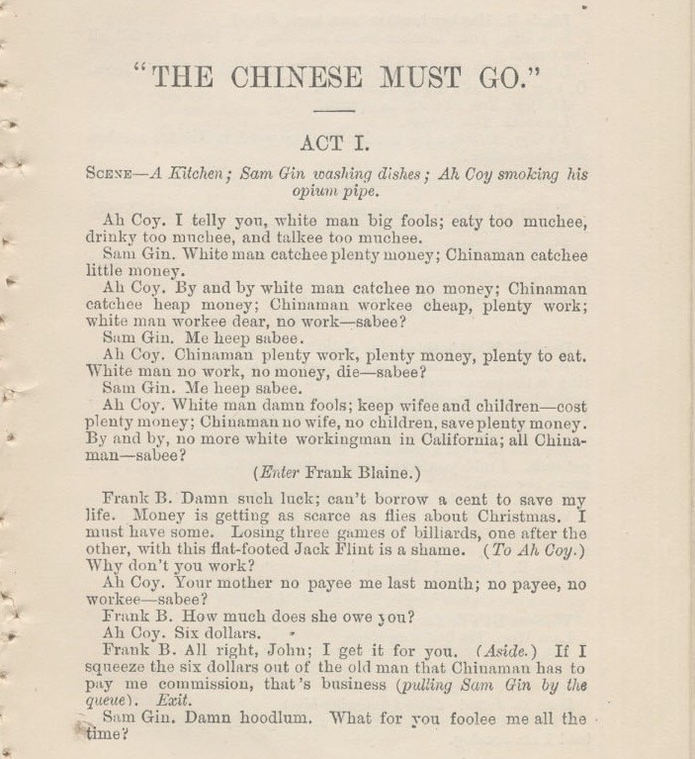

Source: The page above comes from a play called “The Chinese Must Go:” A Farce in Four Acts by Henry Grimm, published in San Francisco, 1879. In just the first page, you will be able to see many of the common stereotypes of Chinese immigrants in the 19th century.

Document B: Political Cartoon, 1871

If this document were your ONLY piece of evidence, how would you answer the question: ‘Why did Americans pass the 1882 Chinese Exclusion Act?’

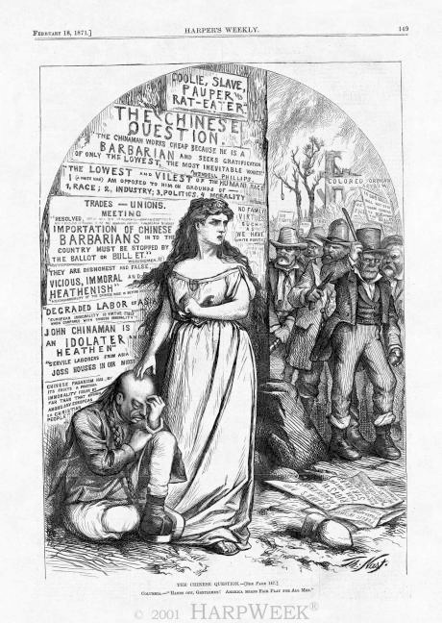

Source: The cartoon was drawn by Thomas Nast for Harper’s Weekly, a Northern magazine. In this cartoon, we see Columbia, the feminine symbol of the United States, protecting a Chinese man against a gang of Irish and German thugs. At the bottom it says "Hands off-Gentlemen! America means fair play for all men."

Document C: Workingmen of San Francisco (Modified)

If this document were your ONLY piece of evidence, how would you answer the question: ‘Why did Americans pass the 1882 Chinese Exclusion Act?’

We have met here in San Francisco tonight to raise our voice to you in warning of a great danger that seems to us imminent, and threatens our almost utter destruction as a prosperous community.

The danger is, that while we have been sleeping in fancied security, believing that the tide of Chinese immigration to our State had been checked and was in a fair way to be entirely stopped, our opponents, the pro-China wealthy men of the land, have been wide-awake and have succeeded in reviving the importation of this Chinese slave-labor. So that now, hundreds and thousands of Chinese are every week flocking into our State.

Today, every avenue to labor, of every sort, is crowded with Chinese slave labor worse than it was eight years ago. The boot, shoe and cigar industries are almost entirely in their hands. In the manufacture of men’s overalls and women’s and children’s underwear they run over three thousand sewing machines night and day. They monopolize nearly all the farming done to supply the market with all sorts of vegetables. This state of things brings about a terrible competition between our own people, who must live as civilized Americans, and the Chinese, who live like degraded slaves. We should all understand that this state of things cannot be much longer endured.

Vocabulary
Imminent: about to happen

Source: The document above is a speech to the workingmen of San Francisco on August 16, 1888.

Document D: Autobiography of a Chinese Immigrant (Modified)

If this document were your ONLY piece of evidence, how would you answer the question: ‘Why did Americans pass the 1882 Chinese Exclusion Act?’

The treatment of the Chinese in this country is all wrong and mean. . .

There is no reason for the prejudice against the Chinese. The cheap labor cry was always a falsehood. Their labor was never cheap, and is not cheap now. It has always commanded the highest market price. But the trouble is that the Chinese are such excellent and faithful workers that bosses will have no others when they can get them. If you look at men working on the street you will find a supervisor for every four or five of them. That watching is not necessary for Chinese. They work as well when left to themselves as they do when some one is looking at them.

It was the jealousy of laboring men of other nationalities — especially the Irish—that raised the outcry against the Chinese. No one would hire an Irishman, German, Englishman or Italian when he could get a Chinese, because our countrymen are so much more honest, industrious, steady, sober and painstaking. Chinese were persecuted, not for their vices [sins], but for their virtues [good qualities].

There are few Chinamen in jails and none in the poor houses. There are no Chinese tramps or drunkards. Many Chinese here have become sincere Christians, in spite of the persecution which they have to endure from their heathen countrymen. More than half the Chinese in this country would become citizens if allowed to do so, and would be patriotic Americans. But how can they make this country their home as matters now are! They are not allowed to bring wives here from China, and if they marry American women there is a great outcry.

Under the circumstances, how can I call this my home, and how can any one blame me if I take my money and go back to my village in China?

Source: The passage above is from Lee Chew, “The Biography of a Chinaman,” Independent, 15 (19 February 1903), 417–423.

Chinese Immigration and Exclusion: Graphic Organizer

What factors contributed to the Chinese Exclusion Act?

STEP 1: Read the timeline carefully. Write your HYPOTHESES for why the Chinese Exclusion Act was passed in 1882.

STEP 2: Read document A-D. For each, write any evidence you find for what led to the Chinese Exclusion Act of 1882.

Based on this document, why did many white Americans support the Chinese Exclusion Act?
Document A:
Play
Document B:
Nast Cartoon
Document C:
Workingmen speech
Document D:
Lee Chew’s Autobiography

In the space below, answer the following question: Why did Americans pass the Chinese Exclusion Act of 1882? Create a thesis and use evidence from the documents. One paragraph will suffice.

