Name____________________________________________ Block______
Analyzing Political Cartoons: The Cold War
Analyze the cartoons and respond to the questions.
1. What are the characters and symbols in the cartoon, and what does each one represent?

2. How do the words help you identify the cartoonist’s intention?

3. What action is taking place in the cartoon?

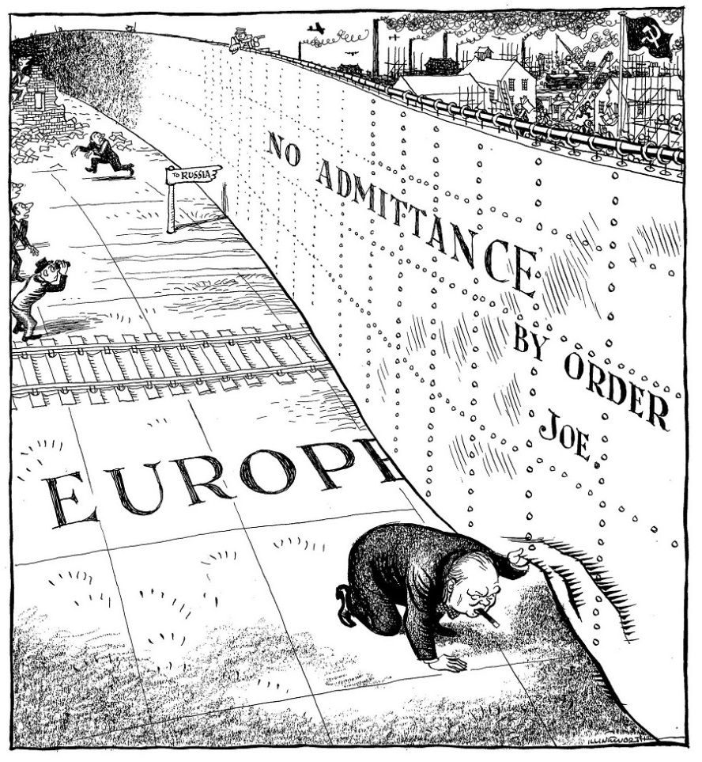
4. What opinion is the cartoonist expressing?

1. What are the characters and symbols in the cartoon, and what does each one represent?

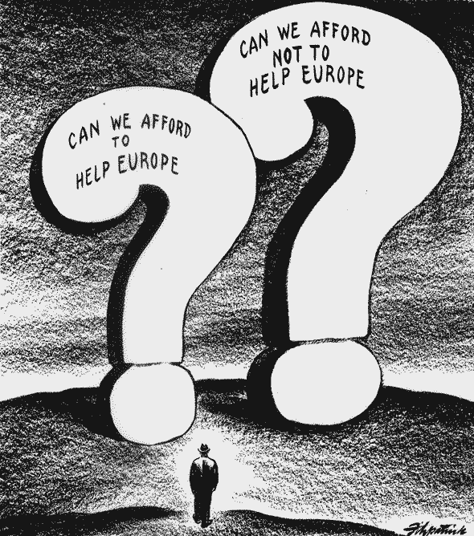
2. How do the words help you identify the cartoonist’s intention?

3. What action is taking place in the cartoon?

4. What opinion is the cartoonist expressing?

1. What are the characters and symbols in the cartoon, and what does each one represent?

2. How do the words help you identify the cartoonist’s intention?

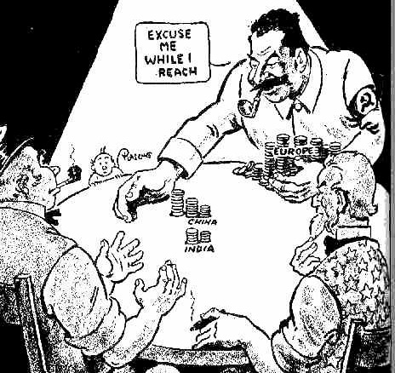

3. What action is taking place in the cartoon?

4. What opinion is the cartoonist expressing?

1. What are the characters and symbols in the cartoon, and what does each one represent?

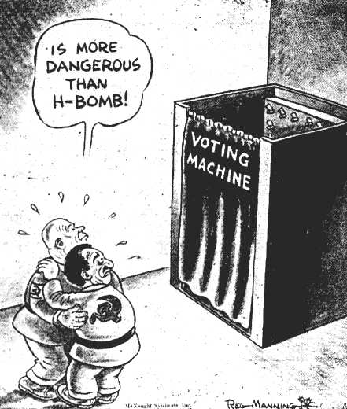
2. How do the words help you identify the cartoonist’s intention?

3. What action is taking place in the cartoon?

4. What opinion is the cartoonist expressing?

