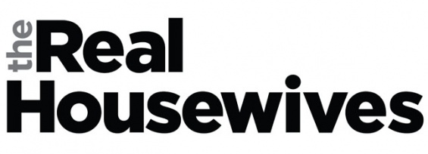
Jamestown Edition

Compose a letter as a wife in Colonial Jamestown to a friend or relative back in England. In your letter you must try to encourage your friend/relative to move across the pond to the colonies. However, you know life in Jamestown is not always unicorns and rainbows… so you have to find a way to tell the truth, but also convince your friend she just MUST COME. Jamestown is the greatest place… isn’t it?! All the “good” women of Jamestown think so!
In your letter you must address the environment, societal and governmental structures of Jamestown. Also, include discussion of what life is like for English women in Jamestown… don’t forget to compare this with the local “savage” women nearby.
Pick and keep a perspective based on the “type” of women you are writing as. Is she poor? Does she work long hours? Did she just arrive and her husband is a leader within the colony? The view point of your woman will give her a different perspective… as will her audience. To whom is your woman writing – poor, rich, related, urban, rural, etc.
General Instructions:
- Times New Roman 12 points font
- Approximately 1 page
- Rooted in reality… add historical evidence where you can
- Write in first person, with the correct view point of your woman
- Don’t forget you might have to “fudge” the truth in order to encourage your friend/relative to emigrate from England
- Have fun with it!
Here are some additional sources to get you started:
- http://www.nps.gov/jame/historyculture/the-indispensible-role-of-women-at-jamestown.htm
- http://www.historyisfun.org/pdf/Curriculum-Materials/Women_in_Early_VA.pdf
- http://www.shmoop.com/jamestown/gender.html

