Name____________________________________________ Block______
EXPANSION AND CAUSES OF THE CIVIL WAR NOTES
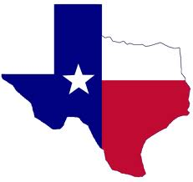
TEXAN INDEPENDENCE

54-40 OR FIGHT!
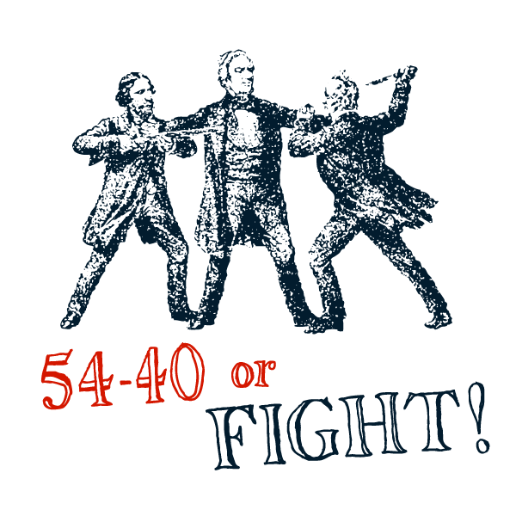
MEXICAN-AMERICAN WAR
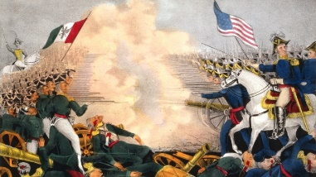
GADSDEN PURCHASE
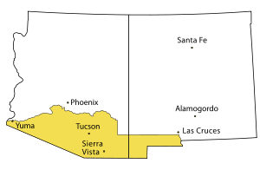
CA GOLD RUSH
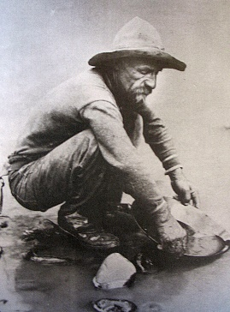
OSTEND MANIFESTO
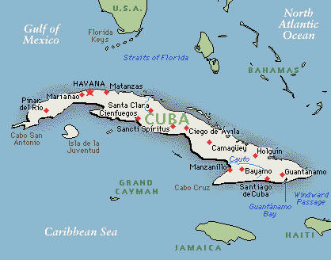

COMPROMISE
OF 1850
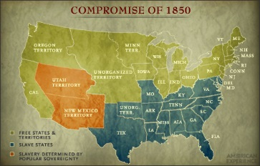
UNCLE TOM’S CABIN
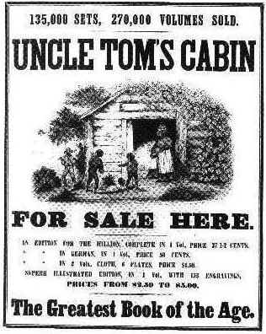

KANSAS-NEBRASKA ACT
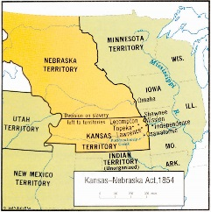
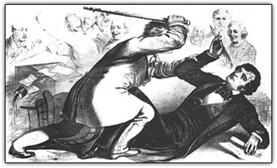
SUMNER-BROOKS AFFAIR

DRED SCOTT DECISION
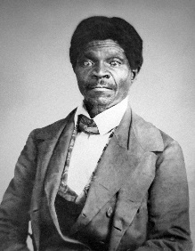
LINCOLN-DOUGLAS
DEBATES
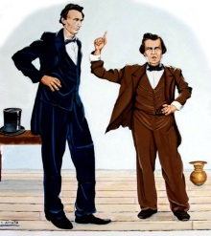
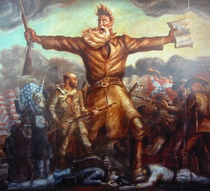
JOHN BROWN’S RAID ON HARPER’S FERRY

ELECTION OF
ABRAHAM LINCOLN
