Station #1: The Conference of Albany   
(a.k.a. the Albany Congress), 1754

### Background

*During the French and Indian War, representatives of seven colonies met in Albany, New York, with representatives of the Iroquois Confederacy, a Native American group. The goal of the Albany Congress was to solidify friendship with the Iroquois in light of the approaching war with France and the continuous pressure felt by Native Americans along the frontier as American settlers continued to move westward.*

*Another goal of the conference was to discuss the possibility of an inter-colonial union. Benjamin Franklin presented a "plan of union" at the conference which would establish a Grand Council which would be able to levy taxes, raise troops, and regulate trade with the Indians. The delegates at the congress approved the plan, but the colonies refused to ratify it, since it threatened their power of taxation.*

### Albany Plan of Union (1754)

It is proposed that humble application be made for an act of Parliament of Great Britain, by virtue of which one general government may be formed in America, including all the said colonies, within and under which government each colony may retain its present constitution, except in the particulars wherein a change may be directed by the said act, as hereafter follows.

1. That the said general government be administered by a President-General, to be appointed and supported by the crown; and a Grand Council, to be chosen by the representatives of the people of the several Colonies met in their respective assemblies.

2. That . . . after the passing such act, the House of Representatives that happen to be sitting within that time, or that shall be especially for that purpose convened, may and shall choose members for the Grand Council, in the following proportion, that is to say,

Massachusetts Bay 7

New Hampshire 2

Connecticut 5

Rhode Island 2

New York 4

New Jersey 3

Pennsylvania 6

Maryland 4

Virginia 7

North Carolina 4

South Carolina 4

48

3. – who shall meet for the first time at the city of Philadelphia, being called by the President-General as soon as conveniently may be after his appointment.

4. That there shall be a new election of the members of the Grand Council every three years. . .

10. That the President-General, with the advice of the Grand Council, hold or direct all Indian treaties, in which the general interest of the Colonies may be concerned; and make peace or declare war with Indian nations. . . .

14. That they make laws for regulating and governing such new settlements, till the crown shall think fit to form them into particular governments.

15. That they raise and pay soldiers and build forts for the defence of any of the Colonies, and equip vessels of force to guard the coasts and protect the trade on the ocean, lakes, or great rivers; but they shall not impress men in any Colony, without the consent of the Legislature.

16. That for these purposes they have power to make laws, and lay and levy such general duties, imposts, or taxes, as to them shall appear most equal and just (considering the ability and other circumstances of the inhabitants in the several Colonies), and such as may be collected with the least inconvenience to the people. . . .

21. That the laws made by them for the purposes aforesaid shall not be repugnant, but, as near as may be, agreeable to the laws of England, and shall be transmitted to the King in Council for approbation, as soon as may be after their passing; and if not disapproved within three years after presentation, to remain in force.

### “Join or Die” Cartoon, by Benjamin Franklin (1754)

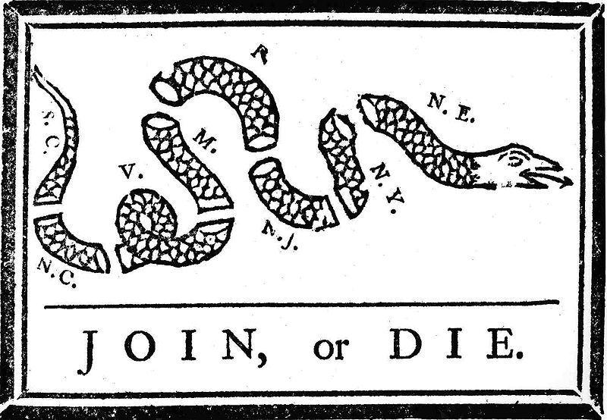

Station #2: Pontiac’s War and the Proclamation of 1763

### Background

*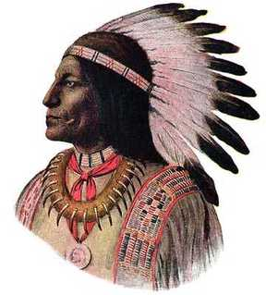The end of the French and Indian War in 1763 was a cause for great celebration in the colonies, for it removed several ominous barriers and opened up a host of new opportunities for the colonists. The French had effectively hemmed in the British settlers and had, from the perspective of the settlers, played the "Indians" against them. The first thing on the minds of colonists was the great western frontier that had opened to them when the French ceded that contested territory to the British.*

*Many Native Americans in the Great Lakes region reacted to the transition from French to British rule with an uprising that came to be known as Pontiac's Rebellion, launched in 1763. Warriors from numerous tribes joined the uprising in an effort to drive British soldiers and settlers out of the region. The war is named after the Ottawa leader Pontiac, the most prominent of many native leaders in the conflict. Hostilities came to an end after British Army expeditions in 1764 led to peace negotiations over the next two years. Native Americans were unable to drive away the British, but the uprising prompted the British government to modify the policies that had provoked the conflict.*

**

*King George III’s royal proclamation of 1763 was inspired in part by Pontiac’s Rebellion and it did much to dampen that celebration among the American colonists following their victory in the French and Indian War. The proclamation, in effect, closed off the frontier to colonial expansion. The King and his council presented the proclamation as a measure to calm the fears of the Indians, who felt that the colonists would drive them from their lands as they expanded westward. Many in the colonies felt that the object was to pen them in along the Atlantic seaboard where they would be easier to regulate. No doubt there was a large measure of truth in both of these positions. However the colonists could not help but feel a strong resentment when what they perceived to be their prize was snatched away from them. The proclamation provided that all lands west of the heads of all rivers which flowed into the Atlantic Ocean from the west or northwest were off-limits to the colonists. This excluded the rich Ohio Valley and all territory from the Ohio to the Mississippi rivers from settlement.*

Station #3: Cultural and Ideological Ties

### George Washington, Letter to Robert Orme, Aide-de-Campe to General Edward Braddock (1755)

*Upon hearing that veteran British General Edward Braddock was headed to the Ohio country with British troops to attack the French and their Indian allies, a young George Washington – then a Major in the Virginian army – eagerly accepted the General’s invitation to volunteer as one of his aides.*

It is true, sir, I have. . . expressed an inclination to serve in this campaign as a volunteer; and this inclination is not a little increased, since it is likely to be conducted by a gentleman of the general’s experience. But besides this, and the laudable desire I may have to serve with my best abilities my king and country, I must be ingenuous enough to confess, that I am not a little biased by selfish considerations. To explain, sir, I wish earnestly to attain some knowledge in the military profession, and [I believe] a more favorable opportunity cannot offer than to serve under a gentleman of General Braddock’s abilities and experience.

### Sermon: Rev. Thomas Barnard, Massachusetts (1763)

Auspicious Day! when Britain, the special Care of Heaven, blessed with a patriot-Sovereign, served by wise and faithful Councellors, brave Commanders, successful Fleets and Armies, seconded in her Efforts by all her Children, and by none more zealously than by those of New England . . .

America, mayest well rejoice, the Children of New England may be glad and triumph, in Reflection on Events past, and Prospect for the future . . .

Now commences the Era of our quiet Enjoyment of those Liberties which our Fathers purchased with the Toil of their whole Lives, their Treasure, their Blood. Safe from the Enemy of the Wilderness, safe from the gripping Hand of arbitrary Sway and cruel Superstition, here shall be the late founded Seat of Peace and Freedom. Here shall our indulgent Mother, who has most generously rescued and protected us, be served and honored by growing Numbers, with all Duty, Love and Gratitude, till Time shall be no more.

### Benjamin Franklin Testimony in the British House of Commons (1766)

*Testimony given by Benjamin Franklin in London in response to the passage of the Stamp Act, Britain’s first internal tax on the colonists, issued in an effort to raise revenue following the French and Indian War.*

Q. Do the Americans pay any considerable taxes among themselves?

A. Certainly many, and very heavy taxes.

Q. What are the present taxes in Pennsylvania, laid by the laws of the colony?

A. There are taxes on all estates, real and personal; a poll tax; a tax on all offices, professions, trades, and businesses, according to their profits; an excise on all wine, rum, and other spirit; and a duty of ten pounds per head on all Negroes imported, with some other duties.

Q. For what purposes are those taxes laid?

A. For the support of the civil and military establishments of the country, and to discharge the heavy debt contracted in the [French and Indian War]. . . .

Q. Do you think it right that America should be protected by this country and pay no part of the expense?

A. That is not [entirely] the case. The colonies raised, clothed, and paid, during the last war, near 25,000 men, and spent many millions.

Q. Do you think the people of America would submit to pay the stamp duty, if it was moderated?

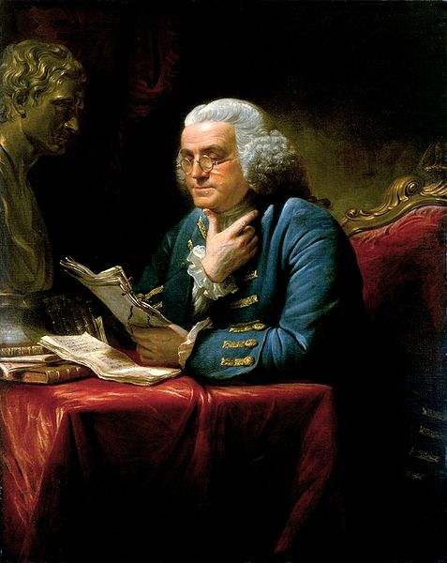A. No, never, unless compelled by force of arms. . . .

Q. What was the temper of America towards Great Britain before the year 1763?

A. The best in the world. They submitted willingly to the government of the Crown, and paid… obedience to acts of Parliament. Numerous as the people are in the [colonies] they cost you nothing in forts, citadels, garrisons, or armies, to keep them in subjection. They were governed by this country at the expense only of a little pen, ink, and paper. . . . They had not only a respect but an affection for Great Britain; for its laws, its customs, and manners, and even a fondness for its fashions, that greatly increased the commerce. . . .

Q. And what is their temper now?

A. Oh, very much altered!

Q. Did you ever hear the authority of Parliament to make laws for America questioned till lately?

A. The authority of Parliament was allowed to be valid in all laws, except such as should lay internal taxes. It was never disputed in laying duties to regulate commerce.

Q. In what light did the people of America use to consider the Parliament of Great Britain?

A. They considered the Parliament as the great bulwark and security of their liberties and privileges, and always spoke of it with the utmost respect and veneration. . . .

Q. And have they not still the same respect for Parliament?

A. No; it is greatly lessened. . . .

Q. If the act is not repealed, what do you think will be the consequences?

A. A total loss of the respect and affection the people of America bear to this country, and of all the commerce that depends on that respect and affection.

Q. How can the commerce be affected?

A. You will find that, if the act is not repealed, they will [buy] very little of your manufactures in a short time. . . . .

Q. Is it their interest not to [buy] them?

A. The goods they take from Britain are either necessaries, mere conveniences, or superfluities. The first, as cloth, etc., with a little industry they can make at home; the second they can do without till they are able to provide them among themselves; and the last, which are mere articles of fashion, purchased and consumed because it is the fashion in a respected country; but will now be detested and rejected. . . .

Q. What used to be the pride of the Americans?

A. To indulge in the fashions and manufactures of Great Britain.

Q. What is now their pride?

A. To wear their old clothes over again, till they can make new ones.

Station #4: The Stamp Act Crisis

### Background

*The Stamp Act was passed by the British Parliament on March 22, 1765. The new tax was imposed on all American colonists and required them to pay a tax on* ***every piece of printed paper*** *they used. The following documents (amongst many others) were taxed under these new provisions:*

* *Ship's papers*
* *Legal documents (wills, bail, warrants, affidavits, labor contracts, etc.)*
* *School diplomas*
* *Licenses (lawyer, doctor, liquor, etc.)*
* *Newspapers*
* *Advertisements*
* *Bonds*
* *Playing cards & dice*
* *Almanac*
* *Calendars*

*The money collected by the Stamp Act was to be used to help pay the costs of defending and protecting the American frontier near the Appalachian Mountains (10,000 troops were to be stationed on the American frontier for this purpose).*

### The Virginia Stamp Act Resolutions (1765)

*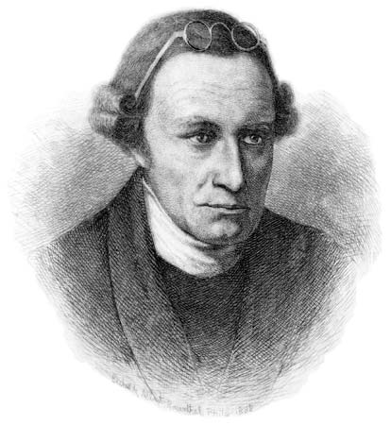Patrick Henry had been a member of the Virginia’s House of Burgess assembly for exactly nine days as the May session was drawing to a close. On May 29, 1765, George Johnston of Fairfax, VA rose to suggest that the House of Burgess consider the Stamp Act. Patrick Henry leaped to his feet and seconded the motion to the shock of the older delegates in attendance. How dare Virginia consider a law that Parliament had already passed? One delegate, George Wyeth, reminded everyone present that “it is our duty to humbly and silently accept the decisions of Parliament.” In disagreement, Henry offered the stunned delegates seven resolutions:*

Resolved, that the first adventurers and settlers of His Majesty's colony and dominion of Virginia brought with them and transmitted to their posterity, and all other His Majesty's subjects since inhabiting in this His Majesty's said colony, all the liberties, privileges, franchises, and immunities that have at any time been held, enjoyed, and possessed by the people of Great Britain. . . .

Resolved, that the taxation of the people by themselves, or by persons chosen by themselves to represent them, who can only know what taxes the people are able to bear, or the easiest method of raising them, and must themselves be affected by every tax laid on the people, is the only security against a burdensome taxation, and the distinguishing characteristic of British freedom, without which the ancient constitution cannot exist.

Resolved, that His Majesty's liege people of this his most ancient and loyal colony have without interruption enjoyed the inestimable right of being governed by such laws, respecting their internal policy and taxation, as are derived from their own consent, with the approbation of their [King], or his substitute; and that the same has never been forfeited or yielded up, but has been constantly recognized by the kings and people of Great Britain.

*[Note: The following resolutions were not approved by the House of Burgesses but were widely circulated around the colony.]*

Resolved, therefor that the General Assembly of this Colony have the only and exclusive Right and Power to lay Taxes and Impositions upon the inhabitants of this Colony and that every Attempt to vest such Power in any person or persons whatsoever other than the General Assembly aforesaid has a manifest Tendency to destroy British as well as American Freedom.

Resolved, That His Majesty's liege people, the inhabitants of this Colony, are not bound to yield obedience to any law or ordinance whatever, designed to impose any taxation whatsoever upon them, other than the laws or ordinances of the General Assembly aforesaid.

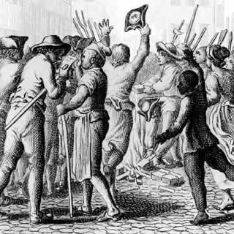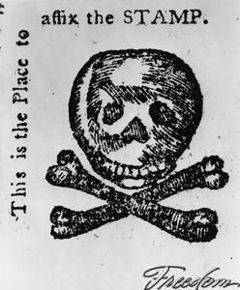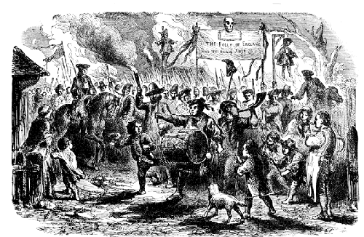

*Burning of Stamp Act papers, Boston, 1765*

*Stamp placeholder in Pennsylvania Journal and Weekly Adviser, 1765*

*New York Riots, 1765 (Banner reads: ‘The Folly of England and the Ruin of America’)*