Name____________________________________________ Block______
PERIOD 6: GILDED AGE POLITICAL CARTOONS
CARTOON #1
1. Title of Cartoon (if it has one):____________________________________________________
If no title then provide a basic visual description of cartoon:
____________________________________________________________________________
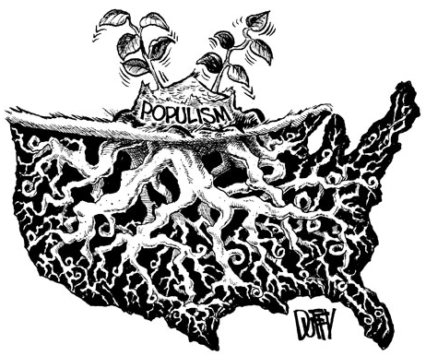
2. What are the characters and symbols in the cartoon, and what does each one represent?

3. How do the words help you identify the cartoonist’s intention?

4. What action is taking place in the cartoon?

5. What opinion is the cartoonist expressing?

CARTOON #2
1. Title of Cartoon (if it has one):____________________________________________________
If no title then provide a basic visual description of cartoon:
____________________________________________________________________________
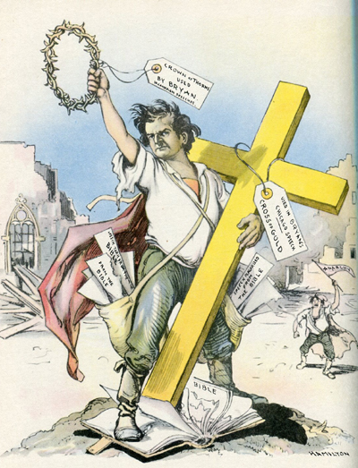
2. What are the characters and symbols in the cartoon, and what does each one represent?

3. How do the words help you identify the cartoonist’s intention?

4. What action is taking place in the cartoon?

5. What opinion is the cartoonist expressing?

CARTOON #3
1. Title of Cartoon (if it has one):____________________________________________________
If no title then provide a basic visual description of cartoon:
____________________________________________________________________________
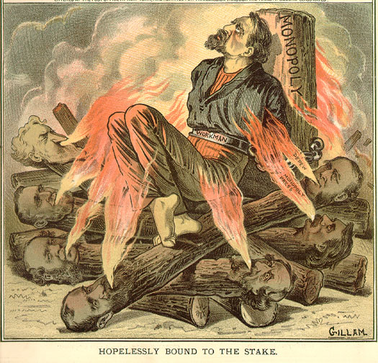
2. What are the characters and symbols in the cartoon, and what does each one represent?

3. How do the words help you identify the cartoonist’s intention?

4. What action is taking place in the cartoon?

5. What opinion is the cartoonist expressing?

CARTOON #4
1. Title of Cartoon (if it has one):____________________________________________________
If no title then provide a basic visual description of cartoon:
____________________________________________________________________________
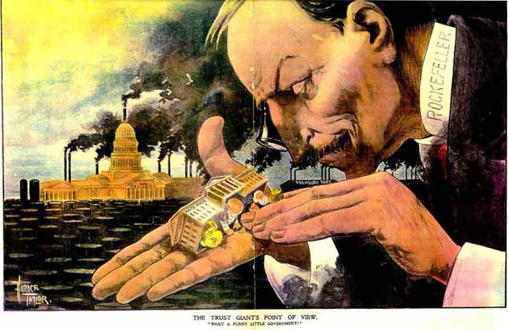
2. What are the characters and symbols in the cartoon, and what does each one represent?

3. How do the words help you identify the cartoonist’s intention?

4. What action is taking place in the cartoon?

5. What opinion is the cartoonist expressing?

CARTOON #5
1. Title of Cartoon (if it has one):____________________________________________________
If no title then provide a basic visual description of cartoon:
____________________________________________________________________________
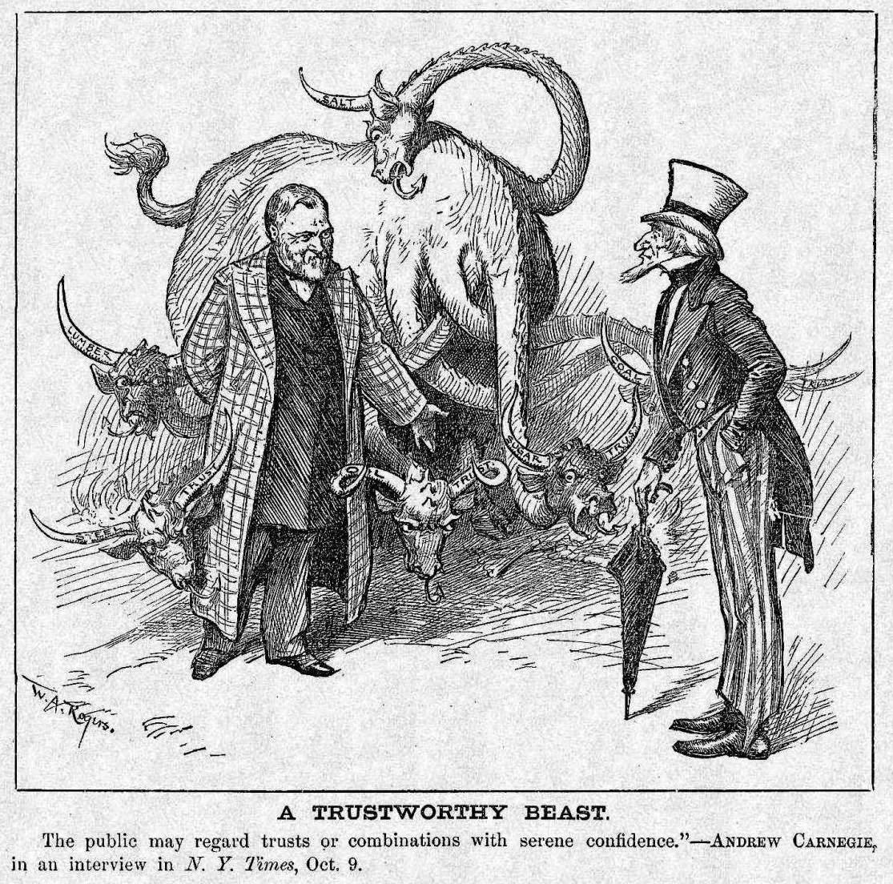
2. What are the characters and symbols in the cartoon, and what does each one represent?

3. How do the words help you identify the cartoonist’s intention?

4. What action is taking place in the cartoon?

5. What opinion is the cartoonist expressing?

CARTOON #6
1. Title of Cartoon (if it has one):____________________________________________________
If no title then provide a basic visual description of cartoon:
____________________________________________________________________________
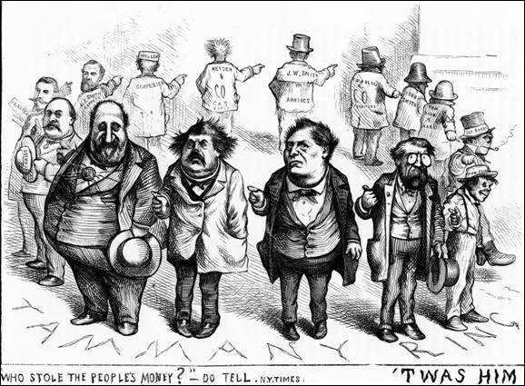
2. What are the characters and symbols in the cartoon, and what does each one represent?

3. How do the words help you identify the cartoonist’s intention?

4. What action is taking place in the cartoon?

5. What opinion is the cartoonist expressing?

