Name_______________________________________ Block_____

HAMILTON VS. JEFFERSON DBQ
Central Historical Question:
What were the differences between Hamilton and Jefferson?

- Read the section of the textbook that describes the differences between Alexander Hamilton and Thomas Jefferson and answer two questions:

  - In your own opinion, what would you say is the BIGGEST difference between Jefferson and Hamilton?

- We can learn a lot about the personalities of historical figures by reading their writing. We’re going to look at two letters from Hamilton and Jefferson to George Washington and we’re going to see if we can get a sense of their personalities from these letters.

- Read the letters and answer the Guiding Questions. Answer the sourcing question before reading the documents. You may work with a partner.

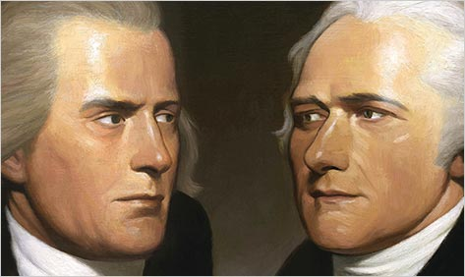

Alexander Hamilton Letter to George Washington, 1792 (Modified)

Dear Sir,

I have received your letter of August 26th. I sincerely regret that you have been made to feel uneasy in your administration. I will do anything to smooth the path of your administration, and heal the differences, though I consider myself the deeply injured party.

I know that I have been an object of total opposition from Mr. Jefferson. I know from the most authentic sources, that I have been the frequent subject of most unkind whispers by him. I have watched a party form in the Legislature, with the single purpose of opposing me. I believe, from all the evidence I possess, that the National Gazette (a newspaper) was instituted by Jefferson for political purposes, with its main purpose to oppose me and my department.

Nevertheless, I can truly say that, besides explanations to confidential friends, I never directly or indirectly responded to these attacks, until very recently.

But when I saw that they were determined to oppose the banking system, which would ruin the credit and honor of the Nation, I considered it my duty to resist their outrageous behavior.

Nevertheless, I pledge my honor to you Sir, that if you shall form a plan to reunite the members of your administration, I will faithfully cooperate. And I will not directly or indirectly say or do a thing to cause a fight. I have the honor to remain

Sir, Your most Obedient and Humble servant A Hamilton
Source: This letter was written by Alexander Hamilton to President George Washington on September 9, 1792. Hamilton was Secretary of the Treasury in Washington’s administration.

Thomas Jefferson Letter to George Washington, 1792 (Modified)

DEAR SIR,

I received your letter of August 23rd. You note that there have been internal tensions in your administration. These tensions are of great concern to me. I wish that you should know the whole truth.

I have never tried to convince members of the legislature to defeat the plans of the Secretary of Treasury. I value too highly their freedom of judgment. I admit that I have, in private conversations, disapproved of the system of the Secretary of Treasury. However, this is because his system stands against liberty, and is designed to undermine and demolish the republic.

I would like for these tensions to fade away, and my respect for you is enough motivation to wait to express my thoughts until I am again a private citizen. At that point, however, I reserve the right to write about the issues that concern the republic.

I will not let my retirement be ruined by the lies of a man who history—if history stoops to notice him—will remember a person who worked to destroy liberty. –Still, I repeat that I hope I will not have to write such a thing.

I trust that you know that I am not an enemy to the republic, nor a waster of the country’s money, nor a traitor, as Hamilton has written about me.

In the meantime I am with great and sincere affection and respect, dear Sir, your most obedient and most humble servant.

Thomas Jefferson

Source: This letter was written by Thomas Jefferson to President George Washington on September 9, 1792. Jefferson was Secretary of State in Washington’s administration.

Guiding Questions

Using BOTH letters by Hamilton and Jefferson, answer the questions below:

- (Sourcing) When were these letters written? What do you predict they will say?

- (Context) Why are both Hamilton and Jefferson writing to George Washington? Based on both of these letters, what seems to have been happening in George Washington’s administration? How can you tell?

- (Close reading) Which letter is angrier? Find a quote to support your claim:

Write one adjective about each man’s personality and find a quote to support your claim.

In this letter, Hamilton seems to be . I’m basing this claim on the following quote:

In this letter, Jefferson seems to be _ _. I’m basing this claim on the following quote:

- (Corroboration) Who do you believe “started” the fight? Based on what they wrote, whom do you trust more: Hamilton or Jefferson? Why?

