Name___________________________________________ Block_____

Irish Immigration Mini-DBQ

Central Historical Question:
Were the Irish considered “white” in the 19th century?

Background
- Long history of oppression by the British.
- Arrived in the U.S. in the 1840s because of the potato famine.
- Mostly settled in cities, worked in factories.
- Extremely poor.
- Anti-Irish sentiment was really high for a number of reasons:
  - Irish were poor and slums developed in cities; people blamed the Irish for crime, disease, prostitution, alcohol abuse, etc.
  - Irish were Catholic; most Americans were Protestant and claimed Catholics could not be trusted because they would be more loyal to the Pope than to the U.S. government (to this day, the U.S. has only had one Catholic president).
- Know-Nothing Party was strongly anti-Irish and anti-immigrant.

Document A: Thomas Nast Cartoon, 1876
This cartoon by Thomas Nast was published on December 7, 1876, in Harper’s Weekly.
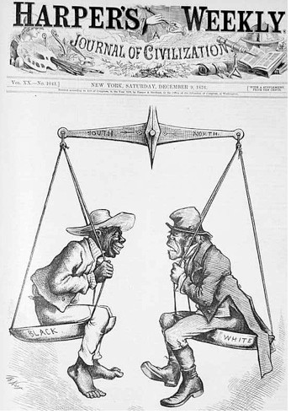
- (Close reading) The man on the right is supposed to be Irish. What comparison is the cartoon making?

- (Close reading) What is the message of this cartoon?

Document B: Know-Nothing Newspaper
This is an excerpt from an article that appeared in a Boston newspaper,
The Know-Nothing and American Crusader.

THINGS WHICH ROMAN CATHOLIC PRIESTS AND ALL TRUE ROMAN CATHOLICS HATE

Providence, July 22, 1854

- They HATE our Republic, and are trying to overthrow it.

- They HATE our Flag, and they grossly insulting it.

- They HATE the liberty of the Press.

- They HATE the liberty of speech.

- They HATE our Public School system.

- They HATE the Bible, and would blot it out of existence if they could!

- They HATE Protestants, and are sworn to exterminate them from our country and the earth.

- They HATE all rulers that do not swear allegiance to the Pope of Rome.

- They HATE to be ruled by Americans, and say “WE WILL NOT BE RULED BY THEM!”

- They HATE to support their own paupers and they are left to be supported by the tax paying Americans.

- They HATE, above all, the “Know-Nothings,” who are determined to rid this country from their cursed power.

—UNCLE SAM

- (Close reading) Based on this document, what were three reasons the Know-Nothings targeted Irish Catholics?

- (Close reading) Based on this document, what are two reasons why the Know-Nothings believed being Catholic was incompatible with being a United States citizen?

Document C: Historian account
This is an excerpt from historian David Roediger’s book Wages of Whiteness.

Irish-Americans workers . . . [were sometimes] used as substitutes for slaves within the South. Gangs of Irish immigrants worked ditching and draining plantations, building levees and sometimes clearing land because of the danger of death to valuable slave property (and, as one account put it, to mules) in such pursuits . . . One Southerner explained the use of Irish labor on the grounds that: “n-----s are worth too much to be risked here; if the Paddies (Irish) are knocked overboard . . . nobody loses anything.”

Irish youths were also likely to be found in the depleted ranks of indentured servants from the early national period (early 1800s) through the Civil War. In that position they were sometimes called “Irish slaves” and more frequently “bound boys.” . . . In New York City, Irish women comprised the largest group of prostitutes, or as they were sometimes called in the 1850s, “white slaves.”

Source: David R. Roediger, Wages of Whiteness, 1991.

- (Contextualization) Why were Irish used for difficult labor in the South?

- (Close reading) Based on this document, how were the Irish treated?

Document D: Cartoon

This cartoon by Frederick Burr Opper was published in the magazine Puck in 1883. It shows a non-Irish woman imploring her Irish cook to continue her duties. The cook shakes her fist in defiance.

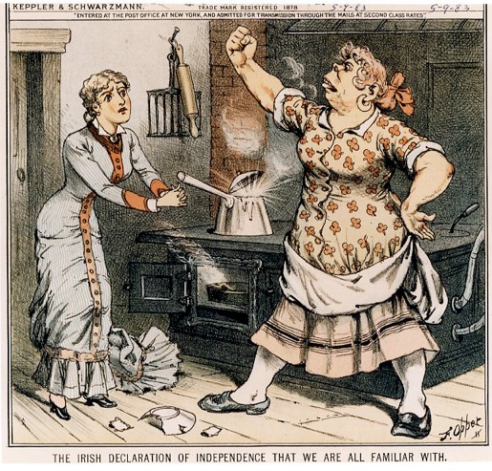

- (Close reading) The woman on the right is supposed to be Irish. Describe what she looks like and how she’s acting. Based on this document, what were some stereotypes about Irish women?

- (Contextualization) Based on this document, what job do you think many Irish women had in the 1880s?

Were the Irish considered “white” in 19th century America?

Evidence that the Irish were considered white | Evidence that the Irish were NOT considered white

Final conclusion: Were the Irish considered white in 19th century America? Please explain your answer using the documents and cartoons above. You must use at least 3 pieces of evidence/quotes in your essay. Minimum of 150 words. You must use a thesis and claim, as well supporting details and a conclusion.

Think about while writing:
- Were the Irish considered “white” in the 19th century?
- What evidence supports the argument that they were considered white? What evidence supports the argument that they were not considered white?
- What does it mean to be white?

______________________________________________________

______________________________________________________

______________________________________________________

______________________________________________________

______________________________________________________

______________________________________________________

______________________________________________________

______________________________________________________

______________________________________________________

______________________________________________________

______________________________________________________

______________________________________________________

______________________________________________________

______________________________________________________

______________________________________________________

______________________________________________________

______________________________________________________

______________________________________________________

______________________________________________________

______________________________________________________

______________________________________________________

______________________________________________________

______________________________________________________

______________________________________________________

______________________________________________________

______________________________________________________

______________________________________________________

______________________________________________________

______________________________________________________

______________________________________________________

______________________________________________________

______________________________________________________

______________________________________________________

______________________________________________________

