Name_____________________________________ Block____

LEAGUE OF NATIONS: MINI-DBQ

Central Historical Question:
Why did Congress reject the League of Nations?

Background:
  - European Allies were furious with Germany after WWI and wanted a treaty that punished Germany and made them pay for the damage of the war.
  - President Wilson, instead, thought that the treaty should try to lay
the groundwork to “end all wars;” for example, he didn’t think that the Allies should punish Germany too harshly or make a land-grab for German colonies.
  - Wilson drafted his plan, called the “Fourteen Points,” and brought it
to Paris; the Fourteenth “point” was the establishment of a League of Nations—an international governing body that would try to resolve international differences and support democratic nations.
  - European nations rejected almost all of Wilson’s ideas, but they
agreed to set up a League of Nations—this became part of the Treaty of Versailles.
  - But when Wilson returned to the U.S. and tried to get Congress to ratify the treaty, they refused, mostly because they opposed the
League of Nations.

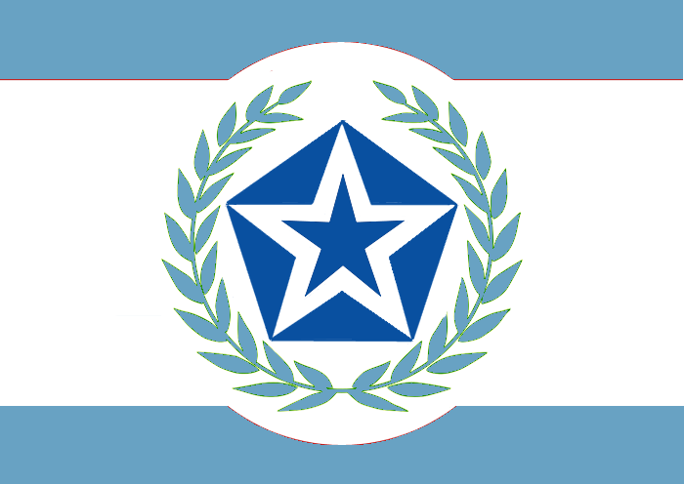

President Woodrow Wilson, September 25, 1919 (Modified)

My fellow citizens, as I have crossed the continent, I have perceived more and more that men have been busy creating an absolutely false impression of the treaty of peace and the Covenant of the League of Nations.

Reflect, my fellow citizens that the membership of this great League is going to include all the great fighting nations of the world, as well as the weak ones.

And what do they unite for? They enter into a solemn promise to one another that they will never use their power against one another for aggression; that they never will violate the territorial integrity of a neighbor; that they never will interfere with the political independence of a neighbor; that they will abide by the principle that great populations are entitled to determine their own destiny; and that no matter what differences arise between them they will never resort to war without first submitting their differences to the consideration of the council of the League of Nations, and agreeing that at the end of the six months, even if they do not accept the advice of the council, they will still not go to war for another three months.

I wish that those who oppose this settlement could feel the moral obligation that rests upon us not to turn our backs on the boys who died, but to see the thing through, to see it through to the end and make good their redemption of the world. For nothing less depends upon this decision, nothing less than liberation and salvation of the world.

Vocabulary
Territorial integrity: borders of a country Abide: accept
Redemption: save from evil

Source: Woodrow Wilson, speech in Pueblo Colorado, September 25, 1919. When President Wilson returned to the United States in 1919 after the Paris Peace Conference, he toured the country to raise support for the treaty and the League.

Henry Cabot Lodge, August 12, 1919 (Modified)

Mr. President:

I can never be anything else but an American, and I must think of the United States first.

I have never had but one allegiance - I cannot divide it now. I have loved but one flag and I cannot share that devotion and give affection to the mongrel banner invented for a league. Internationalism is to me repulsive.

The United States is the world's best hope, but if you fetter her in the interests and quarrels of other nations, if you tangle her in the intrigues of Europe, you will destroy her power for good and endanger her very existence. Leave her to march freely through the centuries to come as in the years that have gone.

No doubt many excellent and patriotic people see a coming fulfillment of noble ideals in the words 'league for peace.' We all respect and share these aspirations and desires, but some of us see no hope, but rather defeat, for them in this murky plan. For we, too, have our ideals, even if we differ from those who have tried to establish a monopoly of idealism.

Our first ideal is our country. Our ideal is to make her ever stronger and better and finer, because in that way alone can she be of the greatest service to the world's peace and to the welfare of mankind.

Vocabulary
Allegiance: loyalty
Mongrel: a mutt; a cross-breed Repulsive: disgusting
Fetter: restrain with chains Intrigues: secret plans Aspirations: hopes
Murky: dark and dirty

Source: Henry Cabot Lodge, speech, August 12, 1919. Washington, D.C. Republican Henry Cabot Lodge was a staunch opponent of the Democrat President Woodrow Wilson.

