Name_____________________________________________________ Block________
Map of Europe: World War II
Refer to p. 431 in the text, label and color the following…provide a key.
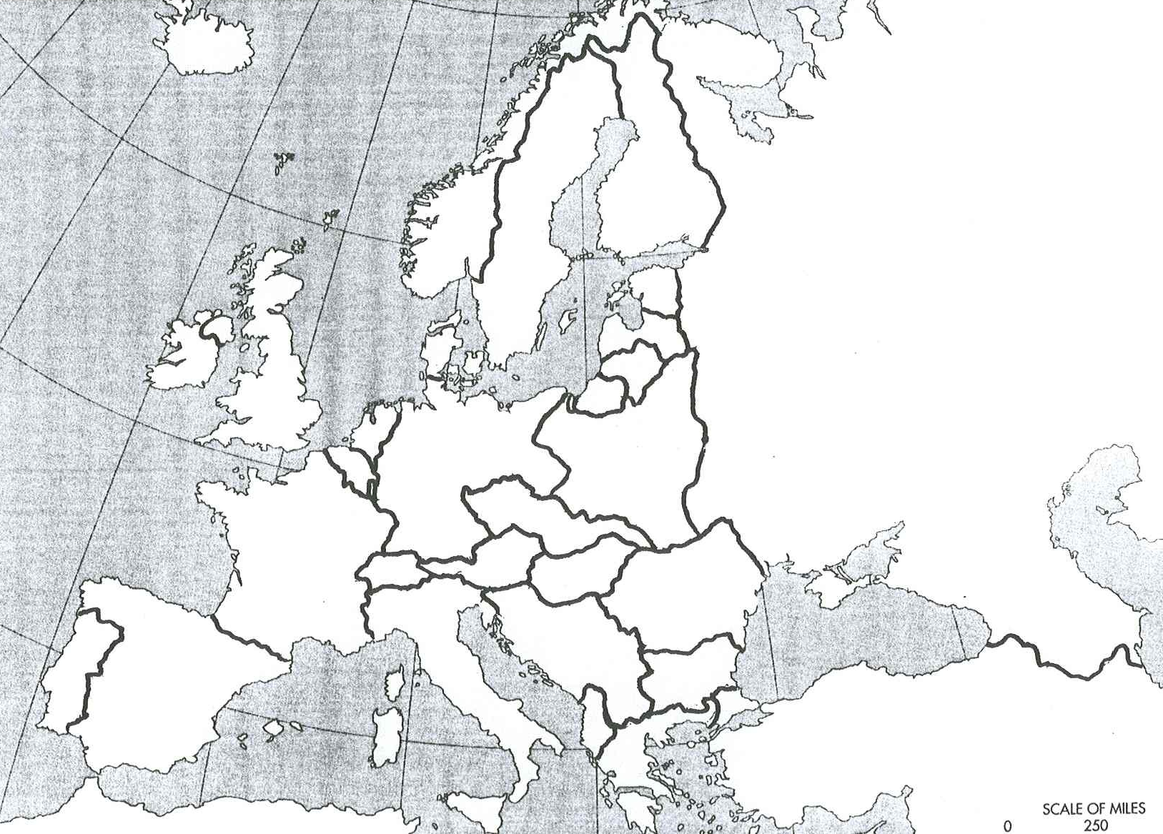
- All European countries
- Axis Powers
- Areas under Axis control
- Areas under Allied control
- Neutral nations
- Areas controlled by Germany due to appeasement
Key:

