Name__________________________________________ Block_____

THOMAS NAST’S POLITICAL CARTOONS: MINI-DBQ
Central Historical Question:
How did Northern attitudes towards freed African Americans change during Reconstruction?

Analyze the following cartoons by Thomas Nast and answer the questions.
Cartoon #1 (1865)
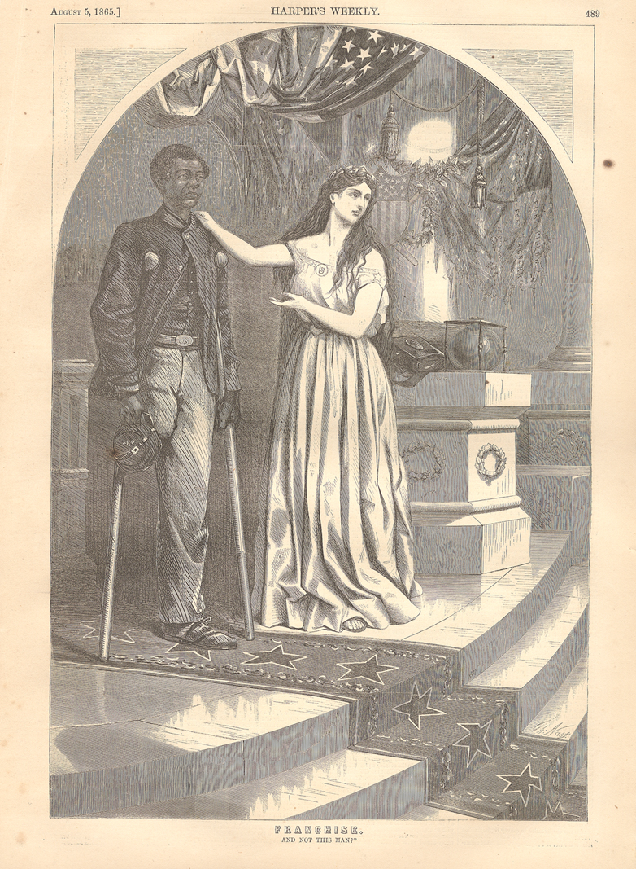
Caption: FRANCHISE. AND NOT THIS MAN?

Source: Thomas Nast was a political cartoonist who drew for a New York magazine called Harper’s Weekly. He supported the North’s side during the Civil War. This cartoon was published in 1865.

Cartoon #2 (1865)
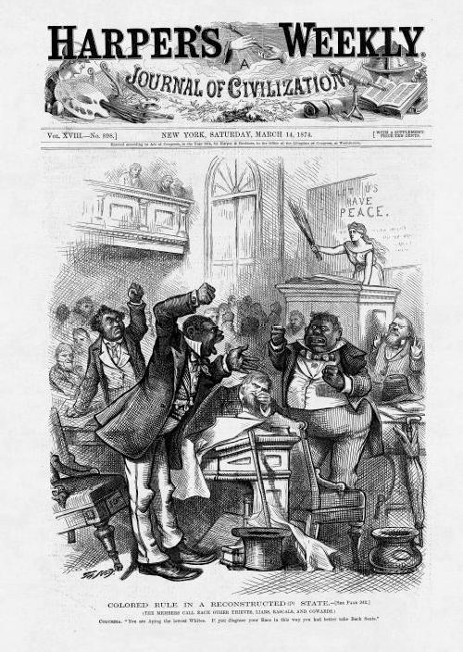

Caption: COLORED RULE IN A RECONSTRUCTED (?) STATE.

(The members call each other thieves, liars, rascals, and cowards.) COLUMBIA: “You are aping the lowest Whites. If you disgrace your race in this way you had better take back seats.”

Source: Thomas Nast was a political cartoonist who drew for a New York magazine called Harper’s Weekly. This cartoon was published on March 14, 1874.

CARTOON #1
Important background knowledge:

Franchise=right to vote
White woman=Columbia=symbol of America

- When was this cartoon drawn? Was this a short or long time after the end of the Civil War?

- Describe the African American man in this cartoon. Why do you think he’s on crutches?

- What is Columbia (white woman) asking for?

- What is the message of this cartoon? Based on the cartoon, would you say Thomas Nast supported or opposed equal rights for freedmen?

CARTOON #2
Important background knowledge:

Many African Americans were elected to state governments during Reconstruction.
By 1874, many Northerners were critical of corruption in government in Republican administrations.
White woman=Columbia=symbol of America

- Describe the African Americans in this cartoon. Is this a positive or a negative image? Explain.

- What is Columbia trying to do?

- What is the message of this cartoon? How does it differ from the message of Cartoon #1?

Corroboration
Compare the two cartoons.

- In what ways are these cartoons similar?

- In what ways are these cartoons different?

- Why might the cartoons have different messages?

Contextualization

- What do these cartoons tell us about the how some people in the North felt about freedmen during Reconstruction? How did these attitudes change over the course of Reconstruction?

