Name____________________________________________ Block______
Analyzing a Political Cartoon: Great Depression
Analyze the following cartoons and answer the questions.
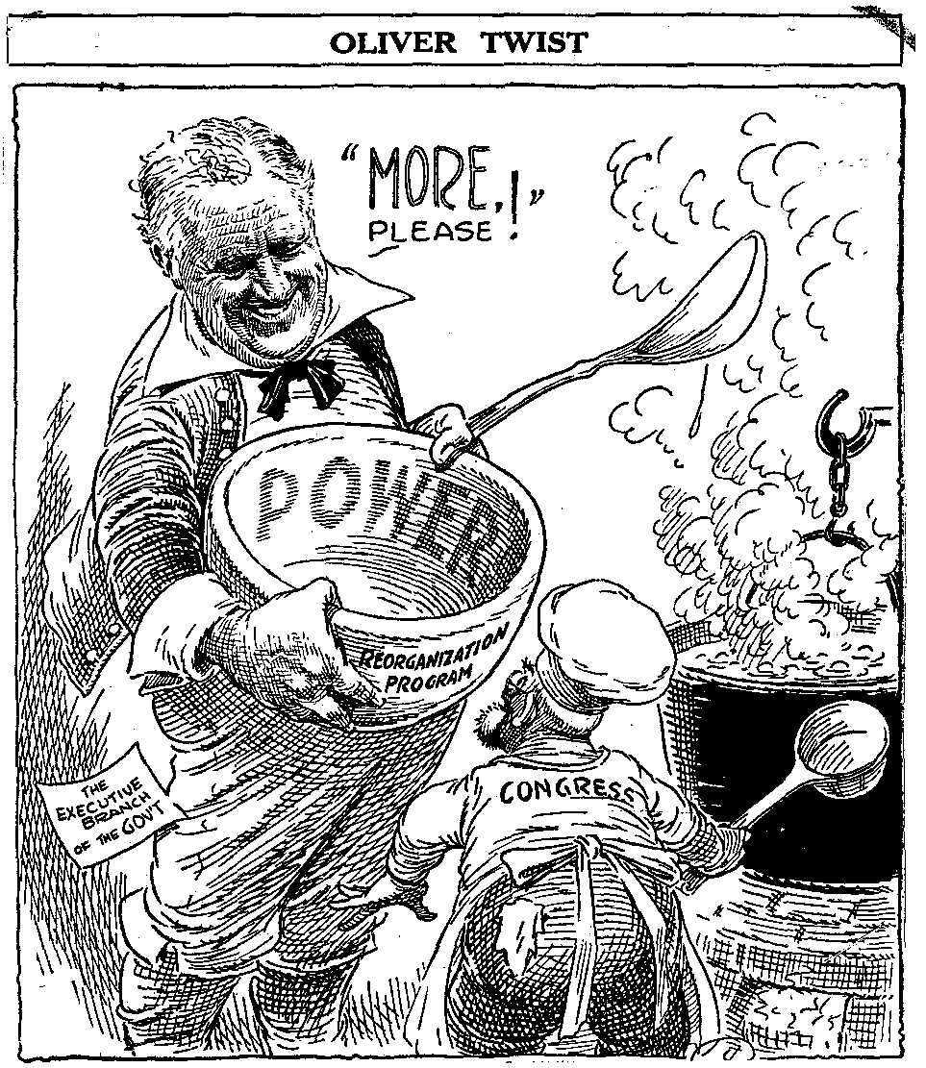
1. What are the characters and symbols in the cartoon, and what does each one represent?

2. How do the words help you identify the cartoonist’s intention?

3. What action is taking place in the cartoon?

4. What opinion is the cartoonist expressing?

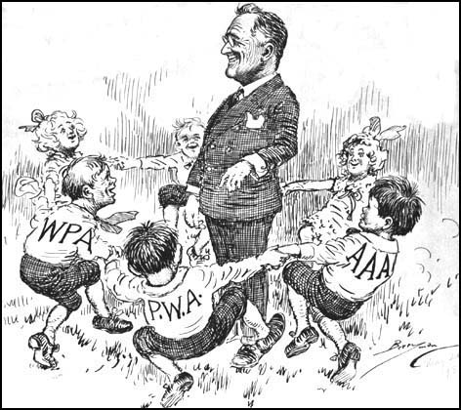

1. What are the characters and symbols in the cartoon, and what does each one represent?

2. How do the words help you identify the cartoonist’s intention?

3. What action is taking place in the cartoon?

4. What opinion is the cartoonist expressing?

