The Gilded Age: A Photographic Analysis of America’s Working Class

Central Historical Question:

How did that lack of big business regulation during the Gilded Age affect the American working class? In the words of Jacob Riis how did the “Other Half Live”?

Objectives:
- The students will analyze photographs taken by Jacob Riis and Lewis Hines to examine the working and living conditions of Americas working families during the Gilded Age.

How the Other Half Lives… Working Conditions
Background:

After the Civil War, the availability of natural resources, new inventions, and a receptive market combined to fuel an industrial boom. The demand for labor to fill these positions in mines, mills and factories was high, and because there was such a huge wave of immigration during the time, a steady supply of workers was available.
These industries were incredibly profitable, but the workers who toiled in them did not enjoy the profits of industry to the same degree as the owners of the industries. In addition to very low wages, workers’ complaints included very long hours and unhealthy and dangerous working conditions.
As you complete the activity take note that many of the workers in the photographs are children. In 1895, the average income of an urban male worker was only about $400 a year, a sum insufficient to support a family. The labor of their wives and children helped to supplement the household income. Children under the age of 16 contributed about 20 percent of the income. These children worked not because their parents were heartless, but because their earnings were absolutely essential for their family's well‐being.
Directions:

As a result of the work of photojournalists Jacob Riis and Lewis Hines, there is a large photography collection which demonstrates the working conditions of America’s poor during the Gilded Age. Your job is to visit each of the following 11 stations. As you approach each station examine all of the photographs available and answer the corresponding question(s). Be prepared to discuss your findings at the end of class.
Stations:

- Immigration and the American Dream
- Faces of the Lost Youth
- The Mill
- The Factory
- The Seafood Industry
- Newsies
- The Coal Mine
- Safety Conditions
- Pastimes and Vices
- Education
- Tenements

Station #1: Immigration

Subjects: What people and objects do you see? Describe their expressions and appearance.

- Action: What are the subjects doing?

Setting: What is going on around the subjects?

- Specific Question: Why do you think immigrants continued to come to America despite the harsh conditions?

Station #2: Faces of the Lost Youth
- Subjects: What people and objects do you see? Describe their expressions and appearance.

- Action: What are the subjects doing?

Setting: What is going on around the subjects?

- Specific Question: Why do you think these pictures are titled “Faces of the Lost Youth”? What do their futures look like?

Station #3: The Mill
- Subjects: What people and objects do you see? Describe their expressions and appearance.

- Action: What are the subjects doing?

Setting: What is going on around the subjects? Describe the working environment and safety conditions.

- Specific Question: What does life look like for Mill workers?

Station #4: The Factory

Subjects: What people and objects do you see? Describe their expressions and appearance.

- Action: What are the subjects doing?

Setting: What is going on around the subjects? Describe the working environment and safety conditions.

- Specific Question: What does life look like for Factory workers?

Station #5: The Seafood Industry

Subjects: What people and objects do you see? Describe their expressions and appearance.

- Action: What are the subjects doing?

Setting: What is going on around the subjects? Describe the working environment and safety conditions.

- Specific Question: What does life look like for Seafood Industry workers?

Station #6: Newsies

Subjects: What people and objects do you see? Describe their expressions and appearance.

- Action: What are the subjects doing?

Setting: What is going on around the subjects? Describe the working environment and safety conditions.

- Specific Question: What does life look like for Newsies?

Station #7: The Coal Mine

Subjects: What people and objects do you see? Describe their expressions and appearance.

- Action: What are the subjects doing?

Setting: What is going on around the subjects? Describe the working environment and safety conditions.

- Specific Question: What does life look like for Coal Mine workers?

Station #8: Safety Conditions

Subjects: What people and objects do you see? Describe their expressions and appearance.

- Action: What are the subjects doing?

Setting: What is going on around the subjects? Describe the environment and safety conditions.

- Specific Question: What challenges do workers face in terms of workplace safety? What needs to change and how can that change be achieved?

Station #9: Pastimes and Vices
- Subjects: What people and objects do you see? Describe their expressions and appearance.

- Action: What are the subjects doing?

Setting: What is going on around the subjects? Describe the environment and safety conditions.

- Specific Question: What problems do these photos reveal about life for America’s working class?

Station #10: Education
- Subjects: What people and objects do you see? Describe their expressions and appearance.

- Action: What are the subjects doing?

Setting: What is going on around the subjects?

- Specific Question: What role do you believe education played in the lives of immigrant families?

Station #11: Tenements

- Subjects: What people and objects do you see? Describe their expressions and appearance.

- Action: What are the subjects doing?

Setting: What is going on around the subjects?

- Specific Question: What problems do these photos reveal about living conditions for America’s working class?

Station #10: Education

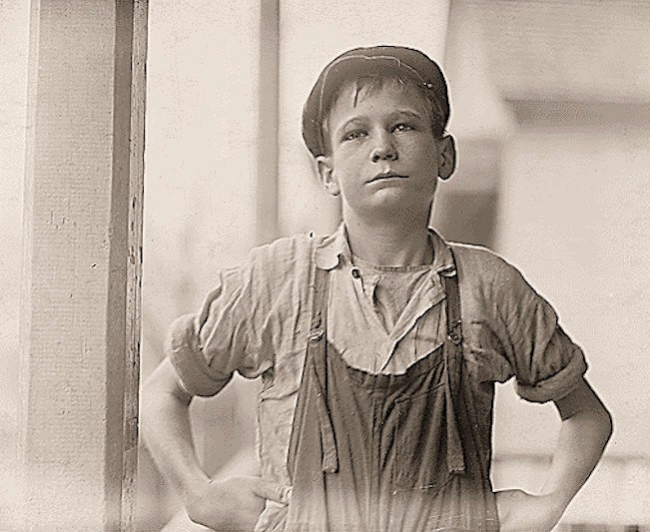

Furman Owens, 12­years­old. Can't read. Doesn't know his A,B,C's. Said, "Yes I want to learn but can't when I work all the time." Been in the mills 4 years, 3 years in the Olympia Mill. Columbia, South Carolina.

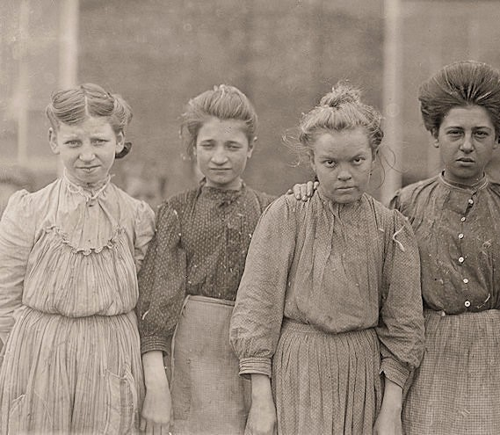
Station #2: Faces of the Lost Youth

Adolescent girls from Bibb Mfg. Co. in Macon, Georgia.

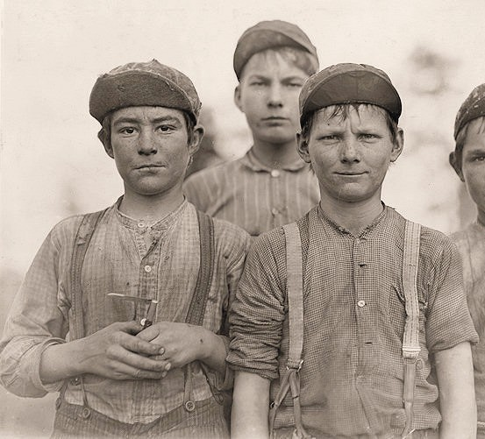
Station #2: Faces of the Lost Youth

Doffer boys. Macon, Georgia.

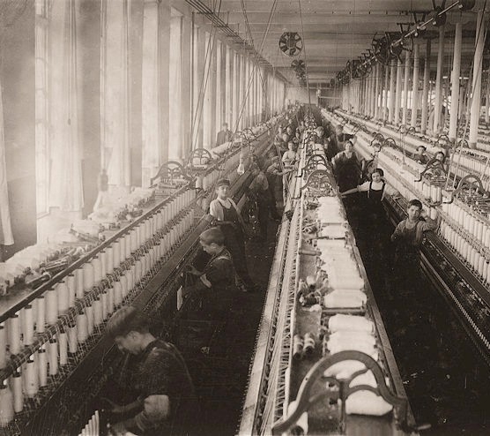
Station #3: The Mill

A general view of spinning room, Cornell Mill. Fall River, Massachusetts.

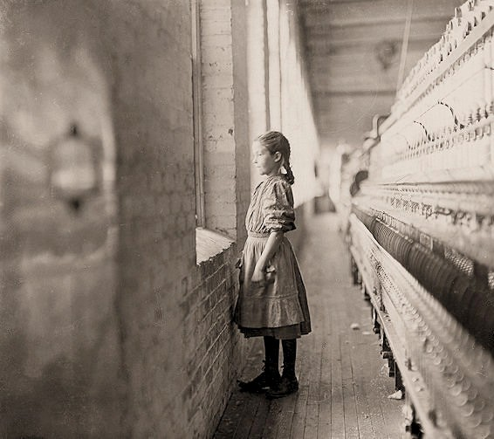
Station #3: The Mill

A moment's glimpse of the outer world. Said she was 11 years old. Been working over a year. Rhodes Mfg. Co.
Lincolnton, North Carolina.

Station #3: The Mill
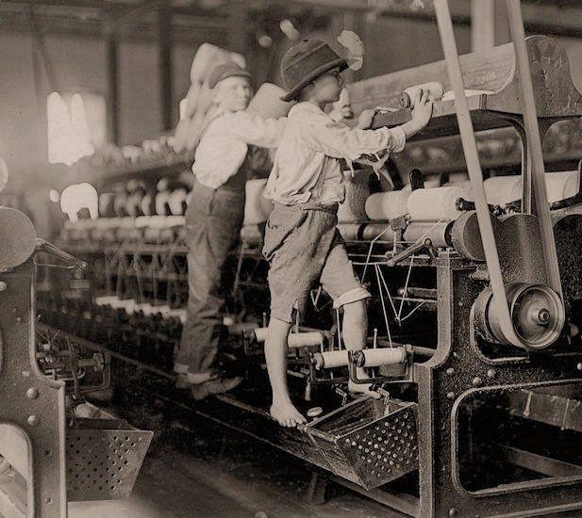
Some boys and girls were so small they had to climb up on to the spinning frame to mend broken threads and to put back the empty bobbins. Bibb Mill No. 1. Macon, Georgia.

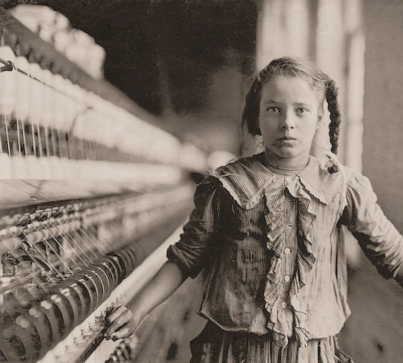
Station #3: The Mill

One of the spinners in Whitnel Cotton Mill. She was 51 inches high. Has been in the mill one year. Sometimes works at night. Runs 4 sides ­ 48 cents a day. When asked how old she was, she hesitated, then said, "I don't remember," then added confidentially, "I'm not old enough to work, but do just the same." Out of 50 employees, there were ten children about her size. Whitnel, North Carolina.

Station #3: The Mill
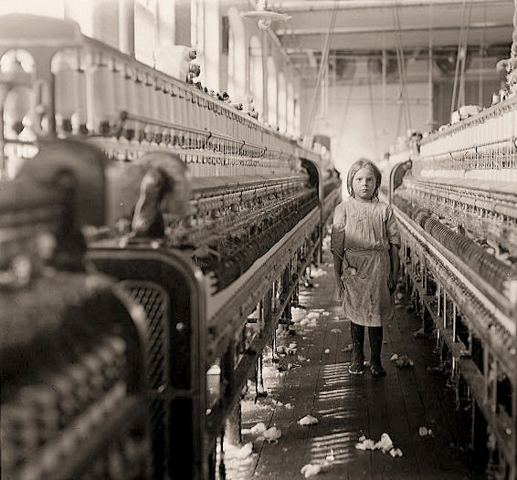
The overseer said apologetically, "She just happened in." She was working steadily. The mills seem full of youngsters who "just happened in" or "are helping sister." Newberry, South Carolina.

Station #4: The Factory
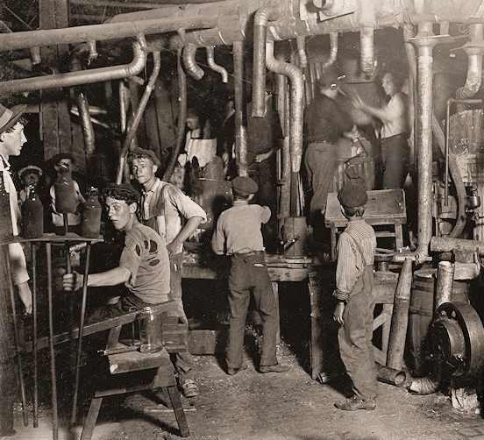
9 p.m. in an Indiana Glass Works.

Station #4: The Factory
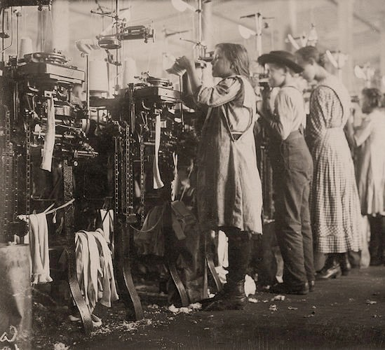
Some of the young knitters in London Hosiery Mills. London, Tennessee.

Station #9: Pastimes and Vices
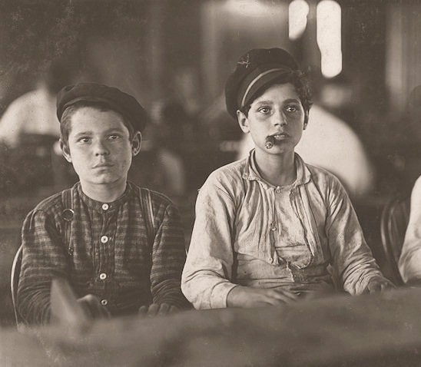
Young cigar makers in Engelhardt & Co. Three boys looked under 14. Labor leaders told me in busy times many small boys and girls were employed. Youngsters all smoke. Tampa, Florida.

Station #4: The Factory
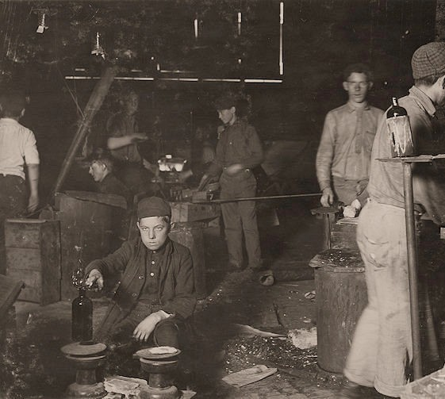
Day scene. Wheaton Glass Works. Boy is Howard Lee. His mother showed me the family record in Bible which gave his birth as July 15, 1894. 15 years old now, but has been in glass works two years and some nights. Millville, New Jersey.

Station #4: The Factory
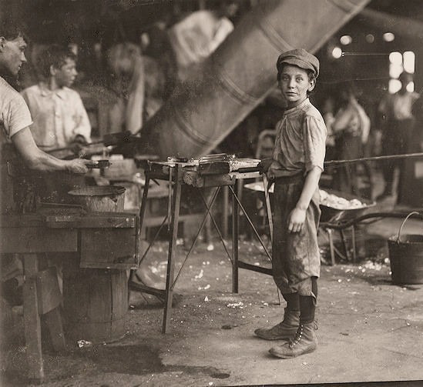
Rob Kidd, one of the young workers in a glass factory. Alexandria, Virginia.

Station #5: The Seafood Industry
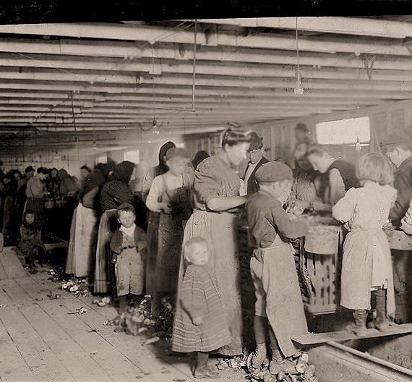
Oyster shuckers working in a canning factory. All but the very smallest babies work. Began work at 3:30 a.m. and expected to work until 5 p.m. The little girl in the center was working. Her mother said she is "a real help to me." Dunbar, Louisiana.

Station #5: The Seafood Industry
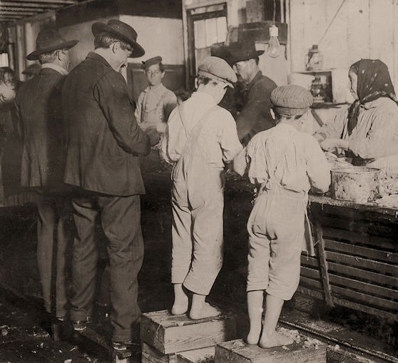
Shrimp pickers, including little 8­year­old Max on the right. Biloxi, Mississippi.

Station #5: The Seafood Industry
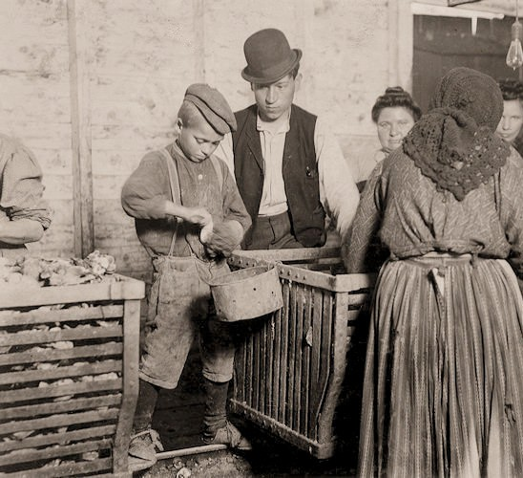
Johnnie, a 9­year­old oyster shucker. Man with pipe behind him is a Padrone who has brought these people from Baltimore for four years. He is the boss of the shucking shed. Dunbar, Louisiana.

Station #5: The Seafood Industry
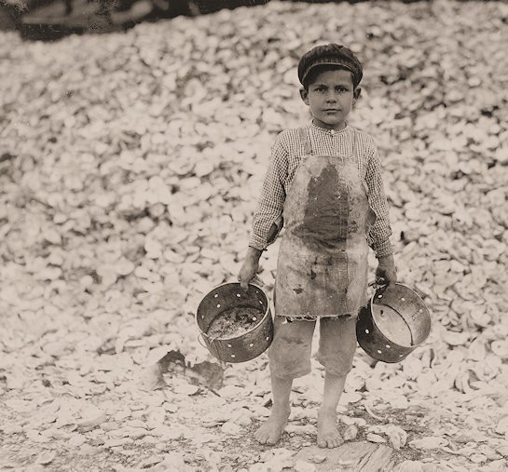
Manuel the young shrimp picker, age 5, and a mountain of child labor oyster shells behind him. He worked last year.
Understands not a word of English. Biloxi, Mississippi.

Station #5: The Seafood Industry
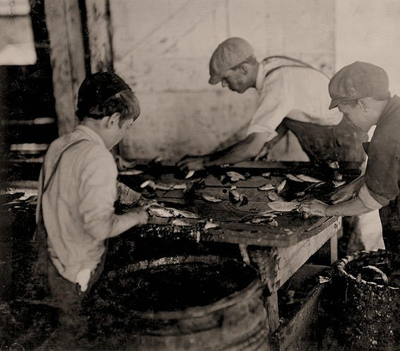
Cutting fish in a sardine cannery. Large sharp knives are used with a cutting and sometimes chopping motion. The slippery floors and benches and careless bumping into each other increase the liability of accidents. "The salt water gits into the cuts and they ache," said one boy. Eastport, Maine.

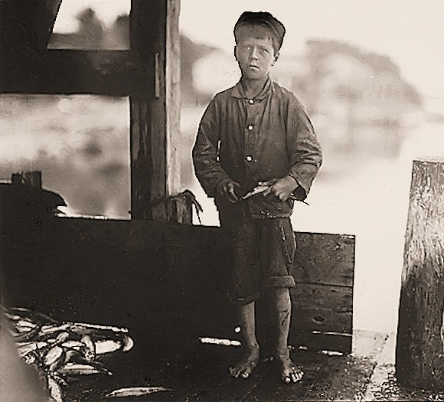
Station #5: The Seafood Industry
Hiram Pulk, age 9, working in a canning company. "I ain't very fast only about 5 boxes a day. They pay about 5 cents a box," he said. Eastport, Maine.

Station #6: Newsies
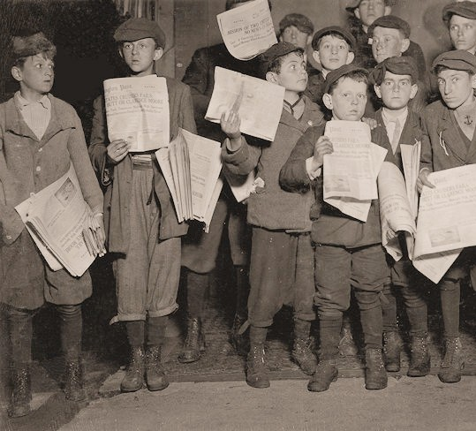
Newsies out after midnight selling extras. There were many young boys selling very late. Youngest boy in the group is 9 years old. Harry, age 11, Eugene and the rest were a little older. Washington, D.C.

Station #8: Safety Conditions

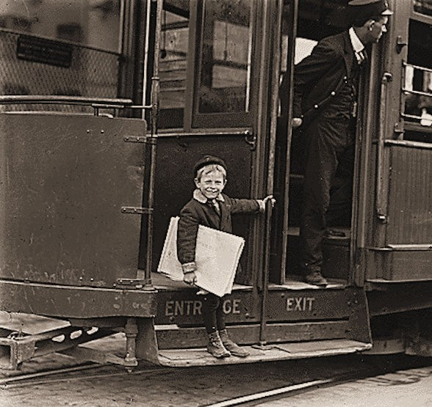

Francis Lance, 5 years old, 41 inches high. He jumps on and off moving trolley cars at the risk of his life. St. Louis, Missouri.

Station #7: The Coal Mine
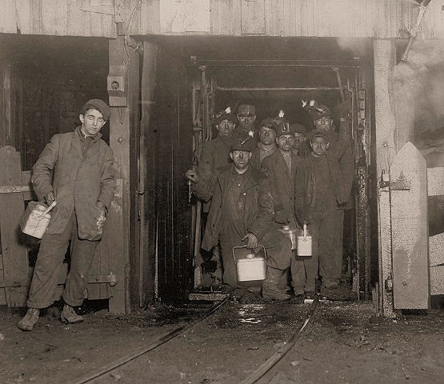
At the close of day. Waiting for the cage to go up. The cage is entirely open on two sides and not very well protected on the other two, and is usually crowded like this. The small boy in front is Jo Puma. South Pittston, Pennsylvania.

Station #8: Safety Conditions
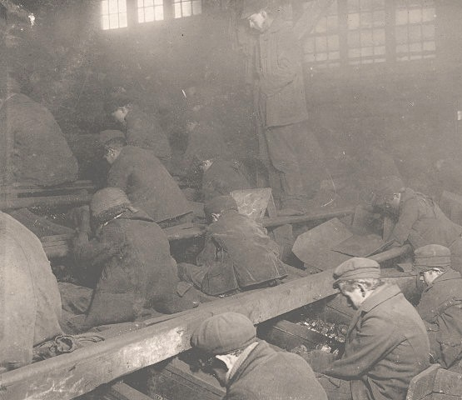
View of the Ewen Breaker of the Pennsylvania Coal Co. The dust was so dense at times as to obscure the view. This dust penetrated the utmost recesses of the boys' lungs. A kind of slave­driver sometimes stands over the boys, prodding or kicking them into obedience. South Pittston, Pennsylvania.

Station #7: The Coal Mine
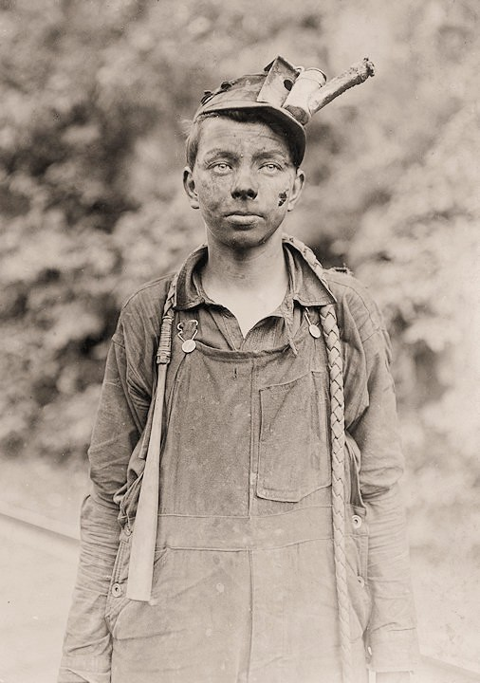

A young driver in the Brown Mine. Has been driving one year. Works 7 a.m. to 5:30 p.m. daily. Brown, West Virginia.

Station #7: The Coal Mine
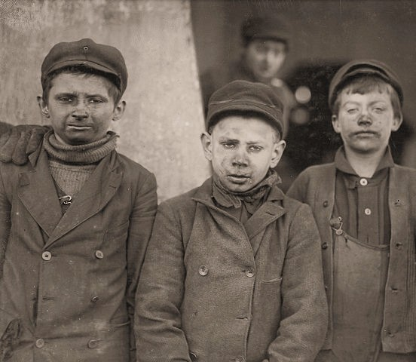
Breaker boys, Hughestown Borough Pennsylvania Coal Company. One of these is James Leonard, another is Stanley Rasmus. Pittston, Pennsylvania.

Station #9: Pastimes and Vices
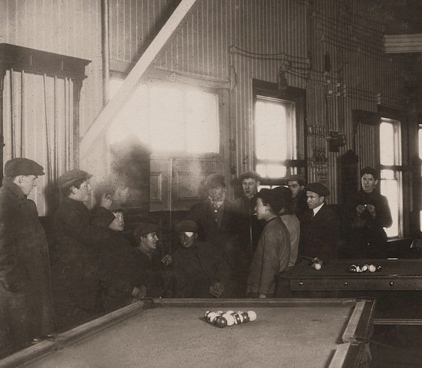
Killing time. Mill boys and men hanging around Swift's Pool Room. Saturday p.m. A common sight any day.
Educational influences; bad stories and remarks ­ will not bear repetition. Fall River, Massachusetts.

Station #9: Pastimes and Vices
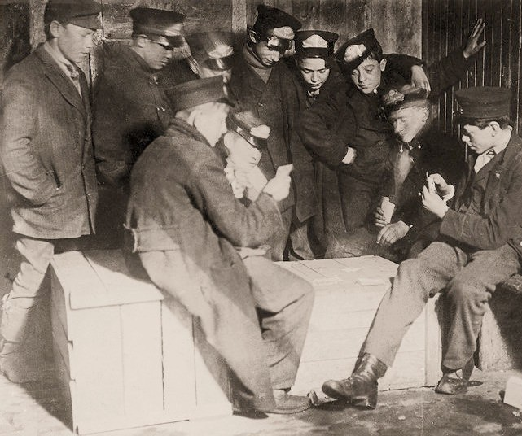
Messengers absorbed in their usual game of poker in the "Den of the terrible nine" (the waiting room for Western Union Messengers, Hartford, Connecticut). They play for money. Some lose a whole month's wages in a day and then are afraid to go home. The boy on the right has been a messenger for 4 years. Began at 12 years of age. He works all night now. During an evening's conversation he told me stories about his experiences with prostitutes to whom he carries messages frequently.

Station #9: Pastimes and Vices
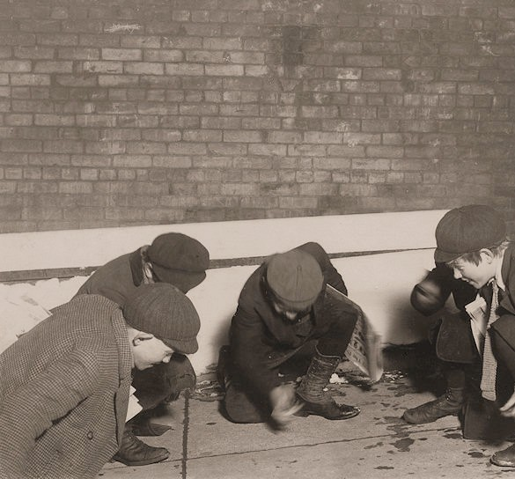
A group of newsies playing craps in the jail alley at 10 p.m. Albany, New York.

Station #6: Newsies
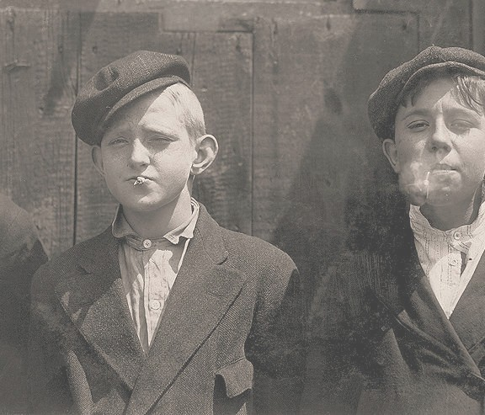
11:00 a.m. Newsies at Skeeter's Branch. They were all smoking. St. Louis, Missouri.

Station #9: Pastimes and Vices
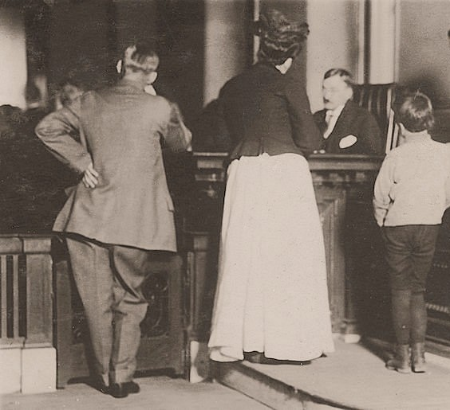
Juvenile Court. An 8­year­old boy charged with stealing a bicycle. St. Louis, Missouri.

Station #8: Safety Conditions
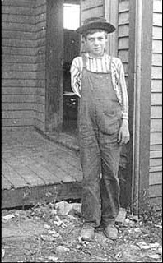

Boy lost arm running a saw in a box factory.

Station #1: Immigration and the American Dream

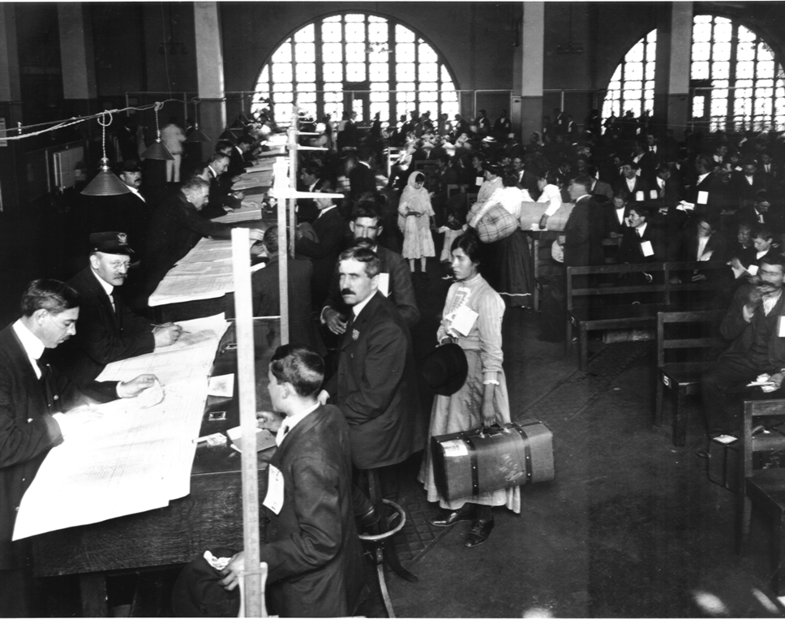
Arrival at Ellis Island

Station #8: Safety Conditions
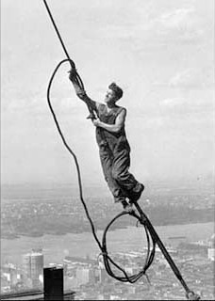

Icarus atop Empire State Building

Station #1: Immigration and the American Dream

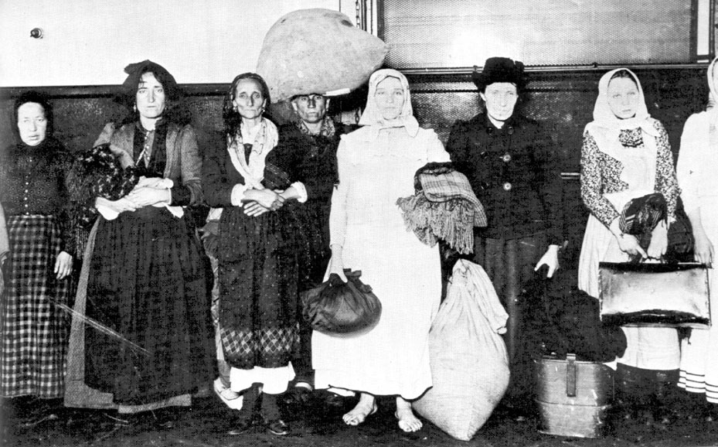
Italians arriving at Ellis Island

Station #8: Safety Conditions
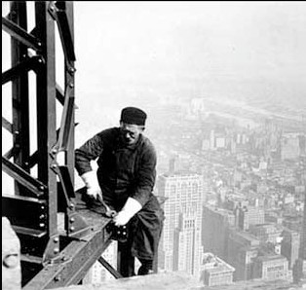

Old time steel worker on Empire State Building

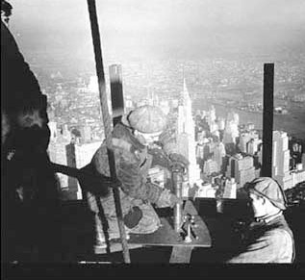
Station #8: Safety Conditions

Riveting at the top of the Mooring Mast on Empire State Building

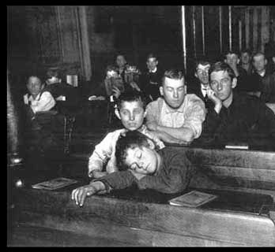
Station #10: Education
Night School at Seventh Avenue Lodging House

Station #11: Tenements
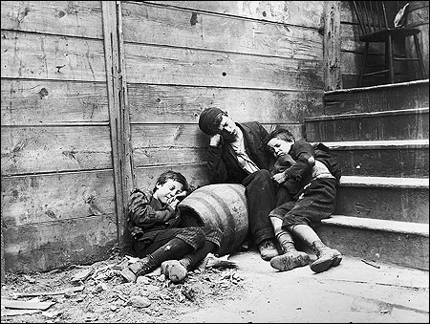

Children sleeping in the streets

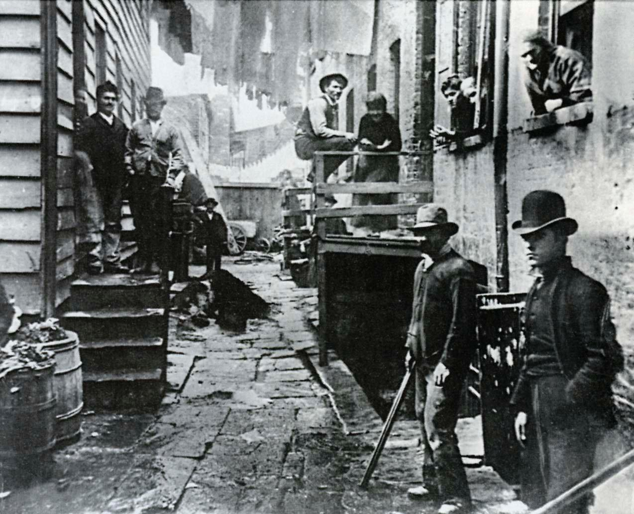
Station #11: Tenements

Men gathered in an alley between New York City tenements

Station #11: Tenements

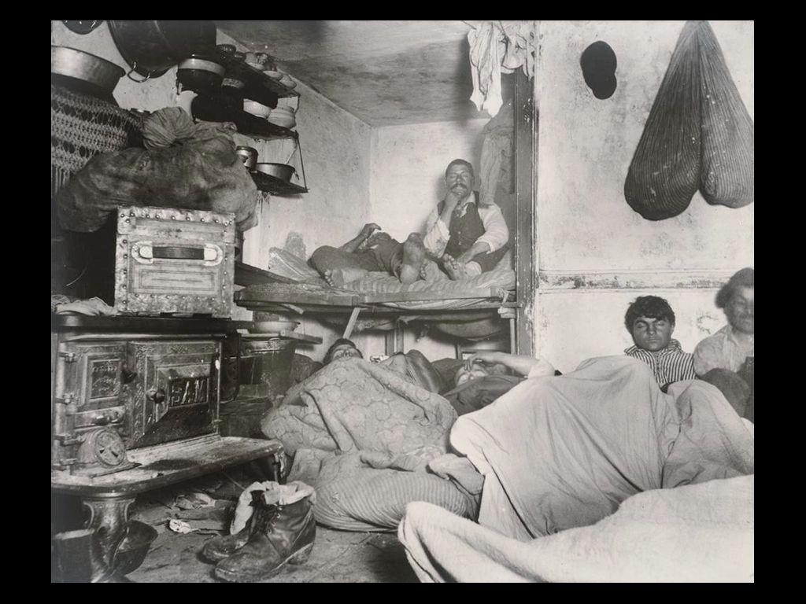

Living conditions in a New York City tenement

Station #11: Tenements
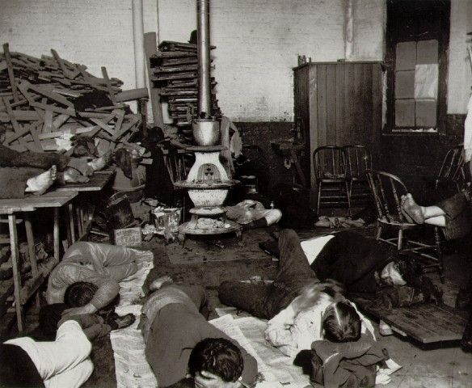

Living conditions in a New York City tenement

