Name____________________________________________ Block_______
Post World War II Map of Europe
Refer to the map on page 487 of your text.
- Label all of the countries in Europe
- Draw the “Iron Curtain”
- Color Communist countries
- Color Non-Communist countries
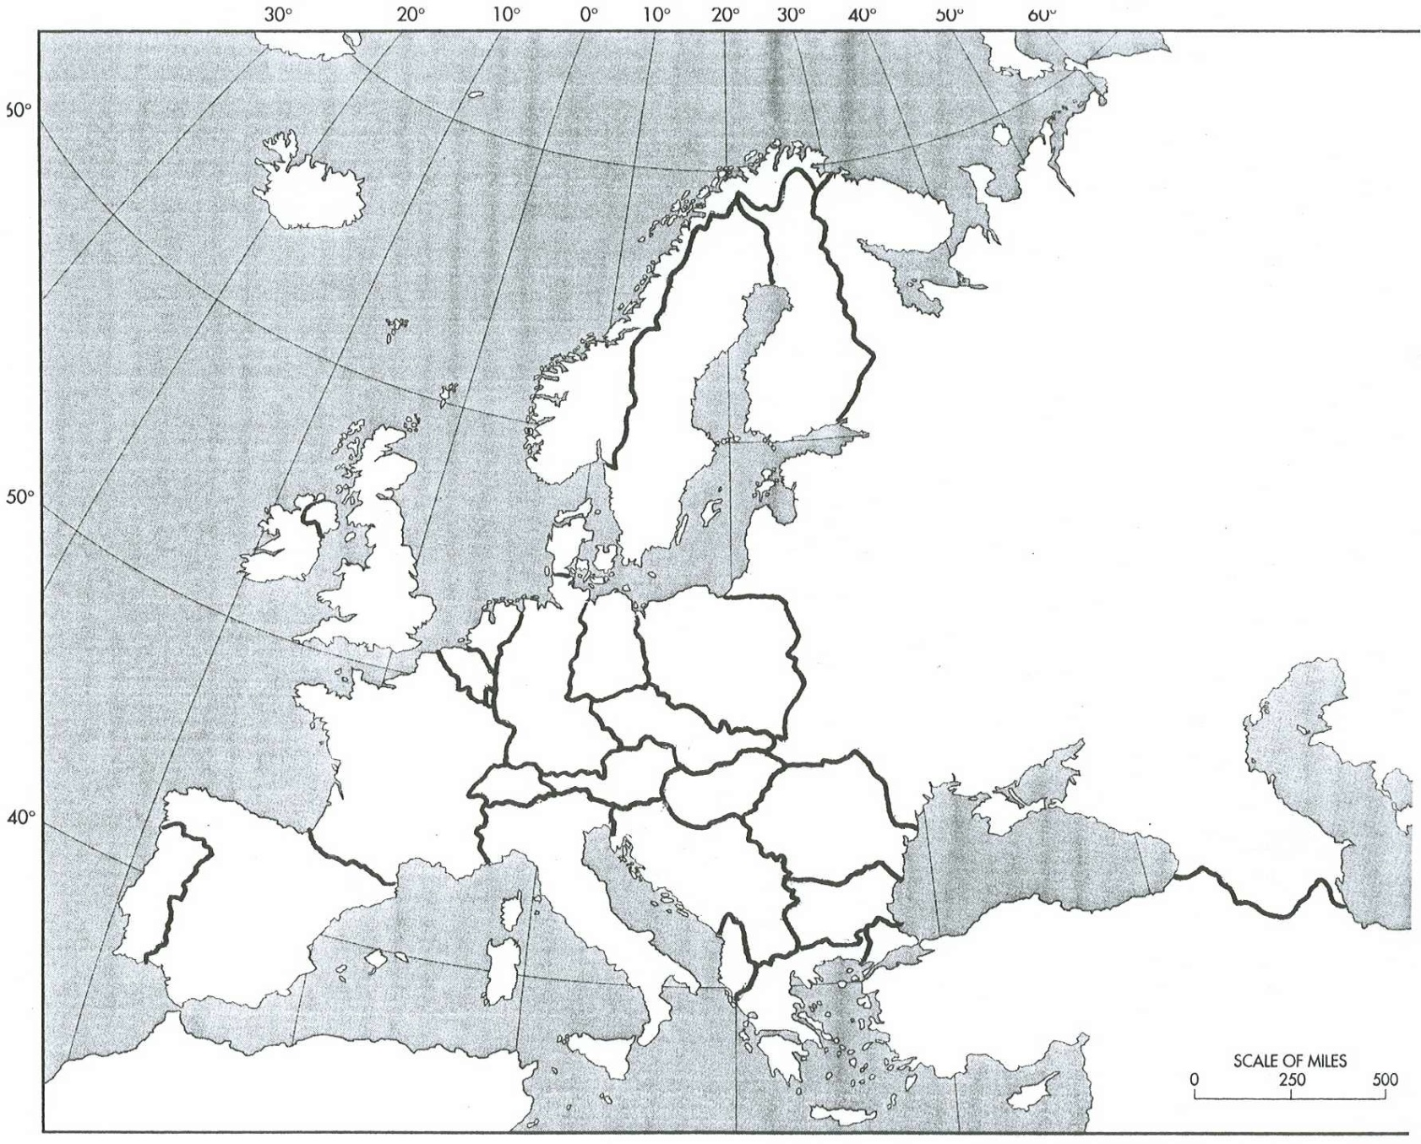
- Create a Key below the map
Key

