Progressive Era DBQ
Directions: Question 1 is based on the accompanying documents. The documents have been edited for the purpose of this exercise. You are advised to spend 15 minutes planning and 45 minutes writing your answer.
Write your responses on the lined pages that follow the questions.

In your response you should do the following.
• State a relevant thesis that directly addresses all parts of the question.
• Support the thesis or a relevant argument with evidence from all, or all but one, of the documents.
• Incorporate analysis of all, or all but one, of the documents into your argument.
• Focus your analysis of each document on at least one of the following: intended audience, purpose, historical context, and/or point of view.
• Support your argument with analysis of historical examples outside the documents.
• Connect historical phenomena relevant to your argument to broader events or processes.
• Synthesize the elements above into a persuasive essay.

- Evaluate the extent to which Progressive reformers and the federal government maintained continuity as well as fostered change during the period 1900-1920.
Doc 1
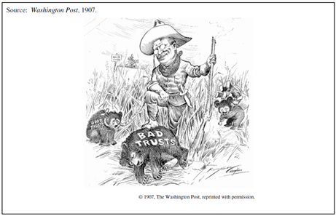

Doc 2
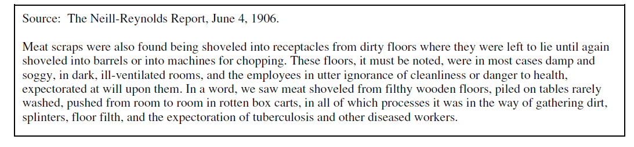
Doc 3
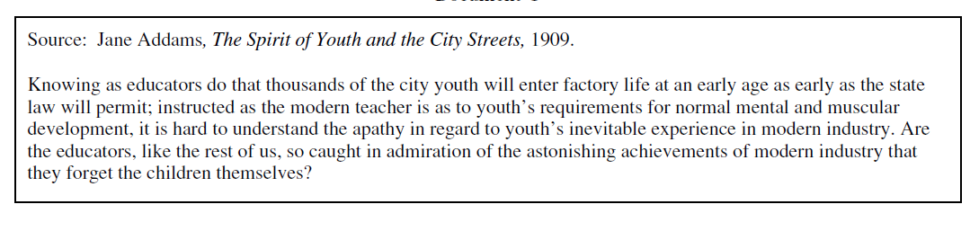
Doc 4
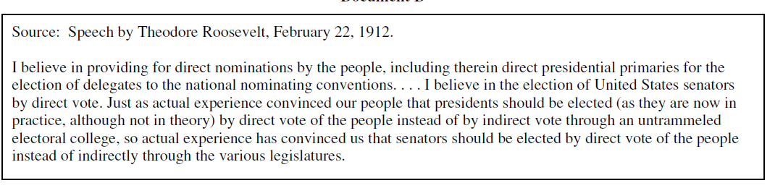
Doc 5
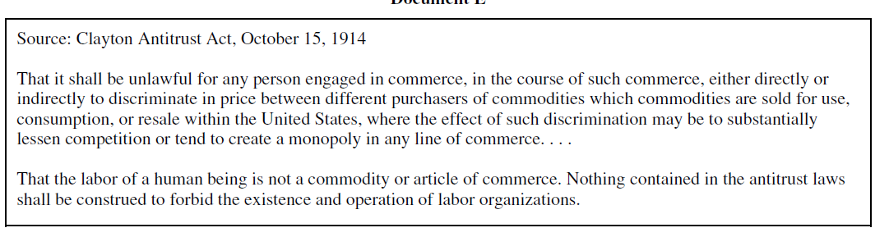

Doc 6
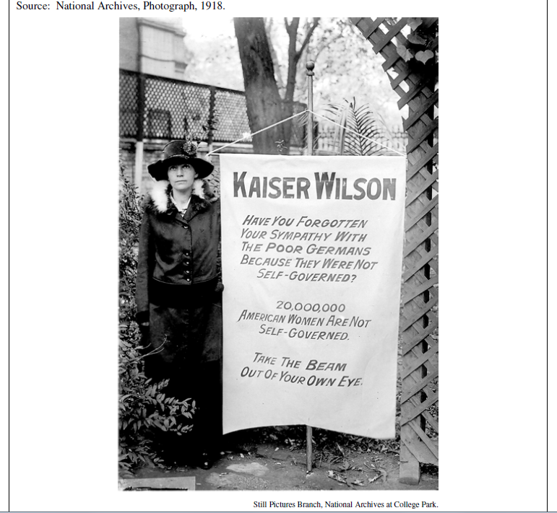
Doc 7
