Name___________________________________________ Block______
Progressive Era: Political Cartoons
Analyze the cartoons and answer the questions.
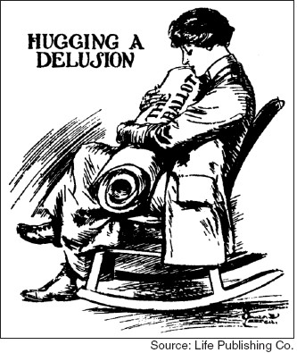
1. What are the characters and symbols in the cartoon, and what does each one represent?

2. How do the words help you identify the cartoonist’s intention?

3. What action is taking place in the cartoon?

4. What opinion is the cartoonist expressing?

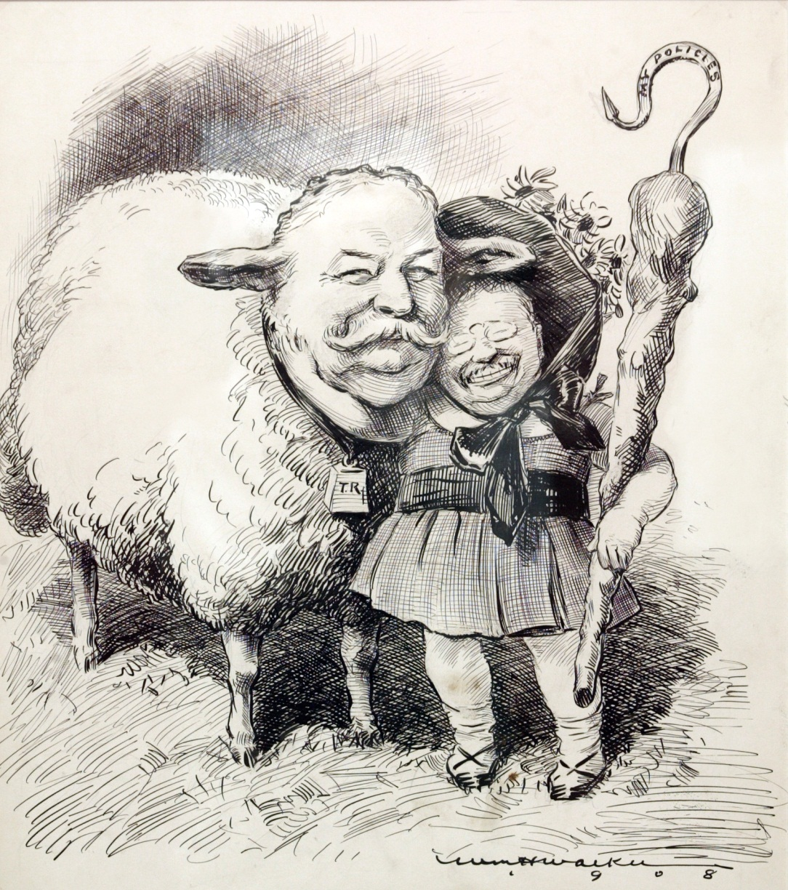
1. What are the characters and symbols in the cartoon, and what does each one represent?

2. How do the words help you identify the cartoonist’s intention?

3. What action is taking place in the cartoon?

4. What opinion is the cartoonist expressing?

