Name___________________________________________ Block_____

Prohibition: Why Was the 18th Amendment Adopted?

Introduction: Why did you think some Americans supported temperance during the early 20th century?
___________________________________________________________________________________________________________________________________________________

Instructions: Work in groups to read the following documents and respond to the questions. After completing all of the documents we will discuss the results and you will write a short essay.

The 18th Amendment
Source: United States Constitution
Context: The US Senate passed the 18th Amendment on December 18, 1917. It was ratified on January 16, 1919, after 36 states approved it. The 18th Amendment, and the enforcement laws accompanying it, established Prohibition of alcohol in the United States. Several states already had Prohibition laws before this amendment. It was eventually repealed by the 21st Amendment on December 5, 1933. It is the only amendment that has ever been completely repealed.

Section 1. After one year from the ratification of this article the manufacture, sale, transportation, importation or exportation of intoxicating liquors in the United States and all its territory is hereby prohibited.

Section 2. The Congress and the States shall both have power to enforce this article by appropriate legislation.

Section 3. This article shall have no power unless it shall have been ratified as an amendment to the Constitution by the legislatures of the States, as provided in the Constitution, within seven years from the date of the submission to the States by the Congress.

Vocabulary
To ratify—to confirm or pass something, such as an amendment Intoxicating liquors—alcohol
Article—a section or item in a written document. Until enough states ratified this amendment, it was known as an article.

Guiding Questions:

- What is your first reaction to the 18th amendment?

- Do you think this amendment could be passed today? Why or why not?

- Why do you think some Americans in 1918 might have wanted this amendment?

Document A: Prohibition and Health

Alcohol poisons and kills; Abstinence and Prohibition save lives and safeguard health.

Dr. S.S. Goldwater, formerly Health Commissioner of New York City, stated the decision of science, the final opinion of our nation after a hundred years of education upon the subject of alcohol.

“It is believed that less consumption of alcohol by the community would mean less tuberculosis, less poverty, less dependency, less pressure on our hospitals, asylums and jails.”

“Alcohol hurts the tone of the muscles and lessens the product of laborers; it worsens the skill and endurance of artists; it hurts memory, increases industrial accidents, causes diseases of the heart, liver, stomach and kidney, increases the death rate from pneumonia and lessens the body’s natural immunity to disease.”

Justice Harlan speaking for the United States Supreme Court, said:

“We cannot shut out of view the fact that public health and public safety may be harmed by the general use of alcohol.”

Vocabulary

Abstinence: Stopping yourself from doing something (e.g., drinking) Consumption: eating or drinking

Source: Statement read at the Eighth Annual Meeting of the National Temperance Council, Washington D.C., September 20, 1920. The National Temperance Council was created in 1913 to work for Prohibition.

Document A
- (Sourcing) When was this document written? Was this before or after the passage of the 18th Amendment?

Why might the National Temperance Council have met in 1920 (after the passage of the 18th Amendment)? What do you predict they will say?

- (Close reading) What does the National Temperance Council claim is caused by alcohol?

- (Context) Do you find these claims convincing? Do you think people at the time found these claims convincing? Explain.

Document B: “Hooch Murder” Bill

‘Hooch Murder’ Bill Drafted by Anderson

Anti-Saloon Head Aims to Reach Those Whose Drinks Cause Death.

William H. Anderson, State Superintendent of the Anti-Saloon League, announced in a statement yesterday that the organization would sponsor a measure at the upcoming State Legislature. The measure would be known as the “Hooch Murder” bill. It says a person can be tried for murder, and punished accordingly, if they are suspected of selling alcohol that resulted in the death of the person drinking it. Commenting on the measure, Mr. Anderson said:

“This bill is intended for whoever it may hit, but it is especially directed at the immoral foreigner, usually an alien, who had largely stopped killing with a knife from hate or with a gun for hire, and has gone into the preparation and thoughtless selling of poison for profit.”

Vocabulary
Hooch: slang term for alcohol, commonly used in the 1920s to refer to illegal whiskey
Alien: a foreigner who is not a citizen

Source: “Hooch Murder Bill Drafted by Anderson,” The New York Times,

November 14, 1922.

Document B
- (Sourcing) When was this document written? Was this before or after the passage of the 18th Amendment?

- (Close reading) What is the “Hooch Murder Bill”?

- (Context) Based on this document, who is the Anti-Saloon League blaming for the sale of alcohol during Prohibition? Why do you think they singled this group?

Document C: “Alcoholism and Degeneracy”
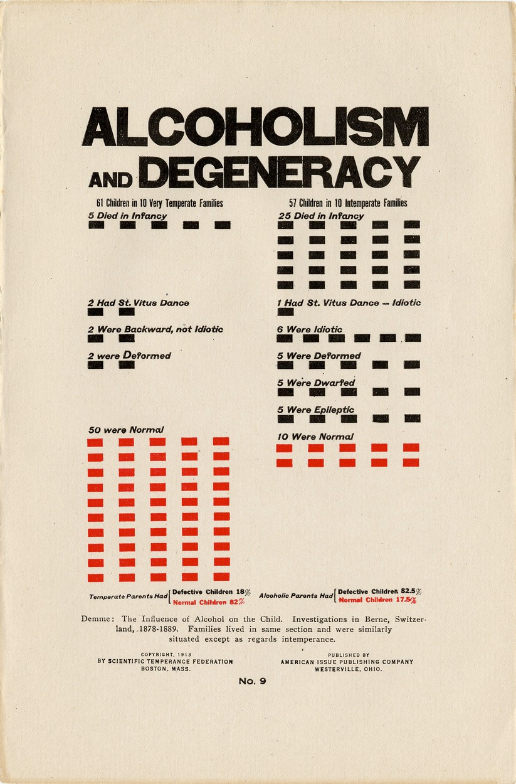

Vocabulary
Temperate: refraining from drinking alcohol Intemperate: drinking alcohol
Degeneracy: being in decline; having qualities that are not normal or desirable

Source: Boston, MA and Westerville, Ohio: Scientific Temperance and American Issue Publishing Company, 1913.

Document D: “Children in Misery”

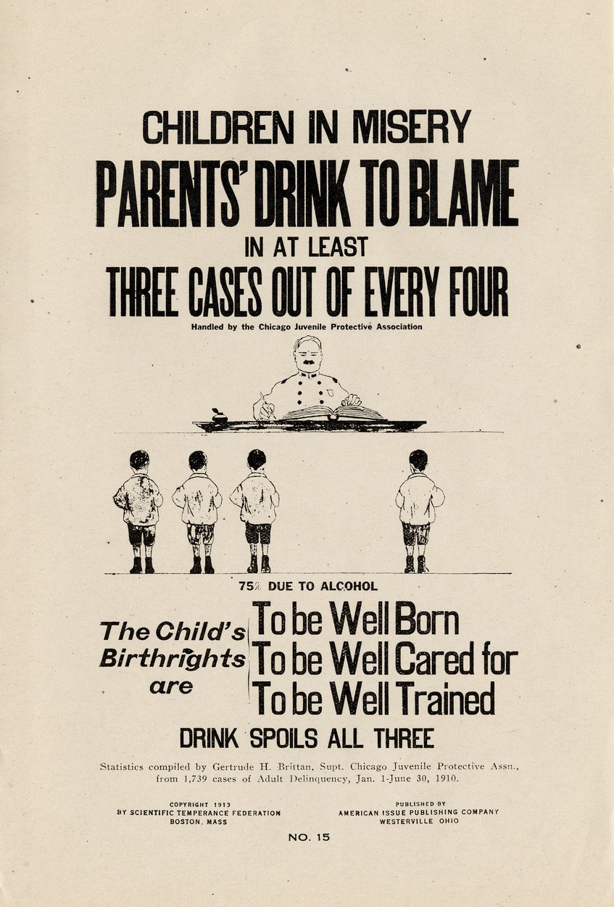

Source: Boston, MA and Westerville, Ohio: Scientific Temperance Federation and American Issue Publishing Company, 1913.

Documents C and D
  - (Sourcing) When were these posters made? Was that before or after the passage of the 18th Amendment?

Who published these posters? What was their perspective?

  - (Close reading) According to these posters, what are two reasons why Prohibition is a good idea?

  - (Close words) Look at the words used in Document C. These were considered “scientific” categories. What does that tell you about science at this time?

  - (Context) Using these posters, explain some of the beliefs about children that were common in the early 20th century. Do you think these beliefs are silly or reasonable? Explain.

Short Essays:
People who supported Prohibition thought it would solve a lot of society’s problems. Use the documents to explain what problems they saw in society and why they thought Prohibition would solve these problems. (Minimum 150 words)
_________________________________________________________________________________________________________________________________________________________________________________________________________________________________________________________________________________________________________________________________________________________________________________________________________________________________________________________________________________________________________________________________________________________________________________________________________________________________________________________________________________________________________________________________________________________________________________________________________________________________________________________________________________________________________________________________________________________________________________________________________________________________________________________________________________________________________________________________________________________________________________________________________________________________________________________________________________________________________________________________________________________________________________________________________________________________________________________________________________________________________________________________________________________________________________________________________________________________________________________________________________________________________________________________________________________________________________________________________________________________________________________________________________________________________________________________________________________________________________________________________________________________________________________________________________________________________________________________________________________________________________________________________________________________________________________________________________________________________________________________________________________________________________________________________________________________________________________________________________

Historians disagree about the motivation behind Prohibition:
- Some say Prohibition was an attempt on the part of middle-class Protestants to control immigrants and the urban poor.
- Some say Prohibition was an attempt to help children and families.
What do you think? Use the documents. (Minimum 150 words)
____________________________________________________________________________________________________________________________________________________________________________________________________________________________________________________________________________________________________________________________________________________________________________________________________________________________________________________________________________________________________________________________________________________________________________________________________________________________________________________________________________________________________________________________________________________________________________________________________________________________________________________________________________________________________________________________________________________________________________________________________________________________________________________________________________________________________________________________________________________________________________________________________________________________________________________________________________________________________________________________________________________________________________________________________________________________________________________________________________________________________________________________________________________________________________________________________________________________________________________________________________________________________________________________________________________________________________________________________________________________________________________________________________________________________________________________________________________________________________________________________________________________________________________________________________________________________________________________________________________________________________________________________________________________________________________________________________________________________________________________________________________________________________________________________________________________

