Name_________________________________________________________ Block______
Using pages 134 and 142 to help you create a map of Reconstruction Era United States.
What you need to put on the map:
- Label all states and territories
- Label and color military districts
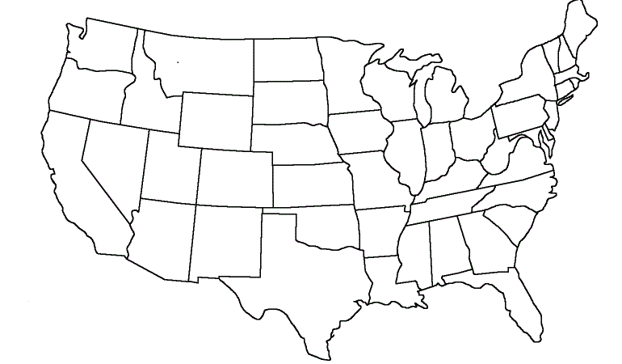
- Label the date of readmission into the Union

