Name__________________________________________ Block_____

100
Slavery: A WebQuest
Follow the directions for each step and complete the required work.
STEP 1:
Go to the link http://www.pbs.org/wgbh/aia/part4/map4.html, read, and answer the following questions.
1. How many slaves were in the United States by 1830?

2. During the 1830s by how much did the slave population grow in the Lower Southern states?

3. What percentage of white southerners did not own slaves?

4. Why did many Northerners oppose the abolitionist (anti-slavery) movement?

STEP 2:
Go to the link http://www.pbs.org/wgbh/aia/part4/4p2956.html, read, and answer the following questions.
1. Why were yeoman farmers in favor of slavery even if they did not own slaves?

2. What crops did slaves raise other than cotton?

3. What kind of labor did slaves do?

4. Why were there health problems and rampant illness among slaves?

5. What was the child mortality rate on rice plantations?

6. How were slave women sexually exploited?

7. What kind of discipline were slaves subjected to?

8. What were the slave codes?

STEP 3:
Go to the link http://www.pbs.org/wgbh/aia/part4/4p2918.html, read, and answer the following questions.
1. What was the “Weeping Time”?

2. When and where did it occur?

3. How many slaves were sold?

4. Who was selling them and why?

5. Summarize Sidney George Fisher’s opinion of the auction in a minimum of 3 sentences.

6. How much money did the auction bring in?

7. What was the highest price paid for a family and an individual?

STEP 4:
Analyze the image and answer the question. You can see a clear, color version of this cartoon at http://memory.loc.gov/rbc/rbcmisc/ody/ody0313/0313018v.jpg.
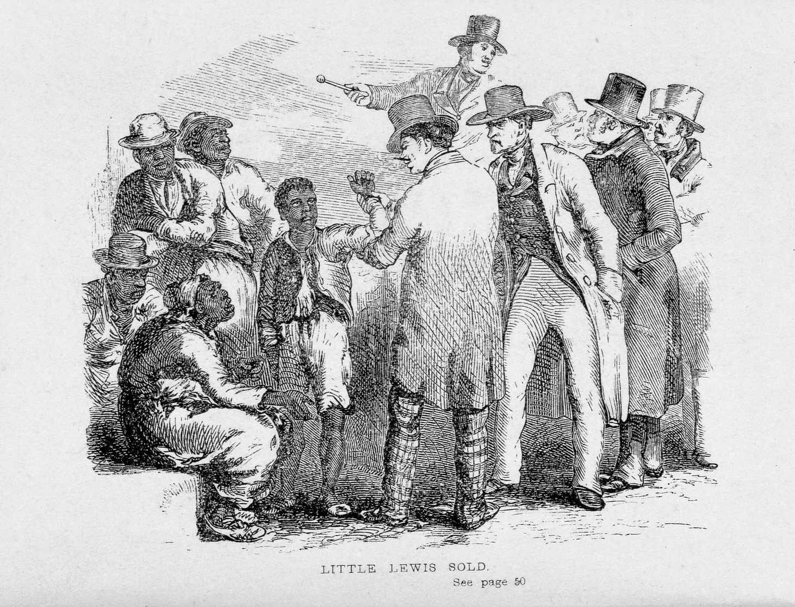
Describe in a short paragraph what you think is occurring in the above image.
____________________________________________________________
____________________________________________________________
____________________________________________________________
____________________________________________________________
STEP 5:
Analyze the cartoon and answer the question. You can see a clear, color version of this cartoon at http://wpscms.pearsoncmg.com/wps/media/objects/1693/1733989/images/img_ah3_p123.html.
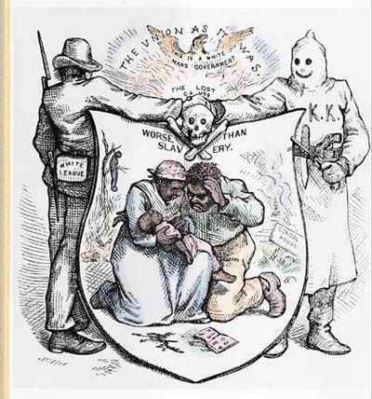
This is a political cartoon that was published after slaves were freed, yet it is a commentary on the conditions African-Americans were subjected to.
What do you think it says about life for African-Americans after the Civil War? ___________________________________________________________
____________________________________________________________
____________________________________________________________
____________________________________________________________

With a partner, if you choose, look at the pictures at http://mrbaileyqrmhs.weebly.com/images2.html and create a fictional story based on one or more of the images. Minimum 350 words. Then, post your story to the blog on my website at http://mrbaileyqrmhs.weebly.com/us-history-blog.html.
________________________________________________________________________________________________________________________________________________________________________________________________________________________________________________________________________________________________________________________________________________________________________________________________________________________________________________________________________________________________________________________________________________________________________________________________________________________________________________________________________________________________________________________________________________________________________________________________________________________________________________________________________________________________________________________________________________________________________________________________________________________________________________________________________________________________________________________________________________________________________________________________________________________________________________________________________________________________________________________________________________________________________________________________________________________________________________________________________________________________________________________________________________________________________________________________________________________________________________________________________________________________________________________________________________________________________________________________________________________________________________________________________

