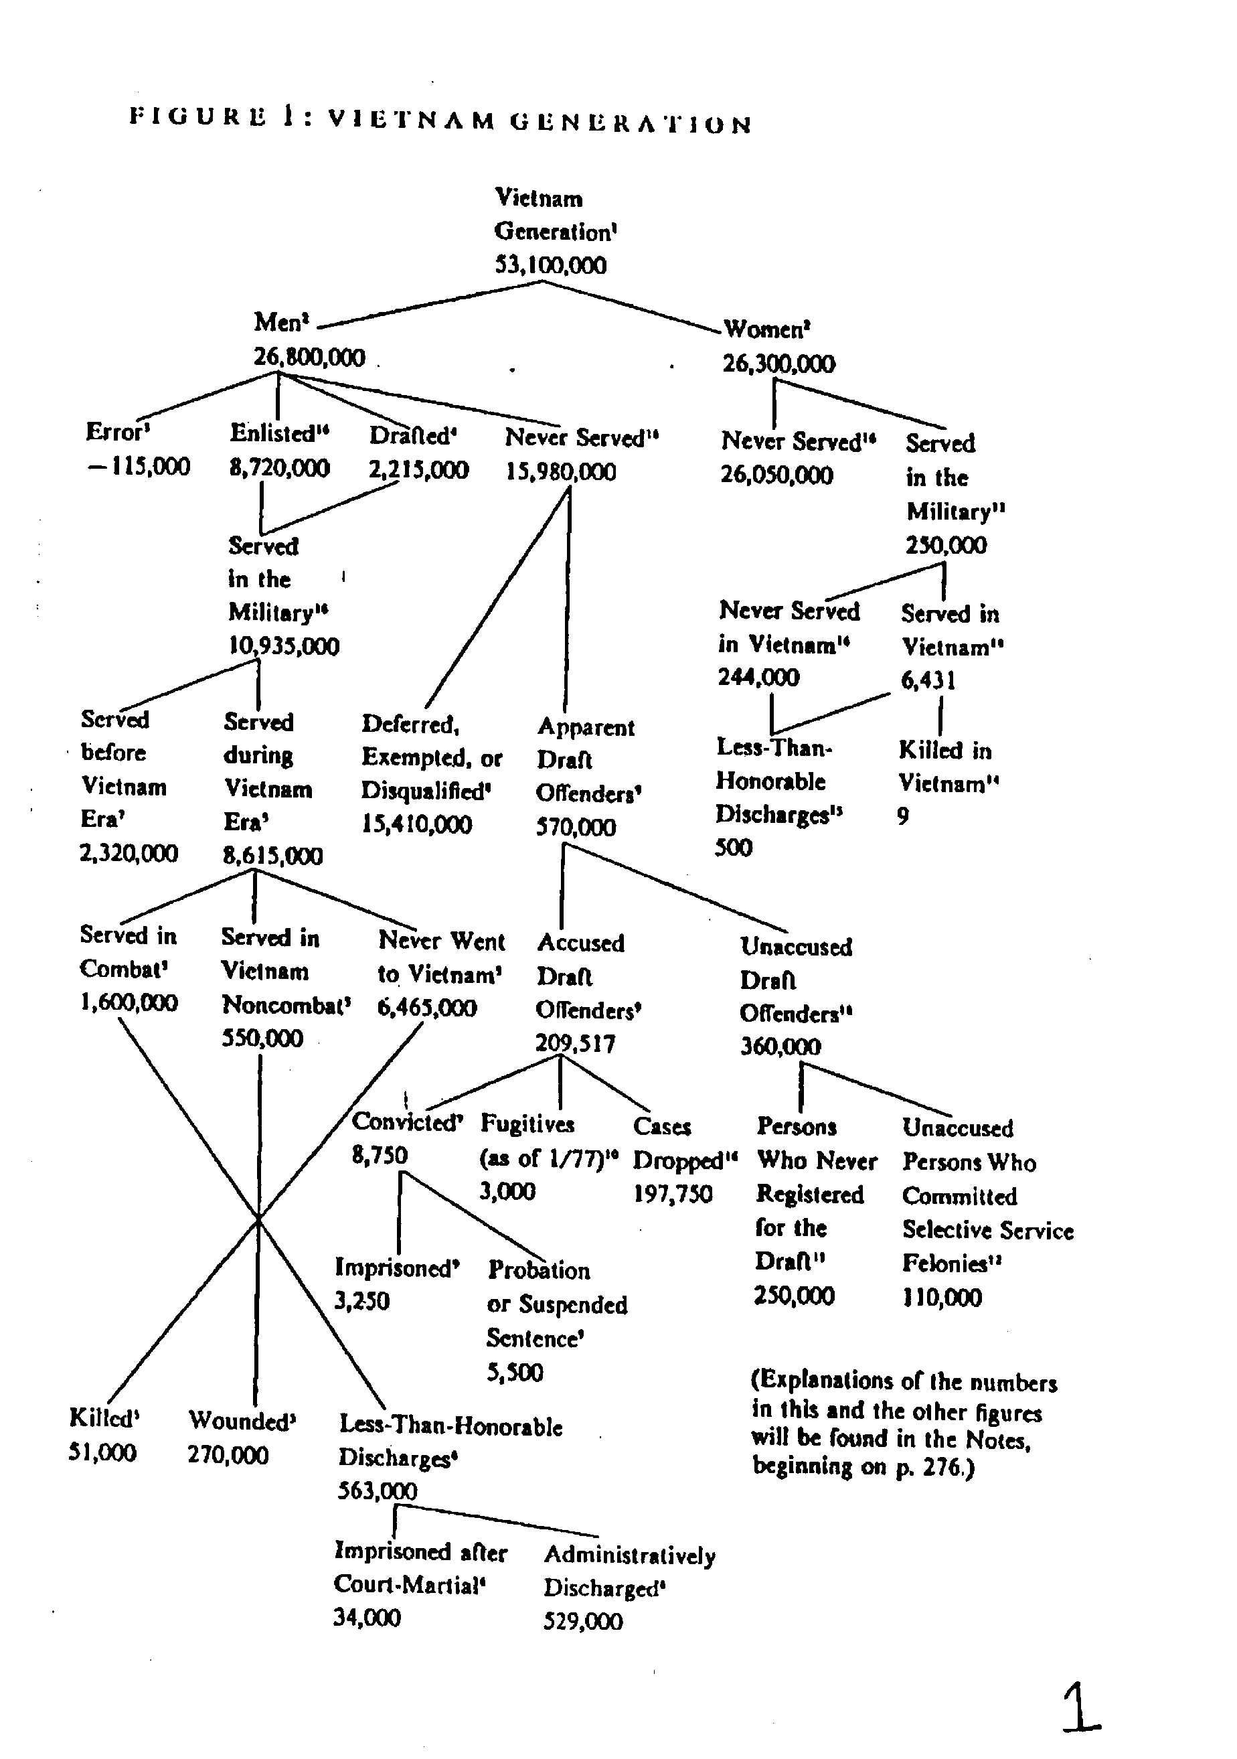
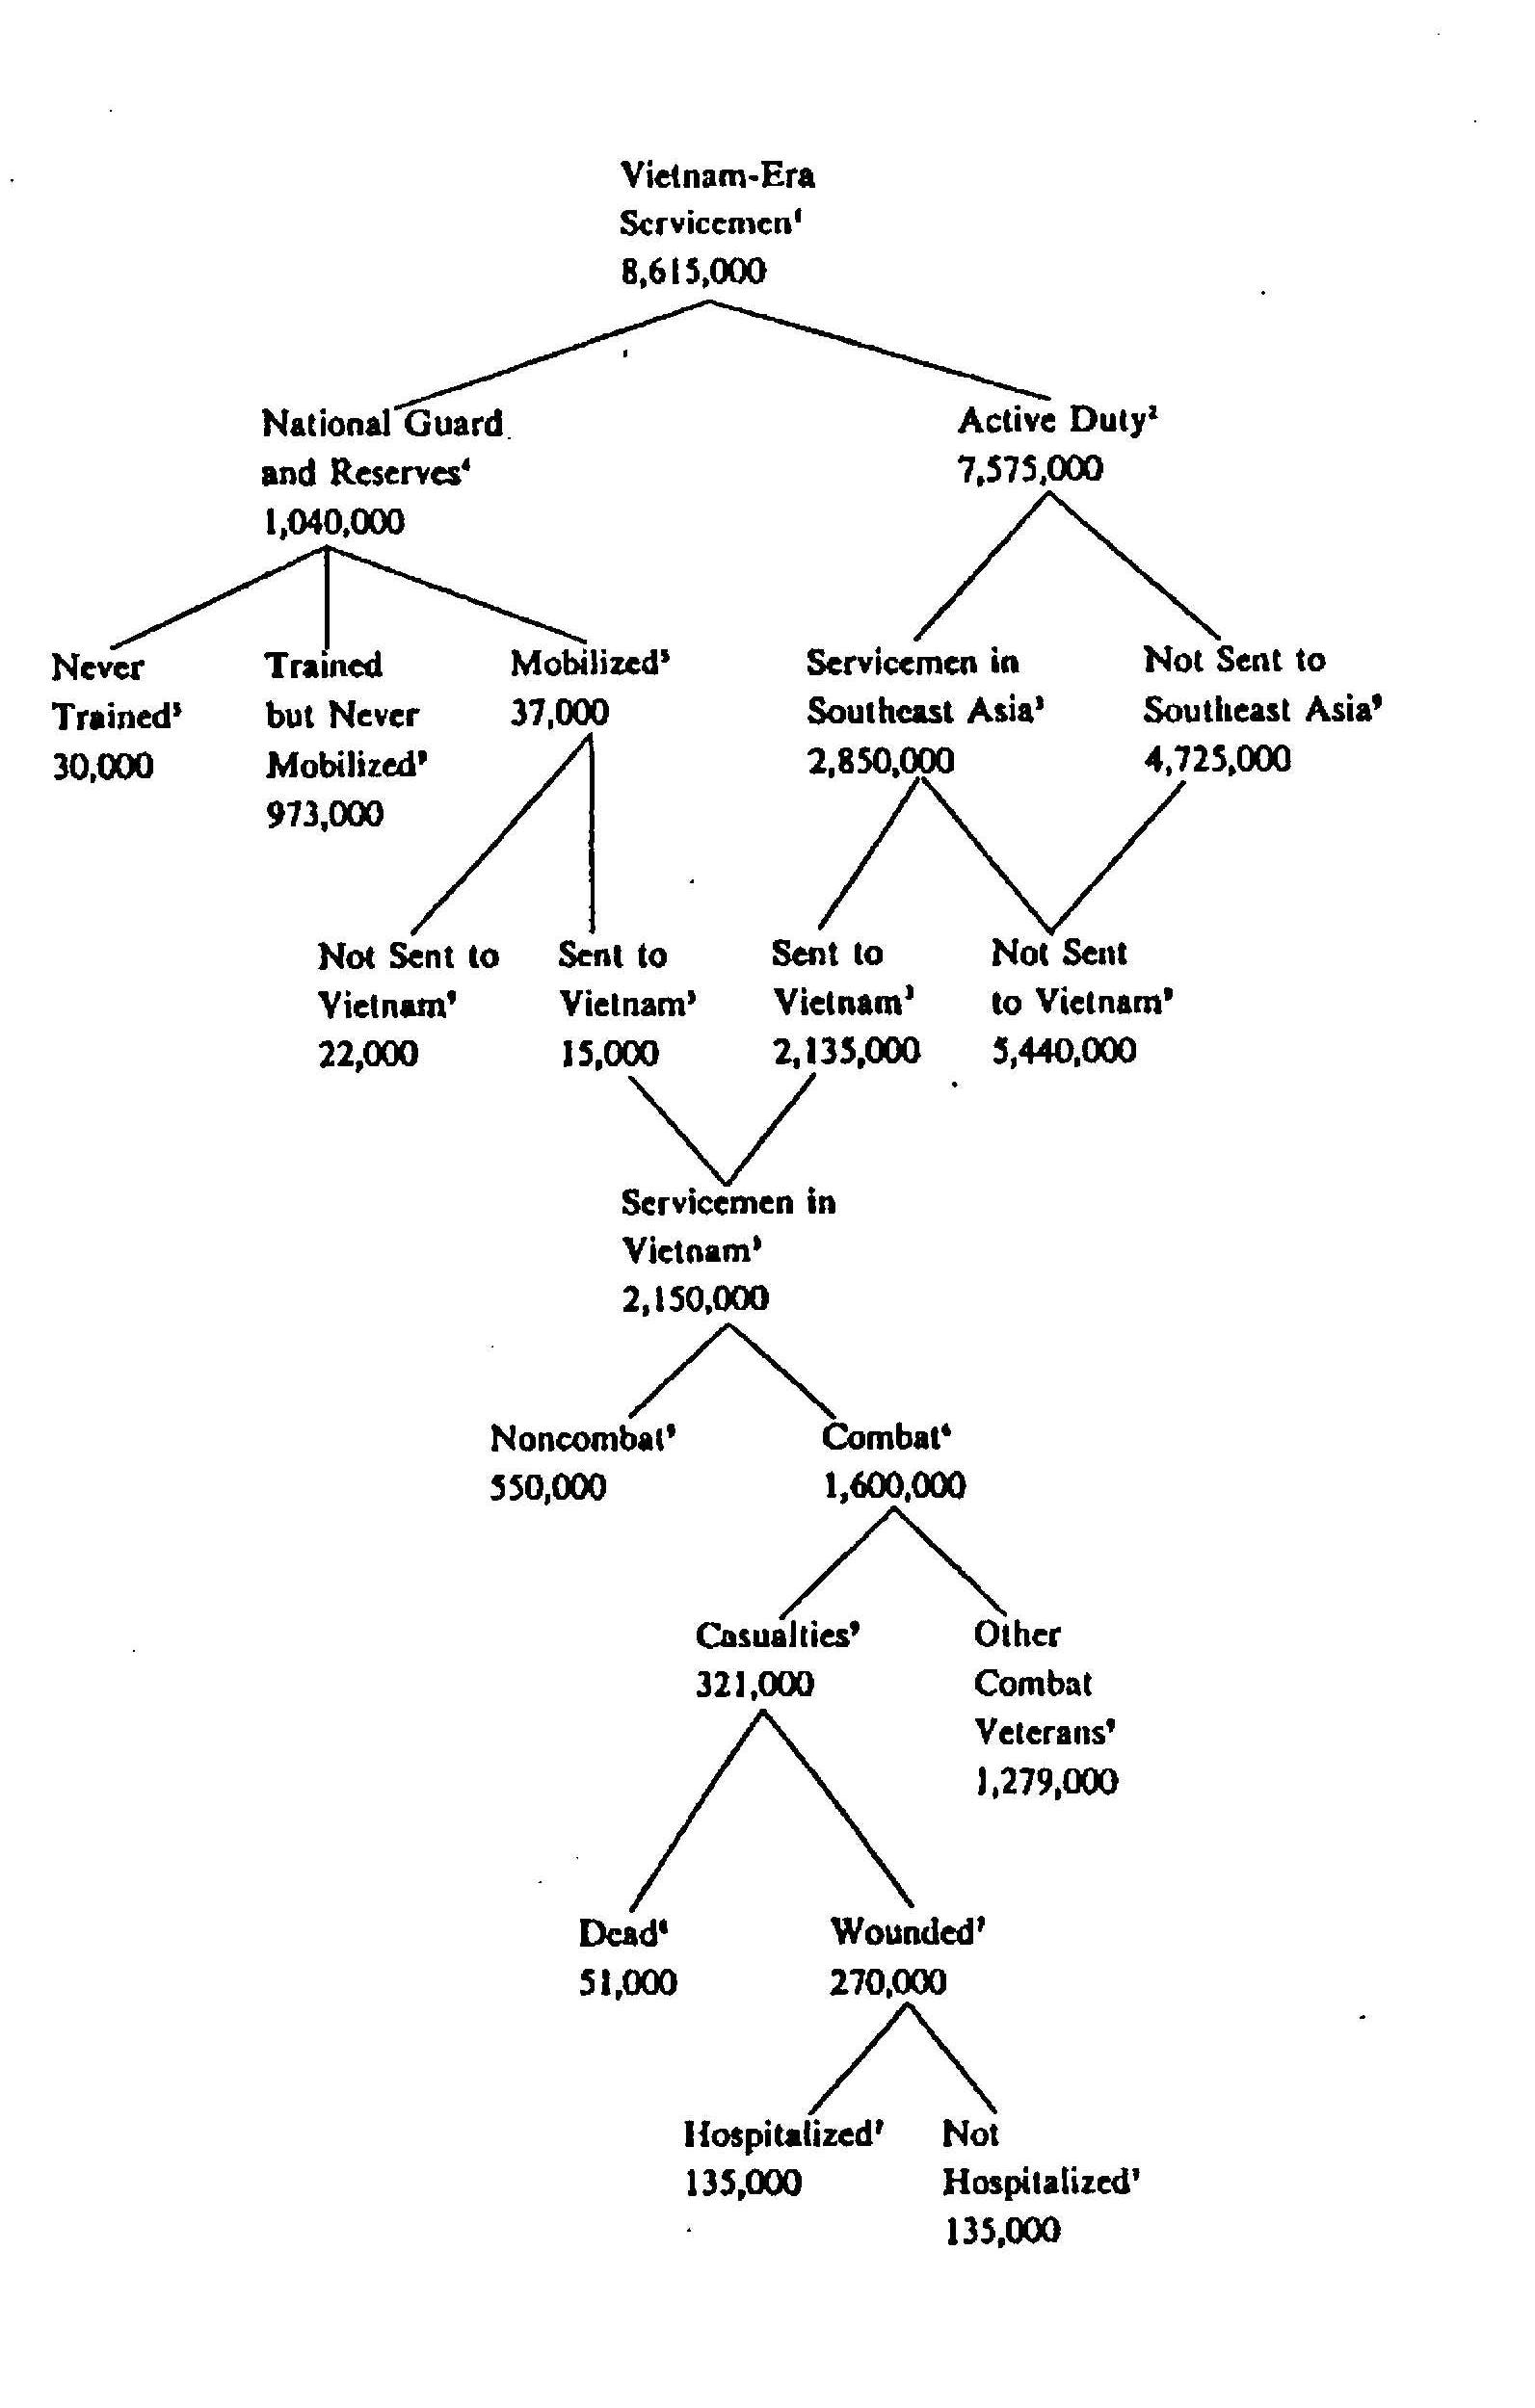
VIETNAM WAR DRAFT STATISTICS

Figure 2: Vietnam Servicemen

Figure 4: Draft Avoiders
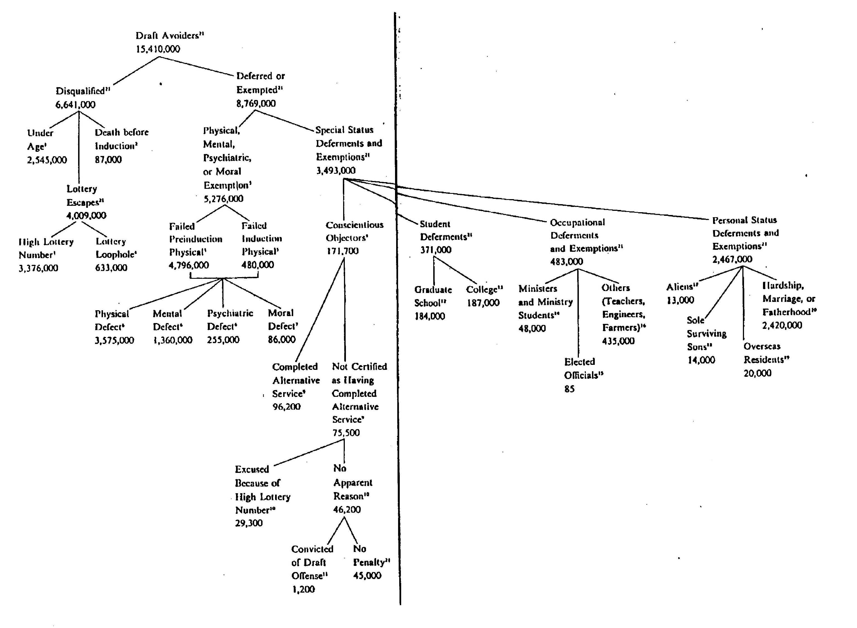

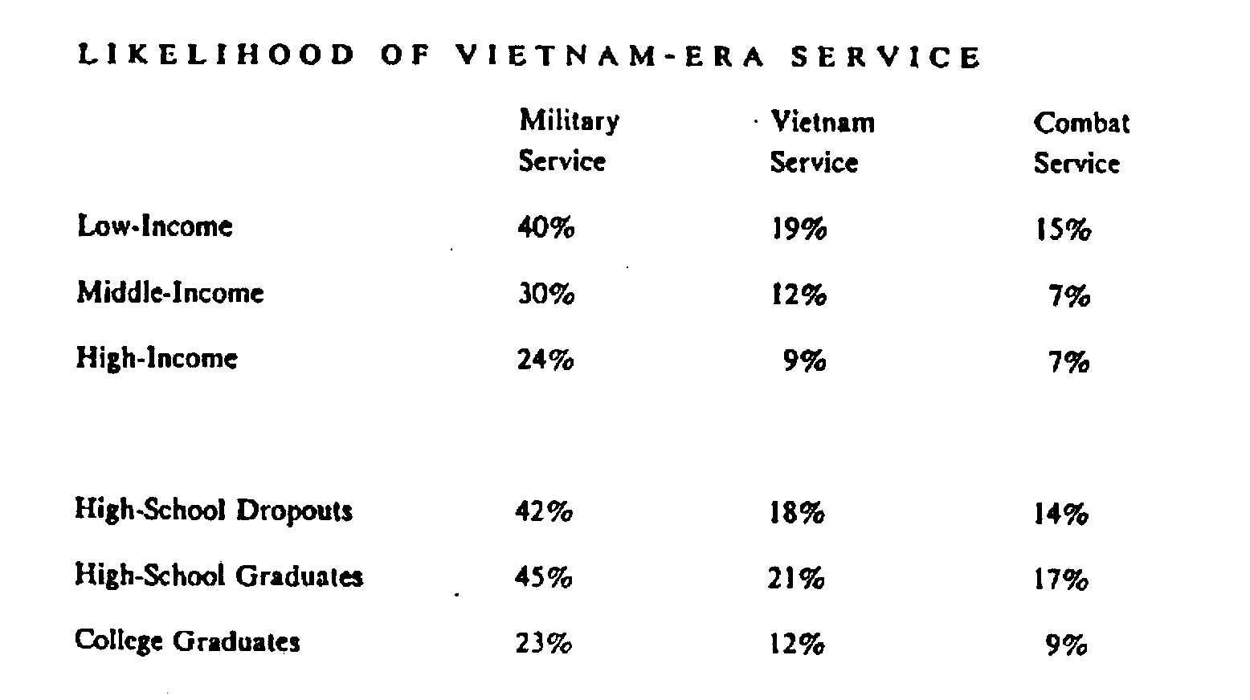
Figure 3:

